|  |  |
| --- | --- |
|  | **Qatar University**  **College of Engineering**  **Department of Computer Science and Engineering** |

Senior Project Report

**How to Attack a Disconnected Computer**

**Project Group Members:**

Malek Ayesh (201509162)

Abdulhady Fezooni (201402257)

Ehab Ghannoum (201509179)

**Supervisor**: Dr. Qutaibah Malluhi

**2020**

This project report is submitted to the Department of Computer Science and Engineering of Qatar University in partial fulfillment of the requirements of the Senior Project course.

# Declaration

This report has not been submitted for any other degree at this or any other University. It is solely the work of us except where cited in the text or the Acknowledgements page. It describes work carried out by us for the capstone design project. We are aware of the university’s policy on plagiarism and the associated penalties and we declare that this report is the product of our own work.

Student: Malek Ayesh Date: 30/04/2020

Signature:

Student: Abdulhady Fezooni Date: 30/04/2020

Signature:

Student: Ehab Ghannoum Date: 30/04/2020

Signature:

# Abstract

This project presents how a disconnected computer, that has no network access, can be attacked to retrieve data. Air-gapped devices are thought to be an impenetrable setup because the device is disconnected from the network and cannot be reached by an attacker. Therefore, an infected air-gapped computer cannot affect others around it, preventing any potential information leaks. People believe/assume that leaking information from an air-gapped machine is impossible. This project invalidates this assumption by utilizing covert channels to get data from victims’ machines. The project employs a hidden acoustic channel that takes advantage of the computer speakers to communicate sensitive data, in an inaudible near-ultrasonic form, to a small microphone. This method is proven to work successfully, as this will be shown in sections below. Hacking methods and the search for new system exploits are being continuously developed, and new techniques to obtain data unlawfully are on the rise. This project aims to alert organizations regarding potential threats that they typically ignore by assuming that air-gapped systems are safe. Currently security researchers are not investing sufficient time and effort in innovating solutions for such niche but capable attacks. Spreading awareness is a main objective of this project, by demonstrating that data can be stolen from an ‘air-gapped’ computer. A demonstration of this attack will hopefully push security field researchers and developers into exploring this uncommon method of unlawful data acquisition and its prevention. This system differs from others in many ways. It uses an uncommon frequency range, near ultrasonic, to transmit data. This gives the system a huge advantage over others that use an audible and radio frequency ranges. The simplicity of the microcontroller lessens the chance of it being detected in realistic operational environments. This is because the reading device can take many forms and can easily be concealed due to its size.

# Acknowledgment

*An exciting and challenging continuation of last semester’s work… Despite the inconveniences faced this semester, it was an overall pleasant experience. First, the team would like to thank Prof. Qutaibah for his support and wonderful encouraging energy throughout this project. Second, we would like to thank our parents for the tremendous and constant support throughout. Third, thank you to all Qatar University faculty members and individuals who help during this project. We appreciate the support. Thank you.*

Table of Contents

Declaration ii

Abstract iii

Acknowledgment iv

List of Figures vii

List of tables ix

1. Introduction and motivation 9

2. Background and related work 9

2.1. Background 9

A. Malware 9

B. Cryptography 9

C. Data encoding techniques 9

D. Digital modulation techniques 9

E. Transmission 9

F. Microphones [17] 9

H. Fourier transform (FT) 9

I. Fast Fourier transform (FFT) 9

G. Spectrogram 9

2.2. Related work 9

3. Requirements analysis 9

3.1. Functional requirements 9

3.2. Design constraints 9

3.3. Design standards 9

3.4. Professional and ethical responsibilities 9

3.5. Assumptions 9

4. Solution design 9

4.1. Overview 9

4.2. Hardware/software used 9

4.2.1. Hardware 9

4.2.2. Software 9

4.3. Hardware design 9

4.4. Software design 9

5. Implementation 9

5.1. Design description 9

5.2. Design novelties 9

5.2.1. Hardware 9

5.2.2. Software 9

5.3. Challenges encountered 9

5.3.1. Hardware 9

5.3.2. Software 9

5.4. Listening device forms 9

6. Testing and Evaluation 9

6.1. Audio frequency range test 9

6.2. Distance and bit duration 9

6.2.a. For 500ms bit transmission duration 9

6.2.b. For 1000ms bit transmission duration 9

6.2.c. For 2000ms bit transmission duration 9

6.2.d. For 3000ms bit transmission duration 9

6.2.e. For 4000ms bit transmission duration 9

6.2.f. Graphical comparison between different bit transmission durations 9

6.3. Distance vs decibels relative to full scale (dBFS) 9

6.4. Packet size vs accuracy 9

6.5. Constraints and their values 9

6.6. Prototype requirements evaluation 9

7. Evaluation of the impact of the engineered solution 9

8. Conclusion 9

9. Future work 9

10. Student reflections 9

References 9

Appendix A – Project Plan 9

A.1. Project milestones 9

A.2. Project timeline 9

A.3. Anticipated risks 9

# List of Figures

Figure 1: Covert Channel Communication 9

Figure 2: Symmetric Encryption 9

Figure 3: Asymmetric Encryption 9

Figure 4: Carrier Signal 9

Figure 5: Frequency Shift Keying 9

Figure 6: FSK Transmitter 9

Figure 7: Asynchronous FSK Detector 9

Figure 8: Synchronous FSK Detector 9

Figure 9: Serial Transmission 9

Figure 10: Parallel Transmission 9

Figure 11: Dynamic Microphones 9

Figure 12: Ribbon Microphones 9

Figure 13: Condenser Microphones 9

Figure 14: Fourier Transform 9

Figure 15: Fast Fourier Transform 9

Figure 16: Spectrogram 9

Figure 17: Use Case 9

Figure 18: Modulate Encrypted Data 9

Figure 19: Workflow 9

Figure 20: Project Solution Design 9

Figure 21: High Level Architecture 9

Figure 22: Arduino Pro Mini 9

Figure 23: Battery Protection & Charging Circuit 9

Figure 24: Li-Po Battery 9

Figure 25: Micro-SD Card Adapter 9

Figure 26: FTDI Mini USB 9

Figure 27: Electret Microphone 9

Figure 28: Operational Amplifiers 9

Figure 29: Microcontroller 9

Figure 30: Microcontroller-to-Computer Connection 9

Figure 31: Storage Method 9

Figure 32: Power Source 9

Figure 33: Amplifier Circuit 9

Figure 34: Victim PC to Attacker PC 9

Figure 35: Text File Encryption 9

Figure 36: Deal with Different Data Size 9

Figure 37: Cipher Text to Binary 9

Figure 38: Add Preamble and Postamble 9

Figure 39: Binary to Sound 9

Figure 40: Zoomed-In Spectrogram 9

Figure 41: Spectrogram 9

Figure 42: After Summing the Rest of the Data 9

Figure 43: After Remove High Frequency from Beginning and Ending of the Data 9

Figure 44: Normalizing Data 9

Figure 45: Data with Threshold 9

Figure 46: Cutting the Zeros from Beginning and Ending of the Data 9

Figure 47: Part 1-3 of the Data 9

Figure 48: Result After Trapz Function the Three Signal 9

Figure 49: Listening Device Connection Diagram 9

Figure 50: Electret Microphone Diagram 9

Figure 51: Low-Pass and High-Pass Amplifier 9

Figure 52: Time vs Voltage 9

Figure 53: Arduino & SD-Card Holder Diagram 9

Figure 54: Microphone Circuit 9

Figure 55: Final Product (Table Lamp) 9

Figure 56: Circuit of Table Lamp 9

Figure 57: Final Product (Disposable Coffee Cup) 9

Figure 58: Distance vs Bit Transmission Duration 9

Figure 59: Distance vs dBFS 9

Figure 60: Packet Size vs Accuracy 9

Figure 61: Project Timeline 9

# List of tables

Table 1: Static Vs Dynamic 9

Table 2: Malware Detection Techniques Comparison 9

Table 3: Comparing Symmetric and Asymmetric Encryption Techniques 9

Table 4: Technical Design Constraints 9

Table 5: Practical Design Constraints 9

Table 6: Arduino Pro Mini 9

Table 7: Low-Pass Filter Calculation 9

Table 8: High-Pass Filter 9

Table 9: Device Speaker Frequency Range 9

Table 10: Accuracy Versus Distance at Bit Duration of 500ms 9

Table 11: Accuracy Versus Distance at Bit Duration of 1000ms 9

Table 12: Accuracy Versus Distance at Bit Duration of 2000ms 9

Table 13: Accuracy Versus Distance at Bit Duration of 3000ms 9

Table 14: Accuracy Versus Distance at Bit Duration of 4000ms 9

Table 15: Accuracy Versus Distance at Distance vs dBFS 9

Table 16: Packet Size vs Accuracy 9

Table 17: Constraint Evaluation & Values 9

Table 18: Evaluation Context 9

Table 19: Anticipated Risks 9

# Introduction and motivation

Air-gapped devices are thought to be an impenetrable setup because the device is disconnected from the Internet and other networks. Therefore, attackers cannot reach them to do harm [1]. Air-gapped devices require data to be physically transferred to/from them via removable media storage devices such as USB flash memory. Security engineers usually implement air gapping to isolate computers in the same location. A common industrial air-gapped setup usually consists of computers in the same room that are connected to distinct networks in an organization or are completely cut-off from any network access. This network separation ensures that no information can be exchanged between the computers. The main security advantage of device separation is that a computer cannot infect others around it. This also limits and restricts data leakage. The false perception that information cannot be extracted from an air-gapped computer still exists and the idea to most people still seems fictional. This project proves that such attacks are possible by using sound covert channels and can be successful in retrieving information from a victim’s machine. Effectively, a covert channel uses a component in a device that can be repurposed to perform another unintended task such as data transfer. Evidently, there are multiple potential covert channels, which can be utilized to retrieve data, including:

* Acoustic; uses microphones and speakers.
* Optical; repurposes any LEDs or using the computer screen itself [2].
* Thermal; exploits heating and cooling of the CPU or other components to get information [3].
* Radio-frequency makes devices behave as an antenna [4].
* 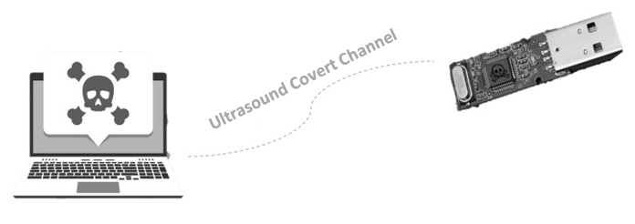Movement detection: Monitors components movements such as fan rotational speed.

Figure 1: Covert Channel Communication

Scientists have proven that there is a way of obtaining data through a covert channel [5]. This project will alert organizations with highly sensitive environments regarding potential threats that they typically ignore. Most organizations focus on network attacks and do not pay attention to other unlawful penetration methods. They blindly consider air-gapping as an ultimate impenetrable protection solution. A main deliverable of this project demonstrates an infected computer’s speakers being used as a covert channel that sends sensitive data in a near-ultrasonic form that is received and stored by a small device. The data stored on this device can then be processed and displayed as useful information on the attacker’s computer. Spreading awareness is one of the main objectives of the proposed research effort. Demonstrating this attack aims to motivate further research to investigate ways to stop such hidden attacks and develop commercial solutions to mitigate the risk of these attacks.

The main goal of this project is to demonstrate that there are more ways to attack a computer than the traditional methods and debunk the misconception that air-gapped computers are safe from attacks [6]. Covert channels are the only comprehensible method to penetrate an air-gapped computer. Examples of such channels are:

1. Using a physically connected portable hardware such as infected USB drives.
2. Relying on insiders. These channels rely on targeting the weak human link (of the security chain) and/or violating the security policies of the organizations [7].

Countries such as Iran, Indonesia, India, Azerbaijan, United States, Pakistan along with other countries were thought to be affected by these attacks [8]. This project aims to prove that there are other non-traditional ways of forcefully obtaining data from an air-gapped computer. This should make researchers think outside the box and trigger their creativity to innovate new techniques of protecting sensitive data.

Part of this project’s purpose is to alert individuals, organizations and nations and make them aware of such uncommon attacks which have risen in the recent years and that may even be taking place in their respective environment without their knowledge. Not resolving this issue will lead to the violation of the privacy of individuals and organizations. As for the project team members, they will attract a lot of attention from governmental ministries and defense sectors, to discuss potential capabilities of such attacks.

This project has many benefits that will contribute to creating a research and development culture in Qatar. The following points highlight some of these benefits.

* The project contributes to the critical area of cyber security, which has been identified as one of the grand research challenges in Qatar. This project will hopefully spark researchers’ interest in the types of attacks demonstrated through this project and will alert them to consider other non-traditional attacks. Exposing hidden security vulnerabilities and providing recommendations on mitigating them will help organizations and government agencies improve their cyber security defenses.
* The project has an important educational component. The project addresses a need by contributing to building Qatar’s human capacity in the important area of cyber security by raising awareness, providing student training, and enhancing research experiences in this area. The project will provide a capstone experience through which students will build a full system that integrates hardware and software components to achieve specific desired goals.
* The project offers opportunity for future research directions in the area. Examples include, investigating new covert channels for performing similar attacks, building defense mechanisms, and exploring side channel attacks on connected computers.
* The field of computer security was always an area of interest for this project team members. This interest comes from the excitement, challenges and risks involved in tackling cyber security problems. The choice of this project has three main reasons which are:

1. Reinforce the team members’ future vision of becoming security engineers.
2. Change the public opinion, who generally despise hackers.
3. Help society and spark the interest of current and future researchers to look into this field.

Due to the scientific nature of this research, the team members gained experience scientific documentation and data representation. The undergraduate researchers practiced information acquisition skills and the ability to research information from online resources, books and scientific research papers. In addition to enhancing theoretical background, the students received a chance to experience these concepts via a useful real-life application scenario.

**The objectives of this project are:**

1. Demonstrate the sound covert channel that will be used to send the data from the air-gapped machine to the attacker device.
2. Alert researchers in the field, practitioners in government organizations, and the private sector about the possibilities of these attacks to trigger their creativity to come up with appropriate security policies and defense mechanisms. Therefore, this project is expected to lead to future collaborations and development.
3. To spread general awareness in workplaces and in the society about cyber security concerns and the importance of protecting sensitive data. Project presentations, demonstrations and a research paper will help fulfil this objective.
4. The outcomes of this project will include suitable recommendations to institutes and organizations. The recommendations will be based on the research and knowledge acquired throughout the research journey.
5. Gain hands-on experience in the fields of data transmission, malware and signal processing including:
6. Malware functionality and ability.
7. Different cryptography techniques

* Public key cryptography.
* Block ciphers.
* Stream ciphers.

1. Different modulation and demodulation techniques

* Investigating different methods of modulation and demodulation and which will be more suitable for near-ultrasound transmission.

1. Investigating various transmission protocols

* Researching synchronous and asynchronous transmission types.
* Searching for the optimal way of starting and ending a data sequence.

1. Microcontroller programming.
2. Electric circuit design.
3. Signal processing and analysis.
4. Optimize the utilization of the covert channel to attack air-gapped computers by exploring different design trade-offs. In this project we will answers the following questions:

* Is it possible to steal data from an air-gapped computer?
* What kind of covert channels can be used to steal data from an air-gapped machine? Although the initial focus is on acoustic channels, other possible channels will be considered and evaluated.
* What are the effective mechanisms for secret transmission of data from an air-gapped machine? This includes:
  + How far can we be from the targeted machine?
  + At what speed can we send data on our covert channel
  + How do we deal with transmission errors and how can we make our transmission faster and more reliable?
  + What are effective data encoding techniques for transmission on this channel.
  + What can the attacker do to further conceal their attack?
  + What are the recommendations for developing effective security policies and security mechanisms to mitigate possible attacks on air-gapped computers?

# Background and related work

## Background

Air gapping means physically isolating a machine from all networks to ensure its security. In 2010 the Irani nuclear power plant, Natanz, was attacked by the Stuxnet computer malware [1]. Stuxnet was suspected to have been introduced to the target environment through infected USB flash drives; thus, crossing the air gap. The attack used a covert channel that spied on the power plant’s activity. The attack was also able to control the centrifuges causing overheating. The focus of this research is on the spying aspect of similar attacks that include obtaining information from the air-gapped computer, processing it and presenting it on the “attacker’s” device. To fully understand the scope of this project, the following subsections introduces relevant basic concepts.

### Malware

Any computer can be attacked using a malware. The malware is designed based on the attacker target.

1. Computer malware

A malware (malicious software) is a term that describe any harmful software. In the computer security field malware is defined as a software which attempt to break a computer system with respect to Confidentiality, Integrity or Availability (commonly referred to as CIA protections). Malware types include; executable code, interpreted code, scripts, macros. The attacked computer is known as target while initiator is the person who launched the malware. There are various types of malware. Each has its distinct way of being injected into the system and its intent. The intent is also known as policy breach.

Virus is a type of malware which moves from one computer to another by attaching a copy of itself to a file. The transmission medium is known as the vector of the virus. The virus could be transmitted to the target by attaching it to an email file or a USB.

Worm is a type of malware which the victim’s computer gets infected by. This is usually done through a network. In this class the actual malware is distributed and not an infected file.

Trojan Horse is a type of malware that is embedded in a software. The victim uses real functions of the software, known as overt effect. Meanwhile, the malware works without the victim’s knowledge. This is known as covert effect.

Backdoor is when the victim’s computer gets infected by this type of malware, the attacker gains access over the computer with no need for authentication procedures.

Bacterium is a type of malware used to consume all of the victim’s computer resources such as; memory, CPU and storage.

Spyware is a class of malware designed to spy on the user’s activity and steal their data. It sends data from the victim’s computer to the attacker through the network or a covert channel.

1. Malware analysis

To detect a malware in a system, researchers and security engineers use analysis techniques.

The main points on the analysis are to discover how the malware function is preformed and what is the intention behind the development of malware. Malware analysis techniques are dived into three groups based on the time and technique.

* Static analysis

This form of analysis is performed by analyzing a software piece of code without executing it. The results from this type of analysis is called static information and it is used to determine if the software contains malicious code or not and to understand how it works. Reverse engineering is applied to the software by using a variety of tools such as decompile, dissembler, debugger and source code analyzers. Many methods used to perform the static analysis such as Inspection, String Extraction, File Format, AV scanning, Disassembly and Fingerprinting [9].

* Dynamic analysis

The main object of the dynamic analysis is to understand the functionality of software by observing the executing [10]. This can be done by different ways such as control flows, tracing the function calls and analyzing the instructions and parameters of functions. The observation of the malware behavior is done by running the malicious code in a virtual environment. Simulator, sandbox, Process Explorer, and Process Explorer are some tools to implement such analysis.

* Hybrid analysis

This type of analysis combines both static and dynamic analyses.

Table 1: Static Vs Dynamic

|  |  |
| --- | --- |
| Static Analysis | Dynamic Analysis |
| Fast & Safe | Time consuming and vulnerable |
| Easy in analyze multiple malware | Difficult in analyze multiple malware |
| Cannot analyze obfuscated and polymorphic malware. | Cannot analyze obfuscated and polymorphic malware. |
| Accuracy is high | Accuracy is low |

1. Malware detection techniques

There are there categories of the detection techniques. Those techniques are used to identify, detect and protect the computer system.

* Signature based

A malware category can be identified by the sequence of bits known as signature which are embedded in its code when it is written [11]. This technique is used by the antivirus programs by disassembling the code of the infected file and check for a pattern in a database of malware signatures.

* Heuristic based

In heuristic based detection the malware can be detected by differentiate between the system state and behavior before being attacked and after. The heuristic process of detection consists of two phases. Firstly, the information of system’s actions is recorded so that information can be used to verify and check in case of attack. Three components are used by the behavior detector [12].

* Data collection: the responsibility of collecting static and dynamic data belongs to this component
* Interpretation: the process of converting the data from previous step into intermediate form.
* Matching algorithm: the matching behavior signature with the converted information.
* Specification based

Normal and abnormal behavior is monitored when applications are run to their specifications. specification-based detection technique is derived from heuristic based technique [13]. In is derived from heuristic based technique AI and machine learning is used to monitor the activities of the system. However, in specification-based detection technique the system specification behavior is analyzed. This technique is performed manually.

Table 2: Malware Detection Techniques Comparison

|  |  |  |
| --- | --- | --- |
|  | Advantage | Disadvantage |
| Signature Based | * Known malwares be detected easily. * Used less resources as compared to other techniques. | * Unknown malwares cannot be detected. |
| Heuristic Based | * Known and unknown new malware can be detected. | * Data need to be updated regarding new and unknown malware. * Need more resources in terms of time & space. * Accuracy is low. |
| Specification Based | * Known, unknown & new malware can be detected. * Accuracy is high. | * Accuracy is low. * Not efficient in detection of new malwares. * Specification development is time consuming. |

### Cryptography

Cryptography is the science of protecting information by changing its form to unreadable ciphered data which can only be viewed and manipulated by intended personnel. Some basic cryptography terms need to be known [14]:

* Plaintext: is defined as a readable message that is encrypted and the resulted of the decryption process.
* Ciphertext: is defined as the data generated by the cipher.
* Cipher: is an algorithm that is used to encrypt or decrypt the data.
* Key: is a string of bits used by a cipher to encode a plaintext into a ciphertext or vice versa
* block cipher is an encryption algorithm which encrypts Plaintext block by block of fixed n-bits. The block size can be 64 bits, 128bits and 256 bits. a cipher takes one block of a plaintext and encrypt it into a block of Ciphertext. If the remainder of a plaintext shorter than the block size the algorithm adds bits to the data in a process called padding.
* Stream cipher: is an encryption algorithm which encrypts a Plaintext bit by bit or byte by byte. The algorithm uses an infinite steam of pseudorandom bits as a key. The secureness of the cipher depends on the pseudorandom generator which should be unpredictable and not be used again.

There are different types of Cryptography which include:

1. Symmetric encryption

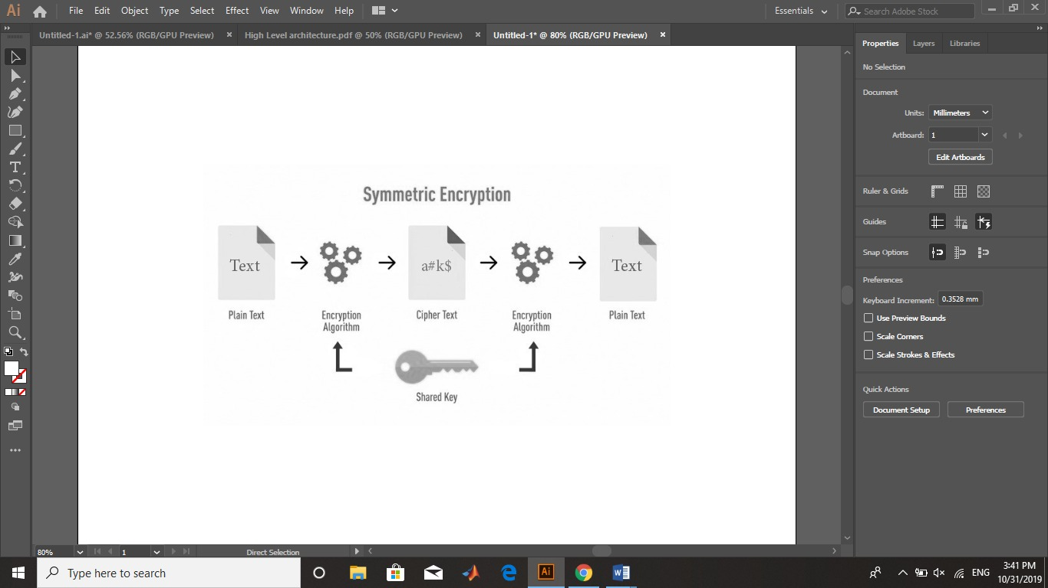One key is shared between two or more users. This single key is used for encryption and decryption of data. In symmetric encryption, an algorithm takes the data, from the sender, as an input and generates ciphered data using the shared key. The receiver side obtains the ciphered data and returns it to its initial form using a decryption algorithm.

Figure 2: Symmetric Encryption

1. Asymmetric encryption

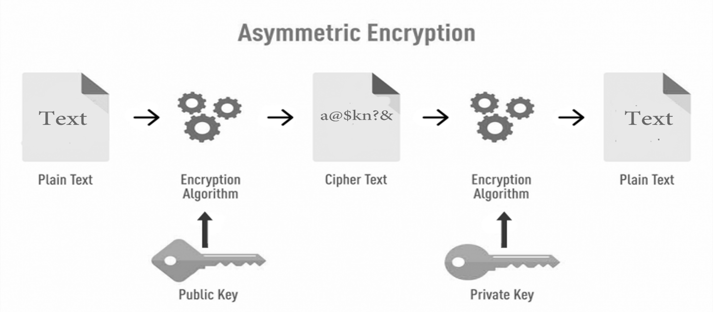Two mathematically related but unidentical keys are used. The two keys are called Public key and Private key. Each key performs its own unique function. In Asymmetric encryption the public key is used to encrypt while the private key is used to decrypt data.

Figure 3: Asymmetric Encryption

**Table 3** summarizes the multiple differences between symmetric and asymmetric encryption.

Table 3: Comparing Symmetric and Asymmetric Encryption Techniques

|  |  |  |
| --- | --- | --- |
|  | Symmetric Encryption | Asymmetric Encryption |
| Number of Keys: | 1 | 2 |
| Algorithm Speed: | Fast | Slower |
| Size of Ciphered Text: | Same or less than original data. | More the original data. |
| Key Size: | 128 or 256 Bits | Minimum of 1024 Bits |
| Hardware Processing: | Simple | Complex |
| Computational Power: | Low | High |
| Key Distribution | Key must be with the individual requesting the data. | Only the private key must be with the individual. It is unique from user to another |

### Data encoding techniques

Encoding is the process of converting any digital data of characters, ranging from letters, numbers and punctuation, to a specific format making, to make it efficient for transmission and storage.

Data is stored either in *digital* or *analog* form. Similarly, transmission signals can either take a digital or analog form. To use data digitally, it must be converted to digital form by using line coding technique. There are four types of data encoding techniques [15]:

1. Analog data to analog signal

Modulation of analog signals in terms of amplitude, frequency and phase.

1. Analog data to digital signal

Known as digitization. Analog data to digital signal conversion is done by pulse code modulation (PCM).

1. Digital data to analog signal

Modulation of analog signals by shifting. This includes amplitude shift key (ASK), frequency shift key (FSK) and phase shift key (PSK). Refer to section 2.1.D for more details concerning FSK analog signal modulation.

1. Digital data to digital signal

Done in two ways; Line Coding and Block Coding. Digital data to digital signals will be explained in detail in section 2.1.D.

### Digital modulation techniques

Modulation is the process of varying one or more properties of carrier signal, a periodic waveform. Modulation if often done with the purpose of data transmission. The figure below represents the carrier signal and is to be used as a reference for **Figure 4**:

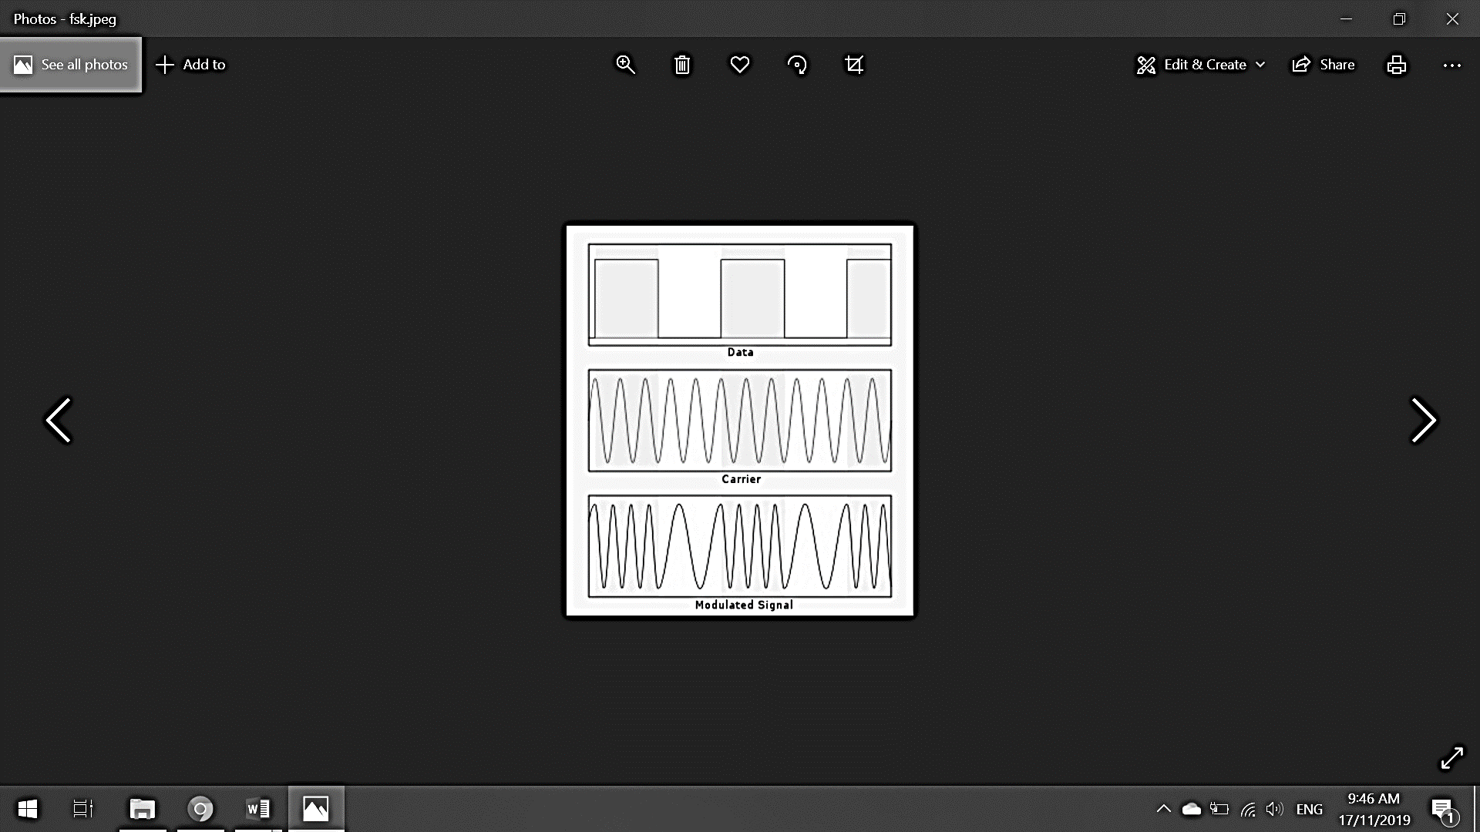

Figure 4: Carrier Signal

There are three types of modulation. The focus of this project is FSK modulation:

1. *Frequency shift keying, FSK*

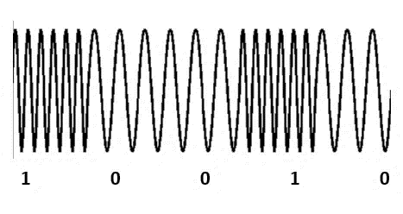In the two states of FSK, ones and zeros, each state is represented by an [analog](https://whatis.techtarget.com/definition/analog) [waveform](https://whatis.techtarget.com/definition/waveform). As demonstrated in **Figure 5**, one is represented by an analog wave of a specific [frequency](https://whatis.techtarget.com/definition/frequency) while zero is represented by an analog wave of different frequency [16].

Figure 5: Frequency Shift Keying

FSK modulator:

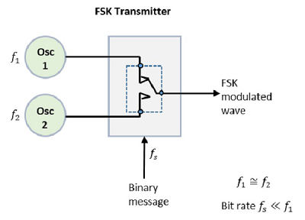The two oscillators with a clock and the input binary sequence are the components of the FSK modulator block diagram. The two oscillators are connected to a switch along with an internal clock, generating a higher and a lower frequency signal. clock is applied to both the oscillators. The binary input sequence is applied to the transmitter to choose the frequencies based on the binary input.

Figure 6: FSK Transmitter

FSK demodulator:

Demodulating an FSK signal can be performed using different methods. Asynchronous detector and synchronous detector are the main methods.

* Asynchronous FSK detector

The Asynchronous FSK Detector is comprises of two band pass filter, two envelope detectors, and a decision circuit.

Figure 7: Asynchronous FSK Detector

Firstly, the two band pass filters take the FSK signal as an input and tuned to space and mark frequencies. The output is a signal which is close to an ASK signal, which is the input of the envelope detector. The envelope modulates each signal asynchronously.

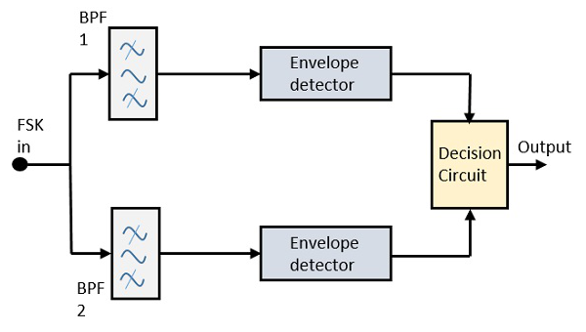The output from any one of the envelope detectors is selected by the decision circuit. Re-shaping the signal to a rectangular in done too.

* Synchronous FSK detector

The synchronous FSK detector is comprises of two mixers with local oscillator circuits, two band pass filters and a decision circuit.

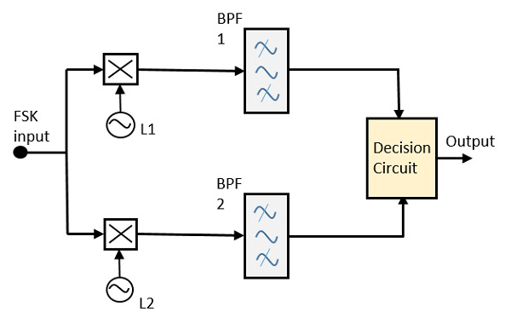The two mixers with local oscillator circuits takes the FSK signal. The output is passed to the two band pass filters. Then the decision circuit select the output from the detectors.

Figure 8: Synchronous FSK Detector

### Transmission

1. Serial transmission

In serial transmission, the data is organized based on specific order which is usually start bits, data, parity bits and end bits. The transmission is done by sending the packet bit after bit.

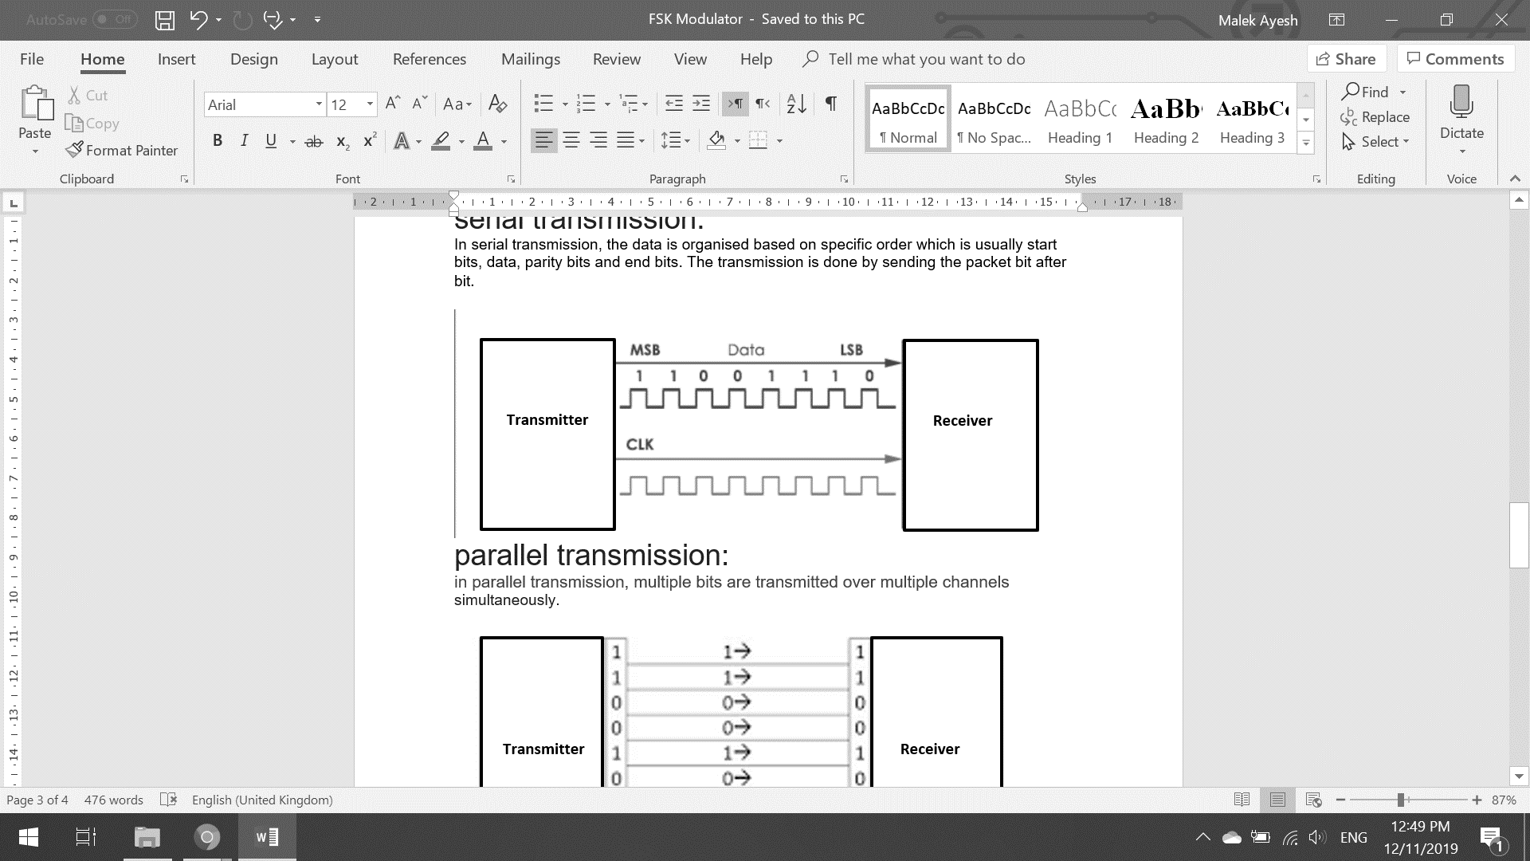

Figure 9: Serial Transmission

1. Parallel transmission

Multiple bits are transmitted over multiple channels simultaneously.

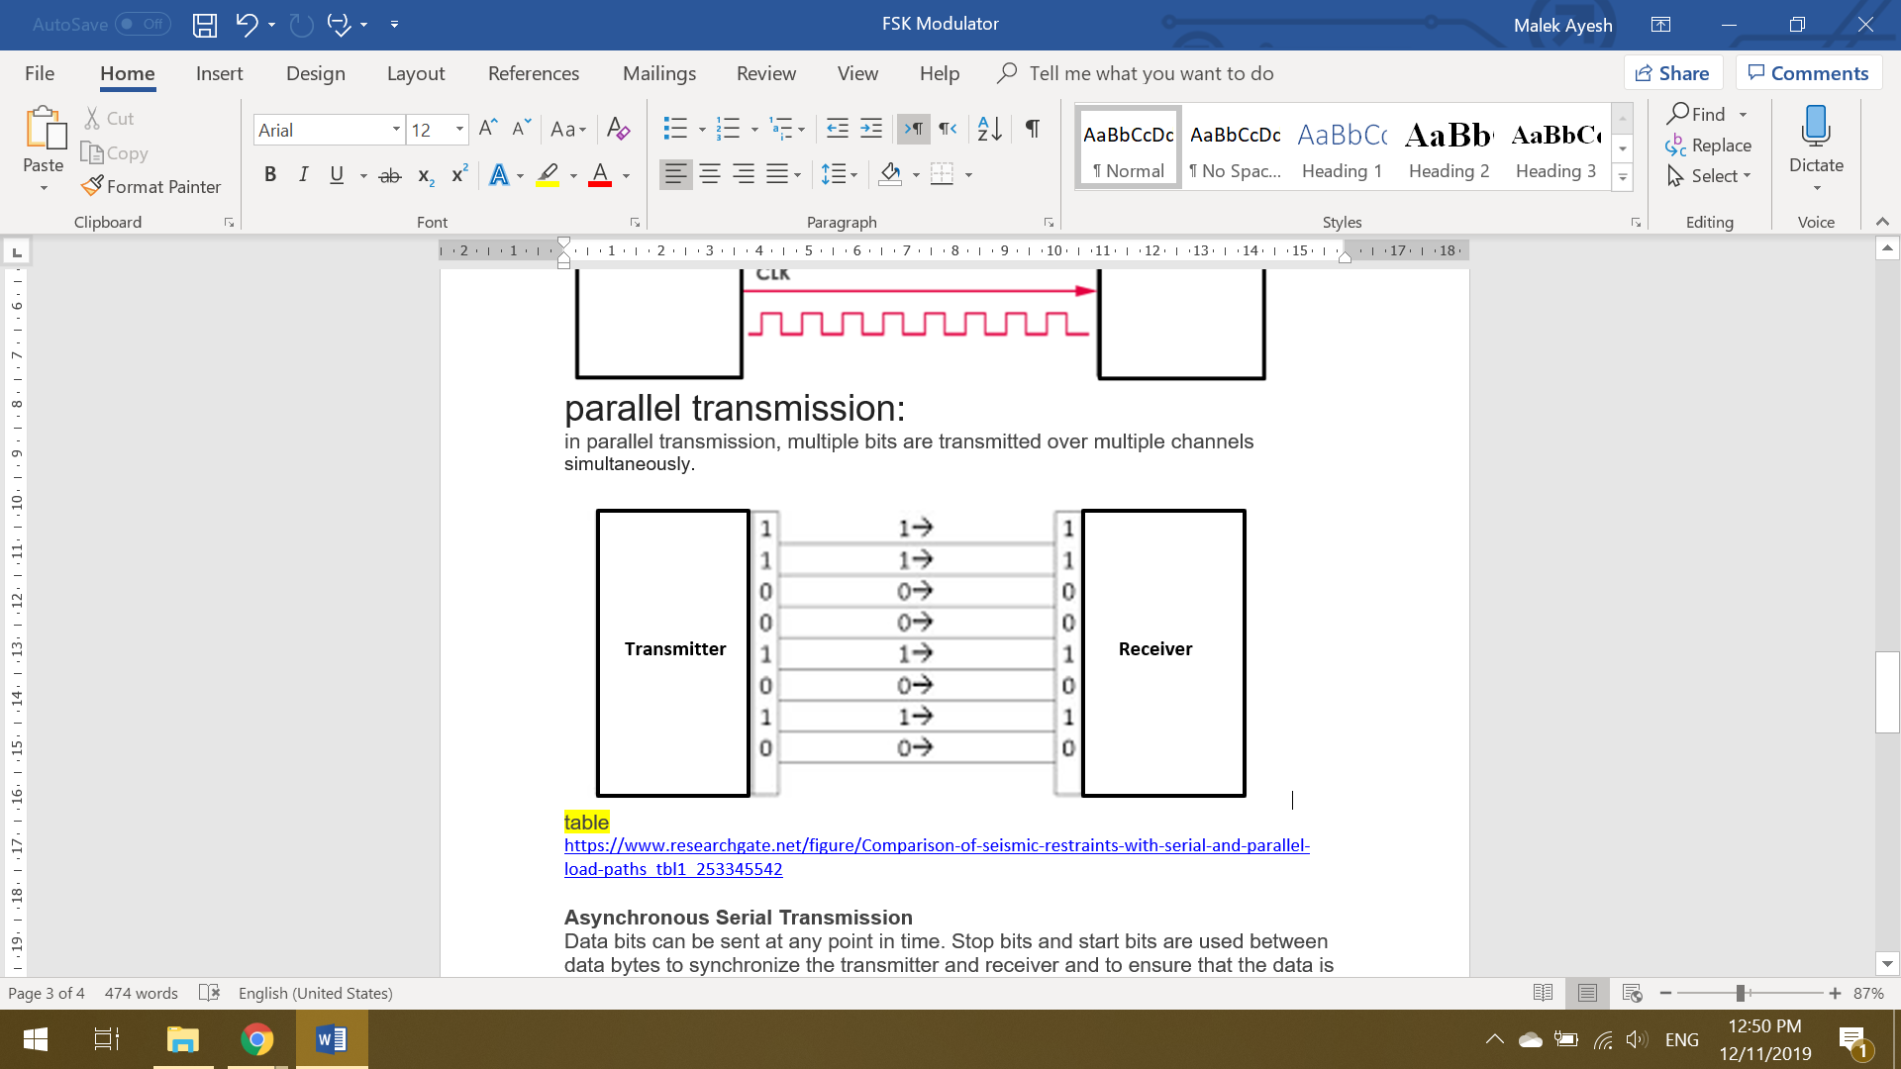

Figure 10: Parallel Transmission

1. Asynchronous serial transmission

Data is sent at any time with Stop bits and start bits between bytes. Stop and start bits are used to synchronize transmission and ensure successful transmission. Time is not constant between sending and receiving data bits.

1. Synchronous serial transmission

Data bits are transmitted using a clock, in a continuous form. The sender and receiver use a synchronized clock frequency. No start and stop bits are used.

### Microphones [17]

Microphone is device that takes sound waves and converts them into an electrical signal. Microphones are used to capture sound. There are three main types of microphones:

1. Dynamic microphones

Consists of a metal coil wrapped with a magnet and has a thin sheet on the front called the diaphragm. When audio is received, as shown in **Figure 11**, the small vibrations move the coil producing an electric signal. They do not require a power source.

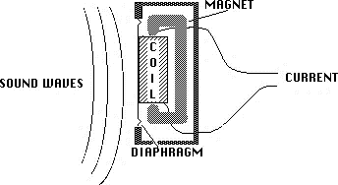

Figure 11: Dynamic Microphones

1. Ribbon microphones

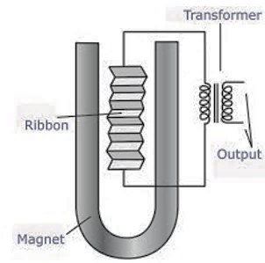Also known for their excellent recording capabilities. It contains a thin piece of corrugated aluminum suspended edgewise between the poles of a magnetic field, depicted in **Figure 12**. When sound enters the microphone at a specific velocity, it vibrates the ribbon generating voltage proportional to the amount of ribbon vibration. Since the vibrations depend on the speed of the air, ribbon microphones are also known as velocity microphones. The vibrations are converted into an electrical signal.

Figure 12: Ribbon Microphones

1. Condenser microphones

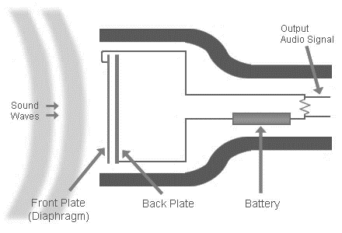Also known as a capacitor microphone. It is used for audio recording purposes and are very sensitive. They contain a diaphragm and a back plate parallel to it. Sound waves hitting the diaphragm cause vibrations which change the distance between the diaphragm and the back plate. This causes a change in capacitance which produces small voltage changes that can be detected across the high resistance load connected across the microphone element. This change is represented as an electric signal. Condenser microphones usually requires a power source, as shown in **Figure 13**, but an electret condenser microphone doesn’t. This is due to its use of a permanently charged material. The power source or charged material is required to power a buffer, which amplifies the incoming signal. The incoming signal needs amplification due to its high impedance. An electret microphone is used for this project.

Figure 13: Condenser Microphones

### Fourier transform (FT)

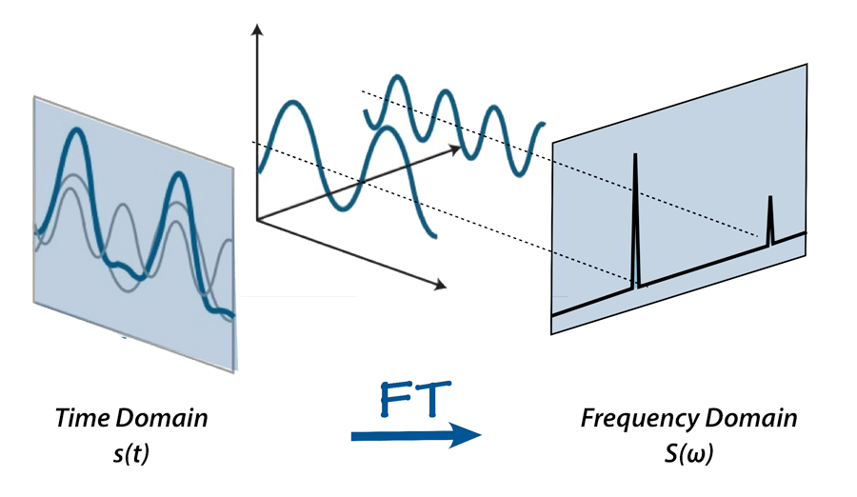An audio signal is created of many single frequency sound waves. The microphone only records the resultant amplitudes of the waves in the time domain. Fourier Transform is used to decompose the signal to its constituent frequencies. The result of Fourier transform are the frequencies in the signal and the magnitude of each frequency.

Figure 14: Fourier Transform

### Fast Fourier transform (FFT)

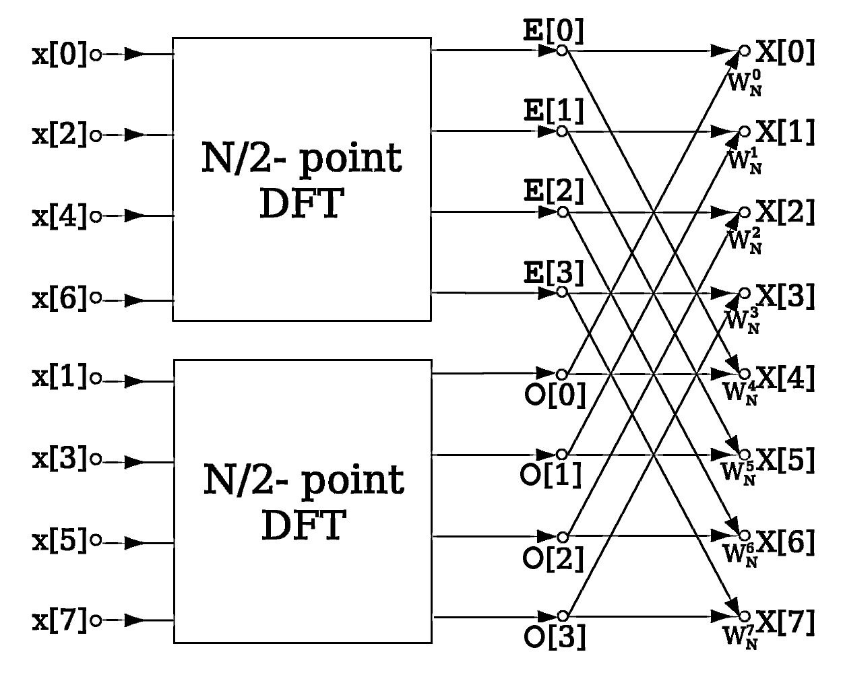Fast Fourier Transformation (FFT) is an algorithm used to calculate Discrete Fourier Transform (DFT) of a given sequence. FTT takes a discrete signal as an input. The result of the algorithm are frequency constituents

Figure 15: Fast Fourier Transform

### Spectrogram

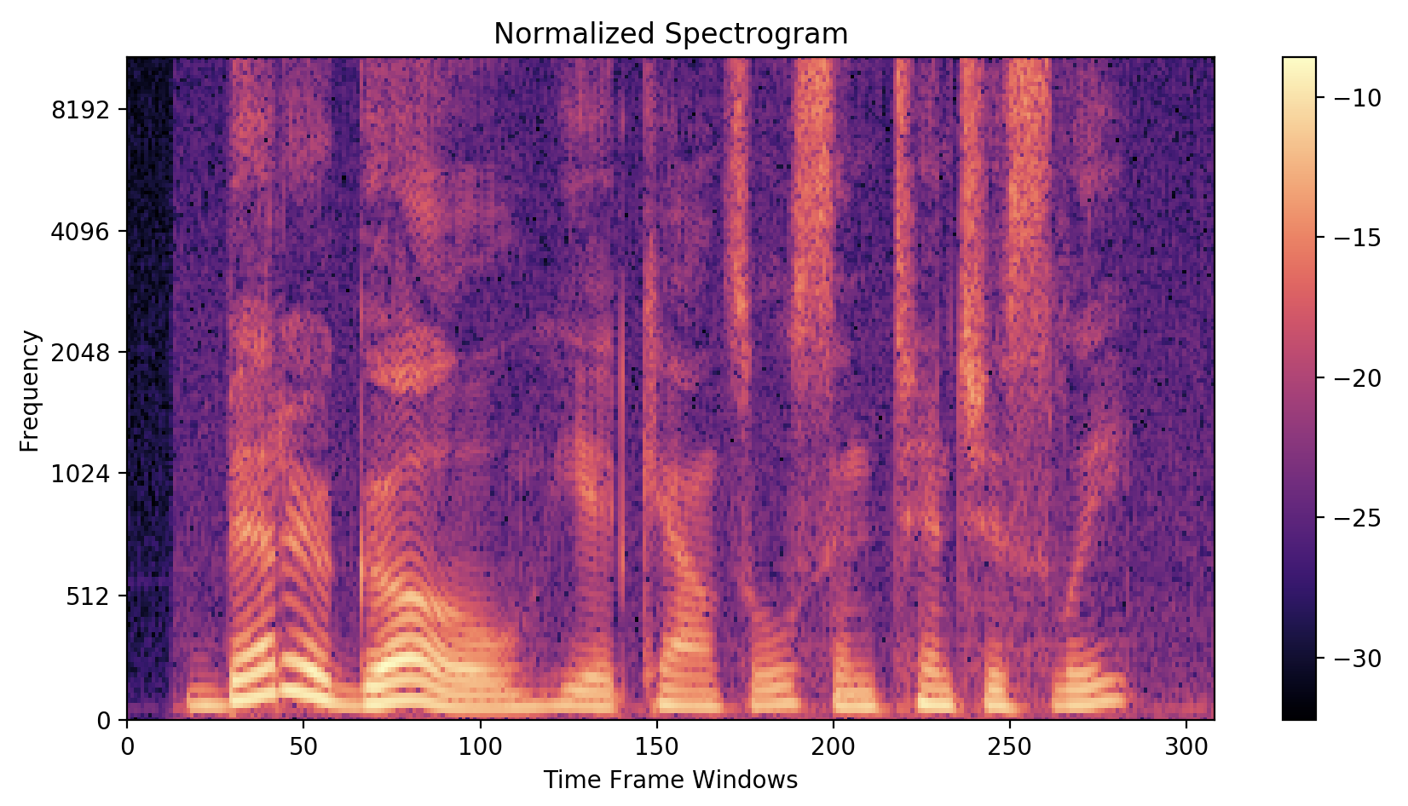Spectrogram is used to give a visual representation of frequencies of a signal as it varies with time. To create a spectrogram of a signal the algorithm breaks the signal into frames then calculate FFT on each frame.

Figure 16: Spectrogram

## Related work

Recently, cyber security researchers were successful in obtaining data from air-gapped computers. Each attempt was distinguished from others by aspects such as the covert channel used, or the hardware deployed. This project shares concepts with those attempts. Similar to a previous attempt, this project focuses on using a covert channel, to bridge the air-gap isolation, to extract data from a computer without it having any network connectivity [18]. An acoustic covert channel is used in a simple setup with an ordinary computer, that is infected with a malware, in proximity to a device that receives the acoustic signals [19].

The data extracted from the malware will then need to be encrypted, just in case the transmission was intercepted. Symmetric key is used due to its increased complexity over a symmetric key. During the encryption process, a public key will be used to encrypt the data at the transmitter side to produce cyphered text. The cipher data will then be sent to the receiver where it will be decrypted. The decryption process consists of obtaining the ciphered text and using a private key to return it to its initial form, from transmitter [20].

Similarly, some previous attempts used near-ultrasound as a covert channel utilizing frequencies between 18KHz to 20KHz to send the extracted data from one computer to another. This specific frequency range was chosen due to it being inaudible to the human ear [19]. Encoding audio data consists converting the digital signal into an analog signal. Commonly this is done by Phase-Shift-Keying (PSK) or Frequency -Shift-Keying (FSK). This project utilizes FSK. Although PSK is found to be very efficient for radio wave transmission but practically it was determined to be more vulnerable to noise, than FSK, in audio communication. To implement FSK, data packets will be represented by two output frequencies ones,18KHz, and zeros, 0KHz, for other frequency [21]. To further deplete noise, filters, such as Gaussian filters, may be applied to further improve received data accuracy. In the beginning of the message transmission, a preamble will be used to signify the start of transmission. The preamble will then be followed by a synchronization sequence. The ones and zeros will be made into a mono channel WAV file ready to be sent through the speakers [22].

The sound waves will be read by a microphone. Like other attempts, this microphone will function using a battery or external power source [23]. The microphone will be attached to an amplification circuit and makes use of a low pass filter and a high pass filter to restrict audio therefore only acquiring the required frequency range [24]. This system does not directly present the stolen data to the attacker’s computer. Instead, a memory card will store the audio data which will then be presented on the attacker’s computer by plugging it in later [25]. The system functions will be tested at different distances and then evaluated by speed, accuracy and error rate.

Some differences between this project and some previous attempts include the covert channel used. This project uses near near-ultrasound frequencies produced from the speakers of the ‘victims’ computer to retrieve stolen data. Unlike one previous attempt utilized the fan noises to extract information [18]. This attempt uses speaker-to-microphone communication, this is a major difference since multiple projects decided to use speaker-to-speaker communication [19] which adds complexity to the project along with increasing its failure rate to communicate all the requested data successfully. A common microphone amplification circuit is used, but with modification, to read only a specified near-ultrasound range, 18KHz. This modification will be done by making suitable high pass and low pass filters, that result in a band pass filter, along with a noise reducing circuit. Overall, most significant difference from other attempts is the utilization of a microcontroller. A microcontroller is used due to its size and its ability to be stripped down to make it extremely simple. This simplicity leads to difficulty of detection and the ability to reach more secure places.

# Requirements analysis

## Functional requirements

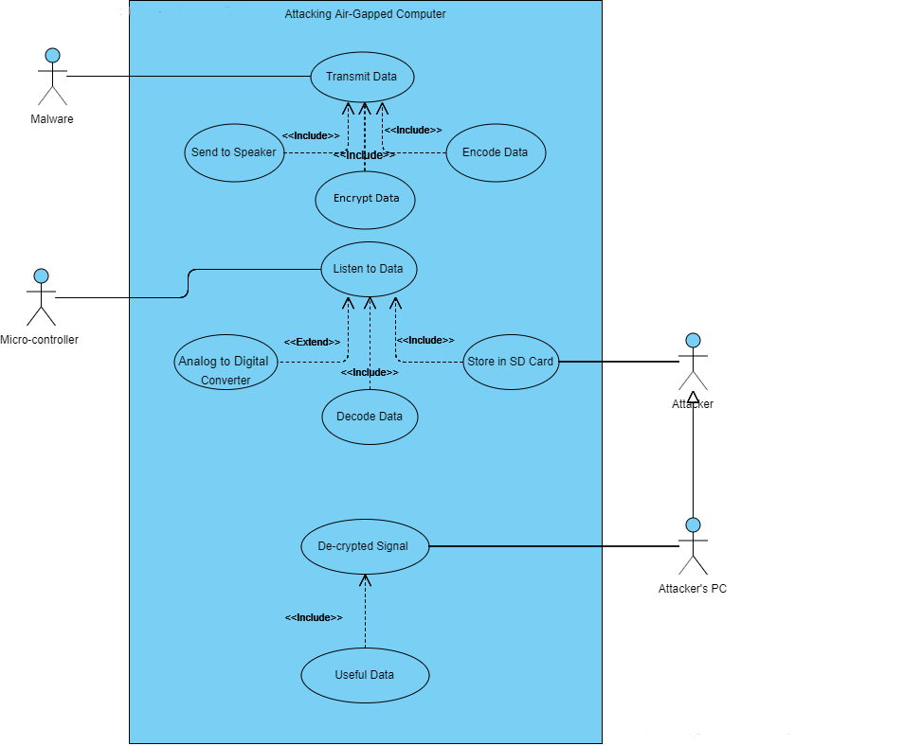This section clarifies the input and output of the system along with the processes of each functional block. **Figure 17** demonstrates the main functional blocks of the system and their interactions with the actors.

Figure 17: Use Case

The following describes the functionality of our system:

1. Data is entered into the system

The malware will generate data which contains characters encoded in ANSI.

1. Operation of functional sections
2. Data transmission by converting digital data to secure analog signal
3. Encrypt data using advanced encryption standard, AES, algorithm

Data will be encrypted using AES encryption algorithm. This will generate ciphertext. The encrypted file is written in hexadecimal form. The size of the ciphertext file will be the same as the text file. Then it will be converted to binary form.

1. Preamp and postamp the encrypted data

The preamble consists of a pattern of bits placed at the beginning of the message to signify the start of transmission and the postamble is used to signify the end of transmission. 12 bits will be used for both preamble and postamble and they consist of alternating ones and zeros. This is to follow ethernet standard [26].

1. Modulate the encrypted data

The encrypted signal with preamble and postamble, in the form of ones and zeros will be represented in frequency values. This will be done by shifting the frequency of the carrier signal to transfer data. This is called Frequency Key Shifting (FSK). Ones will be represented by 18KHz and Zeros will be represented by other frequency. The modulated signal will be sent through the ‘victims’ computer speakers.

1. Receiving, storing and reading data through analog signal to digital data and digital data to information

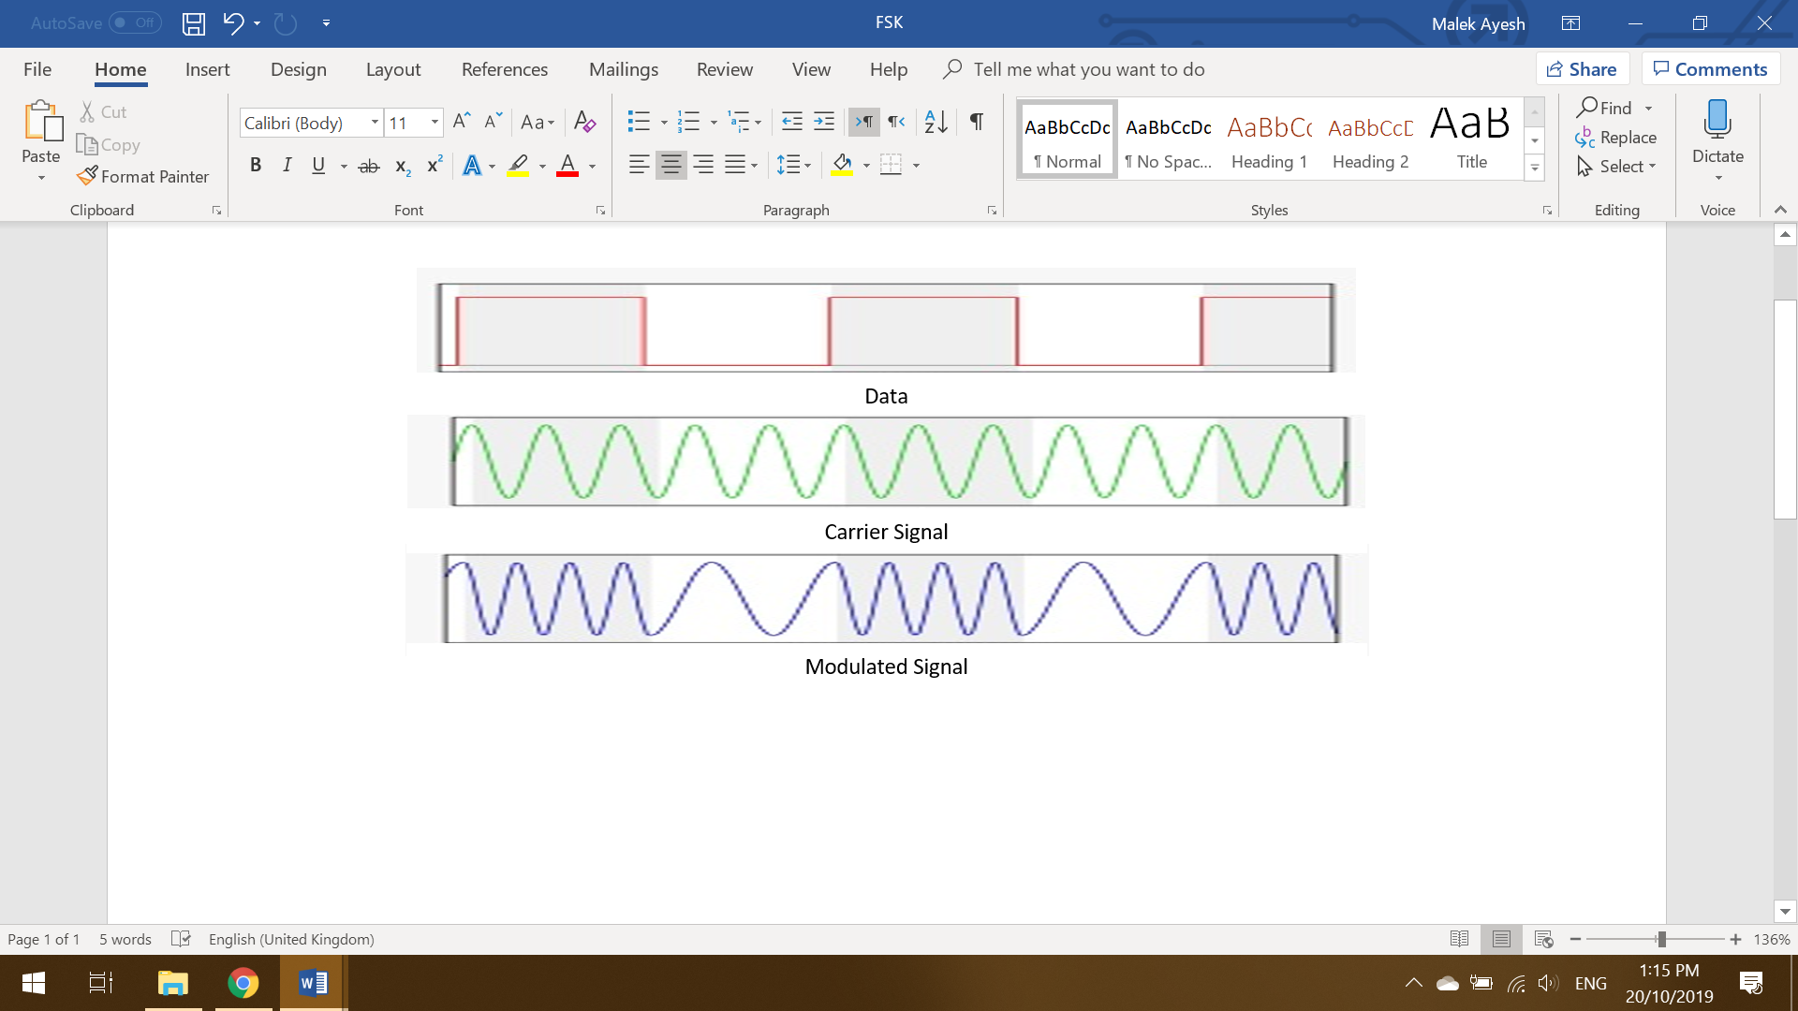A microcontroller with a microphone will read the near-ultrasound analog signal, which has been frequency shifted. The microcontroller takes the frequency shifted signal, in audio form and decodes it. The decoded signal is then stored in digital form on a SD-Card. The SD-Card will then be placed in the ‘attackers’ computer. The ‘attackers’ computer will process the decoded signal from the SD-Card. This will be done by observing the high and low frequencies of the audio signal. The high frequencies will represent one and the low frequencies will represent zero.

Figure 18: Modulate Encrypted Data

The digital data, a sequence of ones and zeros, contains three parts: preamble, data and postamble. The preamble and postamble signify the start and end of the message therefore, to obtain the original message, the preamble and postamble must be removed. This is done by removing the first and last 12 bits. The remaining sequence, without the preamble and postamble contains the encrypted message. This encrypted message will be decrypted using a symmetric key. The decrypted data will be processed, analyzed and returned to its initial form, as in the ‘victims’ computer.

1. System workflow:

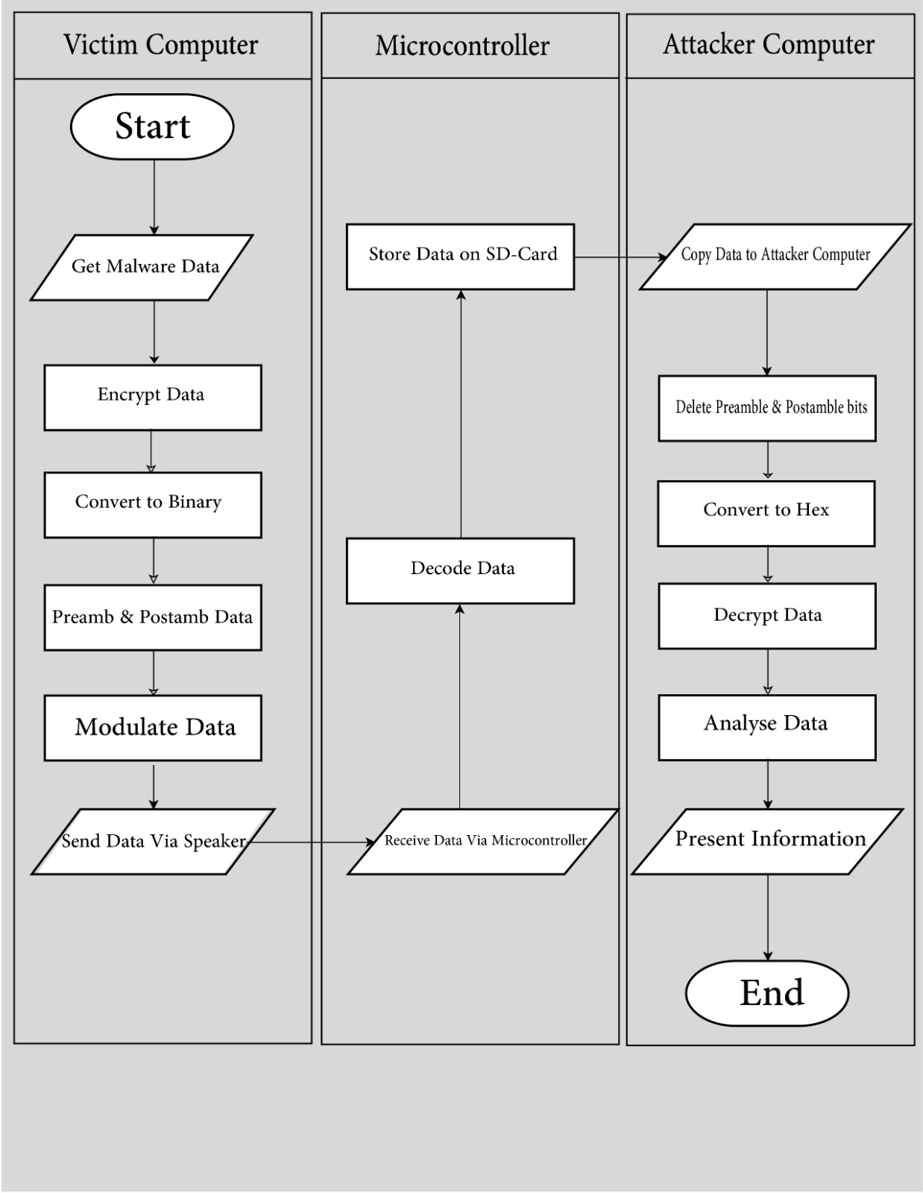The work-flow, represented in **Figure 19** illustrates the inputs, outputs and processes occurring in each device of the system. It shows briefly how the data is stolen from the victim by the attacker.

Figure 19: Workflow

## Design constraints

Table 4: Technical Design Constraints

|  |  |
| --- | --- |
| Name | Description |
| Audio Frequency Range | Data to be transmitted from the victim’s device to the microcontroller will be sent at a near ultrasonic frequency of 18KHz. |
| Transmission Rate | Transmitting audio bits from the victim’s computer should be at an approximate rate of 3000ms/bit |
| Accuracy | The system is expected to 100% accuracy at a distance of 1.00 meter. |
| Memory | A memory with low storage capacity is to be used since ten characters will consume around 1Mb of storage. |
| Battery life | A 250mAh battery will support the system for approximately 13 hours with 250mAh Li-Po battery. |

Table 5: Practical Design Constraints

|  |  |  |
| --- | --- | --- |
| Type | Name | Description |
| Ethical | Ethical | Ethical hacking system that respects individual’s privacy and local legislation. |
| Sustainability | Reliability | The system is not affected any background noise in the operating environment, this includes individuals talking and wind noise. The system utilizes 18KHz audio, which is not a frequency used by humans, devices and is rarely utilized in most environments. |
| Manufacturability | Size | The size of the receiving device should be small and easily concealable. the volume of the device will not exceed 20 cm3. |
| Manufacturability | System Forms | The circuit used must be hidden to avoid detection when data is being stolen. The circuit will take many forms such as a table lamp, coffee cup or packet of cigarettes. |
| Financial | Cost | Non-significant cost. The cost of the hardware device should be affordable and should not exceed $30. |

## Design standards

In this project, the following standards are being used:

1. Information interchange [27]:

* ANSI code.

1. Ethernet [28]:

* Ethernet frame.

1. Encryption and decryption [29]:

* AES, Advanced Encryption Standard.

1. Signal shifting [30]:

* BT FSK, British Telecom Frequency Shift Keying.

1. Audio [31]:

* WAV

1. Memory [32]:

* SD-Card.

1. Ports [33]:

* USB-2.0 and USB-3.0.

1. Printed circuit board, PCB [34]:

* IPC-6012B.

1. Resistor [35]:

* EIA (Electrical Industries Association).

1. Power source [36]:

* International Electrotechnical Commission (IEC) Standards for Lithium Batteries.

## Professional and ethical responsibilities

**IEEE code of ethics [37]:**

1. ***To be honest and realistic in stating claims or estimates based on available data;***

This project will alert society and individuals of the limitations of such attacks. Logical claims will be made in terms of the capability of such attacks. This includes breaching organization’s data along with the privacy violations that can be committed on an Air-Gapped computer. The proposed claims will educate people on the severity of such attacks, without exaggeration, potentially inspiring them to come up with appropriated defense systems.

1. ***To improve the understanding by individuals and society of the capabilities and societal implications of conventional and emerging technologies, including intelligent systems;***

This project aims to improve the knowledge on air-gapped computers in general along with the techniques to defend computers from such attacks. In addition, the procedure of dealing with such attacks and reducing the possibility of them happening. This will be done by participating in conferences and public events to discuss Air-Gapped device attacks.

1. ***To maintain and improve our technical competence and to undertake technological tasks for others only if qualified by training or experience, or after full disclosure of pertinent limitations;***

Always trying to be in the forefront of Air-Gapped technology. Pursuing and committing to a high level of quality in our research. When dealing with a sensitive topic like Air-Gap attacks, the team will only participate in their field of expertise which will guarantee professionalism. The team extensively researched any aspect before testing and all experiments were done with robust scientific knowledge.

1. ***To seek, accept, and offer honest criticism of technical work, to acknowledge and correct errors, and to credit properly the contributions of others;***

The team welcomes any logical opinions from researchers, experts and individuals to enhance the project. The team will also admit and discuss any weak points and concerns with appropriate individuals. Credit will be given to any personnel who contributed in resolving any weakness. Throughout this project, multiple professionals gave constructive criticism. All criticism was taken seriously and was worked upon to improve and optimize the overall system.

1. ***To avoid injuring others, their property, reputation, or employment by false or malicious action;***

performing potentially harmful activities such as penetration testing will be done with consent of the affected party. The team will commit to high level of caution and take all possible precautions to prevent damage or harm to people, devices and facilities inside and out of the controlled lab environment. Although the team had an incident with a Li-Po battery exploding, the facility, where the incident happened, was well equipped to combat such issues and necessary measures were taken to ensure the safety of individuals and property.

1. ***To assist colleagues and co-workers in their professional development and to support them in following this code of ethics;***

In project collaborations, the aim is to aware colleagues about the code of ethics, which should be followed during the project. Colleagues will support and help each other fairly. Knowledge was exchanged between team, while keeping in mind the rules related to plagiarism, dishonesty, conflict of interest and many others.

**ACM code of ethics [38]:**

1. ***Contribute to society and to human well-being, acknowledging that all people are stakeholders in computing;***

* Duty to protect basic human rights regardless of culture, backgrounds and ethnicities.
* Reduce any harmful consequences related to computing systems.
* Strive to always use the project’s efforts and product in responsible ways.
* Avoid causing welfare and health issues.
* Avoid causing any harm to the environment, locally and globally.

1. ***Respect privacy;***

* This project considers privacy to be crucial and protecting it is one of our top priorities. This project will only commence if it gets permission for steps such as testing due to the need of accessing information from devices.
* Accuracy and protection of personal information.
* precaution to block unauthorized access and use of the system.
* Allow people whose information was used to access and check correctness of their data.

## Assumptions

* Malware is given:

The malware is assumed to be preinstalled on the ‘victims’ computer. In the real world this can be done in multiple ways, which include placing an infected USB device into the targeted computer, malware preinstallation in the factory or an agent personally having access to that computer. The malware output is a text file from the ‘victims’ computer. The text file contains ANSI data.

* ‘Victims’ computer has speakers and supports ‘attackers’ microphone frequency:

The attacked computer must have a speaker. This speaker must be enabled and supports the near-ultrasound frequencies similar to ones found in the ‘attackers’ computer, 18KHz and above.

* The microcontroller is within reasonable distance of the ‘victims’ computer:

It is assumed that the microcontroller and its circuit are within appropriate distance from the attacked computer, for the system to function properly. This distance should be less than 2 meters.

* The working environment does not have abnormal levels of noise:

The test location is assumed to have normal levels of near-ultrasonic noise. Noise can come from different sources which includes other devices functioning nearby that may emit similar frequencies to the ones used in this project. Abnormal noise levels include facilities having some sort of near-ultrasound frequency jamming.

# Solution design

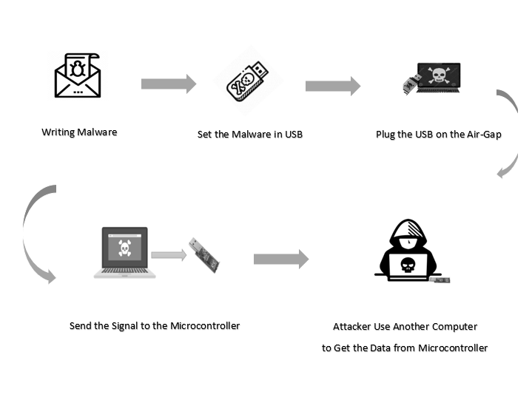**Figure 20** demonstrates how the malware, that is installed on the air-gapped computer, transmits inaudible acoustic data via speakers of the victim's machine. A small attacker listening device reads the signal and store the data on its SD-card. The attacker can then obtain the needed information, from the victim, by placing the SD-card from the listening device into their computer and analyzing the audio files.

Figure 20: Project Solution Design

## Overview

This section provides an overview of the solution and its high-level architecture.

1. Solution overview

This project demonstrates that that isolated devices can be attacked, which may create awareness about existing hidden vulnerabilities in systems. This system retrieves data from one isolated computer and places it on another without the help of any common communication channels like Wi-Fi and Bluetooth, nor the utilization of any plug-in devices and peripherals such as; CD, DVD, USB and mobile phones.

This solution utilizes common components that usually exist on a typical computer. These components are repurposed to perform an additional function on the top of the normal one. The computer being attacked would have a virus installed on it, this virus organizes the useful information requested by the malicious attacker and prepares it for sending. The information is then sent by using the hacked computer’s speakers. The speakers produce the data at a high frequency, which is not audible by the human ear, and, therefore, cannot be detected. The attacker can place a small inconspicuous device near the victim computer. This device listens to the inaudible sound produced and stores it. A small listening device is used due to its size, portability and its nonthreatening appearance. The small device could then be connected to the attacker’s computer, where it gets processed, decrypted and converted into useful information.

1. High-Level architecture

The main software components in each piece of hardware used along with their interactions with each other are discussed in this section. **Figure 21** demonstrates a step-by-step sequence of events that occur when obtaining data from an air-gapped computer.

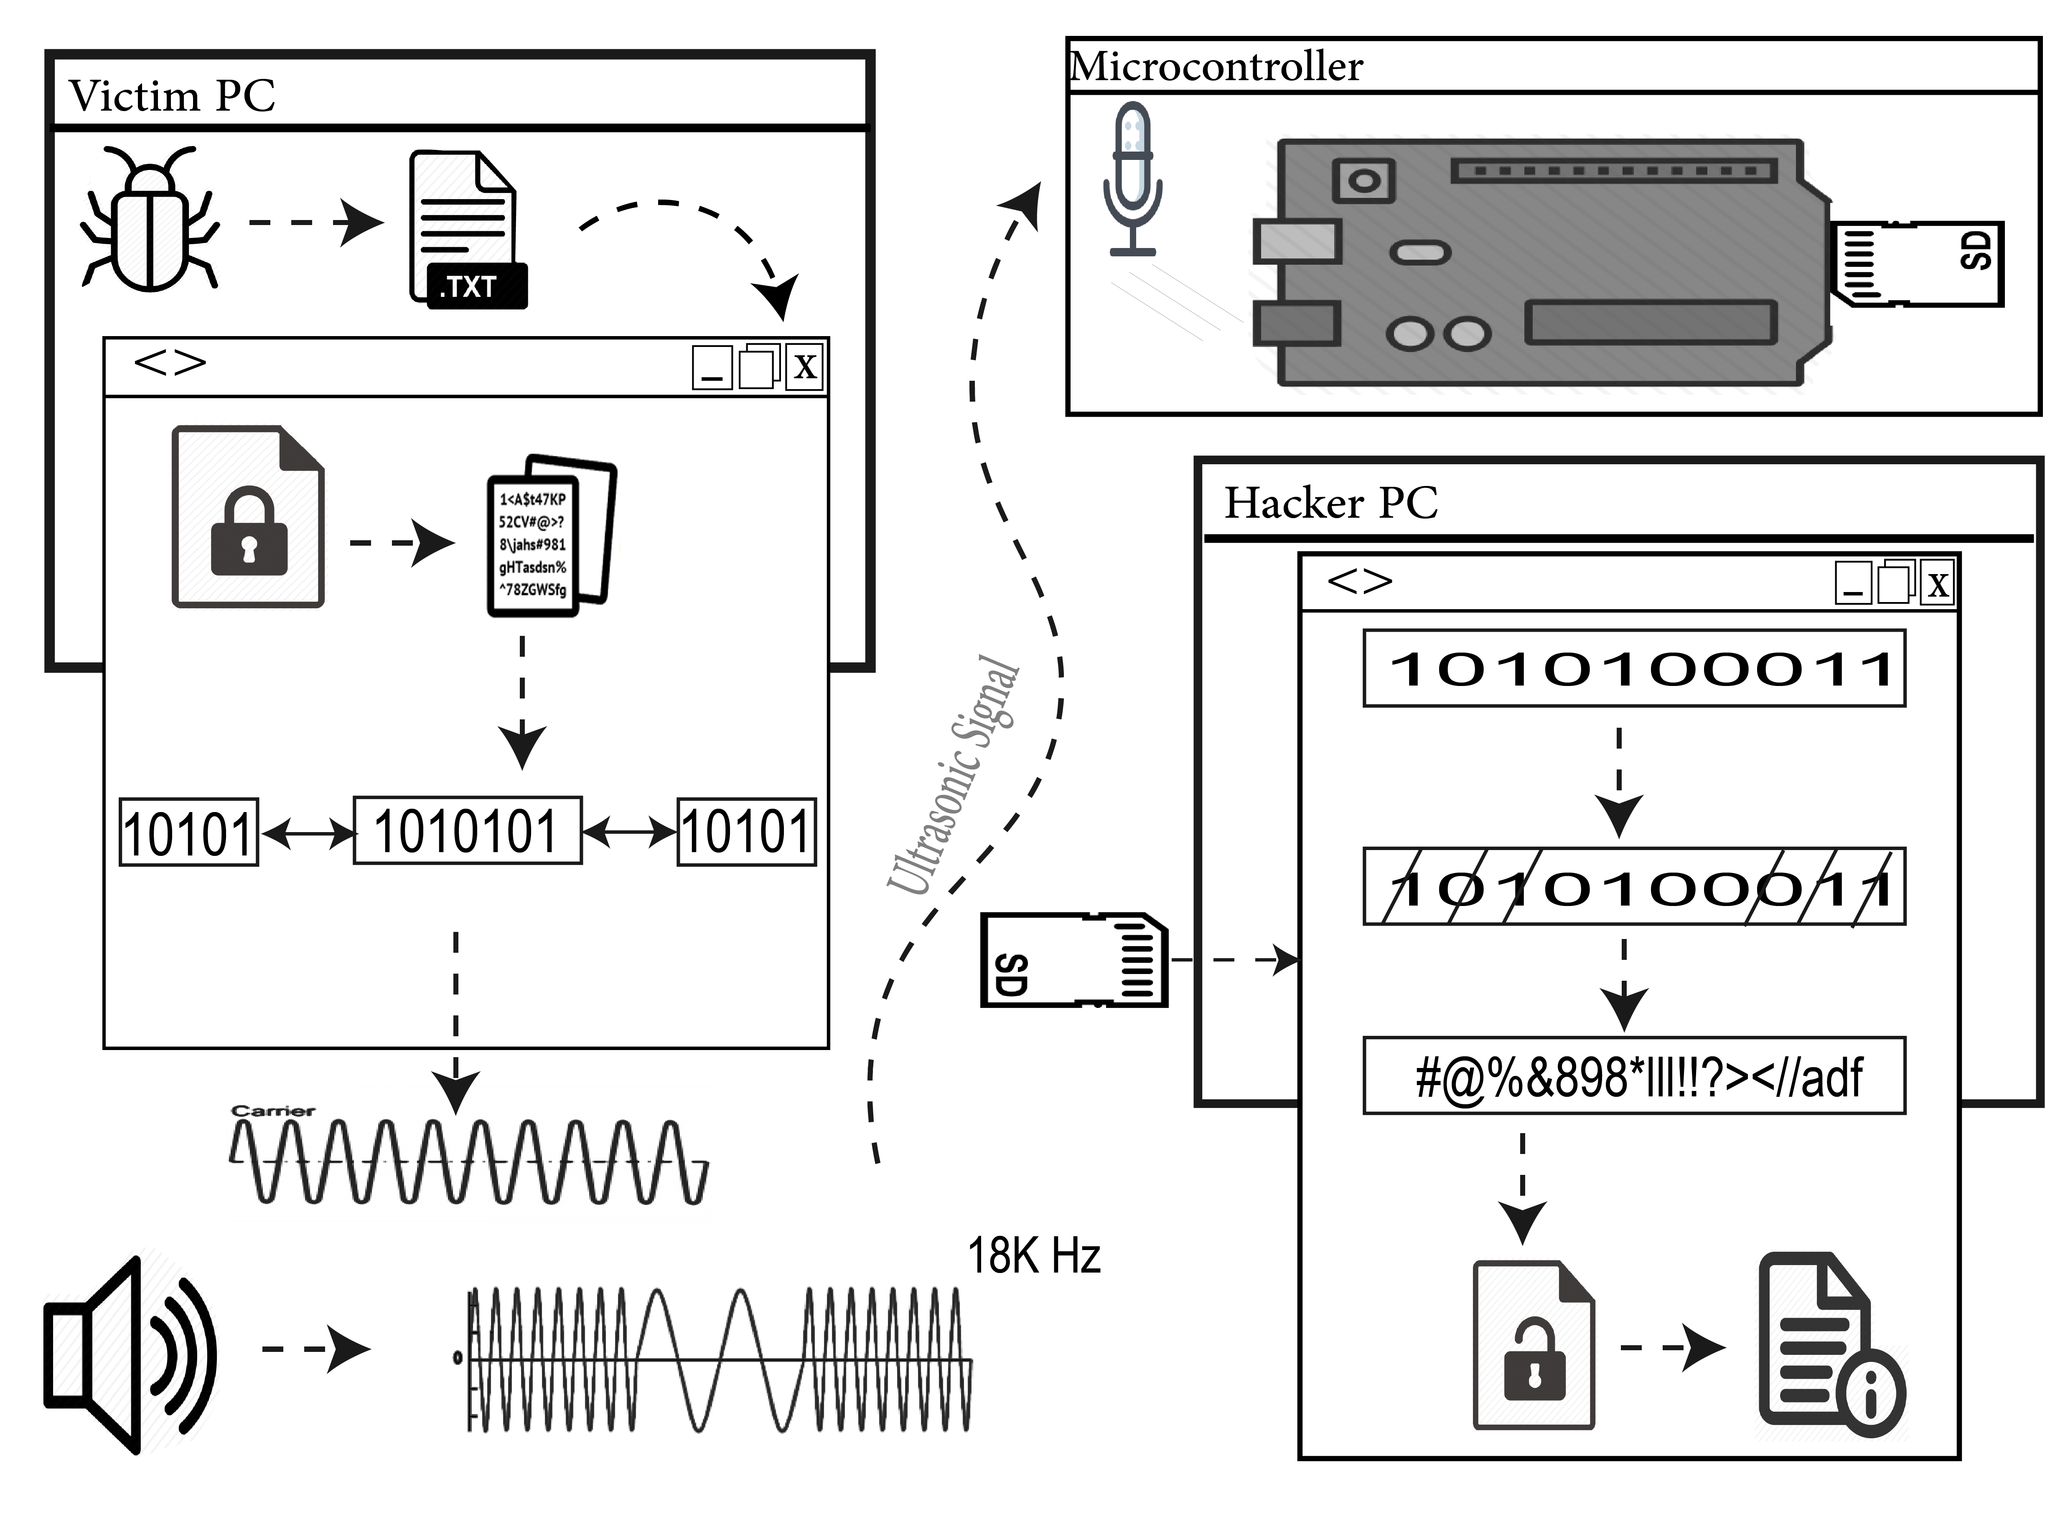

Figure 21: High Level Architecture

## Hardware/software used

### Hardware

1. **Arduino Pro Mini**

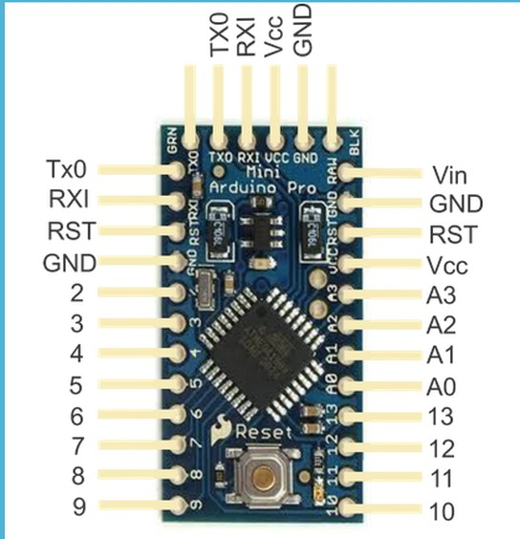The Arduino Pro Mini is tiny in size (18x30mm) making it an excellent candidate for a spy bug. Due to its small size, it lacks a micro-USB port but rather uses FTDI to inject the program into it. The Pro Mini is just right for the job as it has four analog pins, which can be used to connect the microphone’s circuit to it.

Figure 22: Arduino Pro Mini

The Pro Mini is minimal with no extravagant features such as Wi-Fi and Bluetooth. Since minimal features are used, it is expected to also be power efficient. Other more sophisticated microcontrollers such the Arduino Nano are not used due to the significant increase in size over the Mini Pro with no real benefits that can be utilized in our project

TheArduino Pro Mini is a microcontroller is based on the ATmega328. The Arduino Pro Mini has 6 analog inputs, one is utilized for the microphone input in this project. The Pro Mini also has fourteen digital input/output pins, of which 6 can be used as PWM outputs, an on-board resonator, a push button. The Pro Mini can be connected via USB using an FTDI breakout board to upload code and get power.

Table 6: Arduino Pro Mini

|  |  |
| --- | --- |
| Microcontroller | Arduino Pro Mini |
| Board Power Supply | 3.35 -12 V (3.3V model) / 5 - 12 V (5V model) |
| Circuit Operating Voltage | 3.3V / 5V |
| Digital I/O Pins | 14 |
| PWM Pins | 6 |
| UART | 1 |
| SPI | 1 |
| I2C | 1 |
| Analog Input Pins | 6 |
| External Interrupts | 2 |
| DC Current per I/O Pin | 40 mA |
| Flash Memory | 32KB of which 2 KB used by bootloader |
| SRAM | 2 KB |
| EEPROM | 1 KB |
| Clock Speed | 8 MHz (3.3V versions) / 16 MHz (5V versions) |

1. **3.7V DC LIPO battery with TP4056 charging/regulation circuit**

A 3.7V battery is used, which can supply 250mAh capacity. This battery is ideal due to its small size, being rechargeable and containing sufficient energy to power up the components. The LIPO battery is connected to a pre-made charging and regulation circuit, TP4056. The TP4056 is suitable due to its small size and portability along with it being compatible with Micro-USB for charging the LIPO battery. The charging circuit has an output of 4.2V which suitable and safe for the battery. This charging circuit is used due to availability and compatibility. The TP4056 charging circuit does not use Transistor-Transistor Logic (TTL) Technology, instead it uses Complementary Metal-Oxide- Semiconductor (CMOS) technology. One way to distinguish TTL from CMOS technology, in this case, is by knowing that the TP4056 does not use 5V to operate. This is not an issue but the system user must be cautious with CMOS based components as to not touch any exposed wires or pins, since stored charges in the human body might damage the circuit.

Figure 23: Battery Protection & Charging Circuit

Figure 24: Li-Po Battery

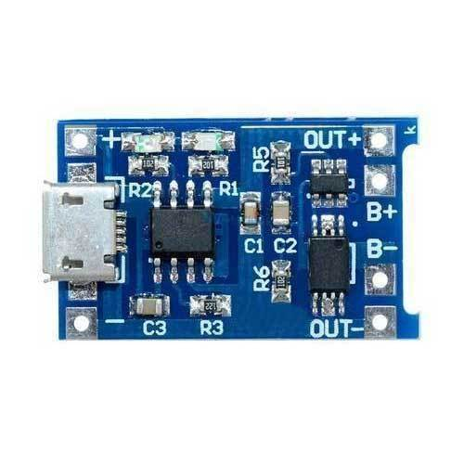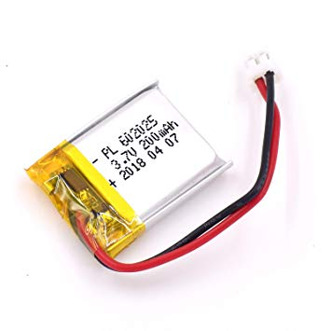

How it works:

The TP4056 outputs a fixed 4.2V. Charge current can be adjusted externally with the help of a single resistor. when the charge current drops to one tenth of the programmed value after the final float voltage is reached, The TP4056 automatically terminates the charge cycle. The TP4056 has 6 pins and requires just wires in order to build a Lithium Ion battery charger circuit.

1. **Micro-SD Card Adapter**

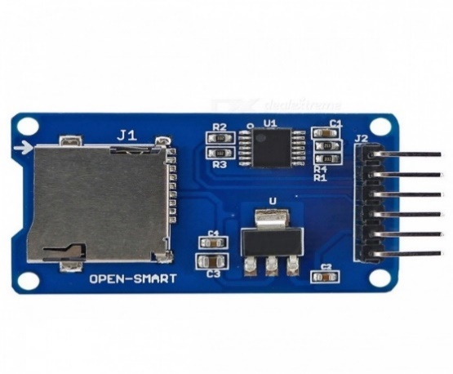Since the Arduino Pro Mini does not have sufficient memory for large audio storage nor a USB connection, we use a Micro-SD adapter, which is attached to the microcontroller. The Micro-SD card acts as a data transfer mechanism between the Arduino and the computer.

Figure 25: Micro-SD Card Adapter

How it works:

A microSD card adapter is a device that the enables reading your microSD card by a computer. Essentially, it looks like a standard SD card, but you slide your microSD into it, and then the SD card can be read from a computer. The opening at the bottom of the SD-card adapter is where you insert your microSD, by pushing it inside the slot show in the above **Figure 25**.

1. **FTDI Mini USB**

This Basic FTDI Breakout is used for programming devices via the FTDI pins. Selectable 5V & 3.3V via an onboard jumper.

Figure 26: FTDI Mini USB

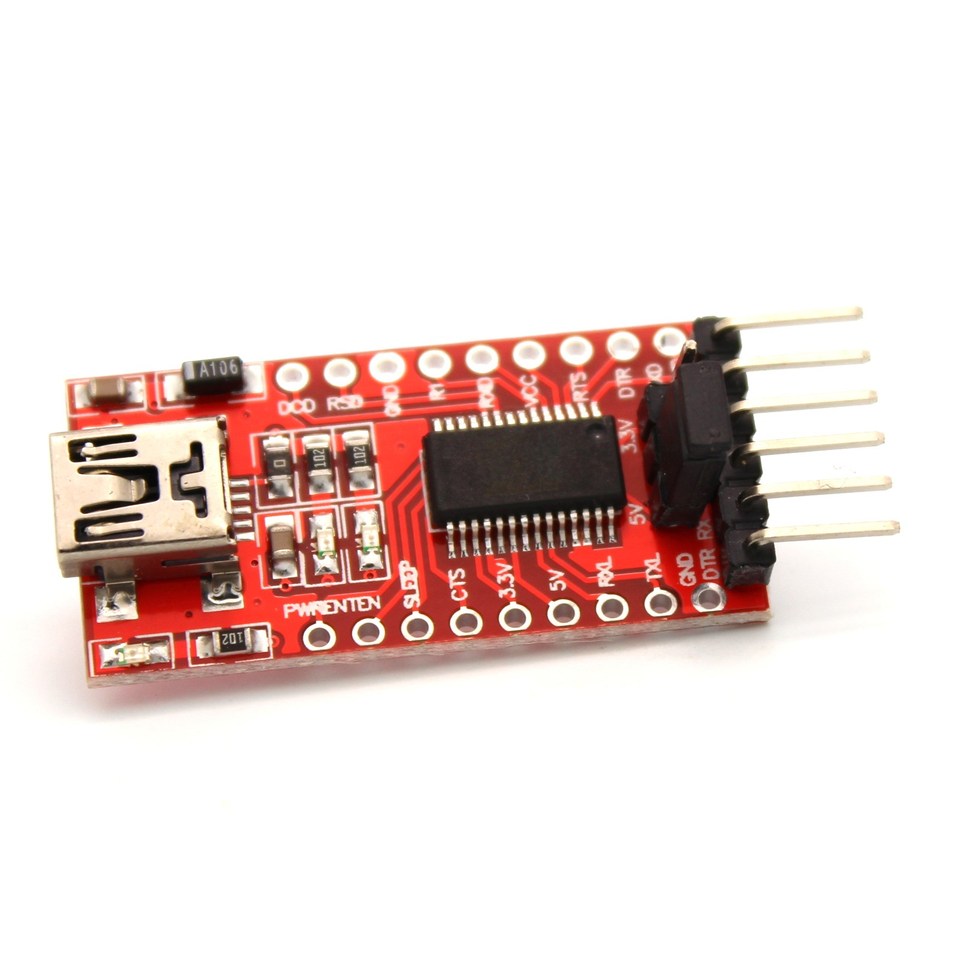

1. **Microphone Circuit**

Since small and precise microphones are barely available on the market, the team decided to construct its circuit from scratch. The microphone circuit allows for flexibility and control of some features such as the lower frequency range and the higher frequency range that the microphone can read. The microphone setup mainly consists of:

1. Electret Microphone

An electret microphone is used due to its availability and low cost. Electret microphones are used in devices like mobile phones. These devices have proven to pick-up sound from a distance making them ideal for this application.

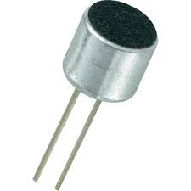

Figure 27: Electret Microphone

1. Ne5534 operational amplifiers and miscellaneous components

Miscellaneous components are used for the construction of frequency filters that allow the microphone to only read near-ultrasound frequency ranges with low noise and high gain.

Figure 28: Operational Amplifiers

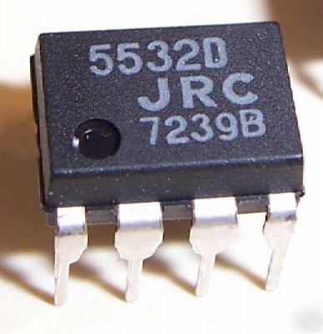

### Software

This project uses three different software, to write the programs for air gapped and attacker computer python 3.7 and vscode were used while Arduino studio was used. Each program has different set of libraries.

* **Victim machine**

In victim machine the program read a text file then it encrypts it using AES algorithm. Then it converts the cipher text to binary and add the preamble and postamble. After that, the program generate sound depending on the binary data from last step. To preform those tasks the below libraries were used:

1. PyCryptodome: is a self-contained Python package of low-level cryptographic primitives.
2. Pyaudio: is a cross-platform audio input/output stream library.
3. NumPy: is the fundamental package for array computing with Python.
4. Binascii: this module contains a number of methods to convert between binary and various ASCII-encoded binary representations.
5. OS: this module provides a portable way of using operating system dependent functionality.
6. Time: this module provides various time-related functions.

* **Microcontroller software**

In microcontroller the program records a wav file and store it in a SD card. To record wav files the libraries below were used:

1. TMRpcm: Arduino library for asynchronous playback of PCM/WAV files direct from SD card.

* **Attacker machine software**

In attacker machine the program takes the wav file provided and extract data from it as binary then it removes the preamble and postamble. After that, it decrypts it and display the data from the air gapped. Performing those tasks requires:

1. Sys: this module provides access to some variables used or maintained by the interpreter and to functions that interact strongly with the interpreter.
2. SciPy: s a Python-based ecosystem of open-source software for mathematics, science, and engineering.
3. Matplotlib: is a comprehensive library for creating static, animated, and interactive visualizations in Python.
4. Io: this module provides Python’s main facilities for dealing with various types of I/O.

## Hardware design

This section discusses the hardware components used in this project. This includes the reason behind the choice, compatibility, and calculations.

1. Microcontroller:

The Arduino Pro Mini was selected for the data retrieval device. Arduino provides a robust platform in terms of reliability and ease of use. Arduinos are programmed with Arduino IDE and have excellent of support. The Arduino Pro Mini is cheap and readily available. In this project an Arduino Pro Mini is used because it has analog pins that are used to connect the custom microphone, which reads near ultrasonic frequencies. This cannot be done with Raspberry PI microcontrollers despite their powerful processing capabilities and large amount of support found for their platform.

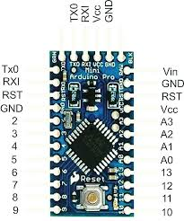The design of the listening device utilizes Analog Pin 0 (A0) which receives the output from the microphone circuit, therefore pin A0 is as defined as an input pin. The electret microphone and its circuit are analog devices therefore their output is a voltage rather than a series of zeros and ones. Using an analog pin to collect data from the microphone circuit avoids using an Analog to Digital Converter (ADC), which takes the voltages and translates them into an equivalent digital value. Avoiding the use of an ADC saves physical space and more importantly, reduces a lot of unnecessary complications while setting it up.

Figure 29: Microcontroller

Pin 2 is also be needed. Pin 2 is defined as an input pullup pin and a push button is connected to it. A pull-up pin reports “HIGH” when the button pressed which will make the microcontroller start recording. If the button is pressed again, after the first recording has started, the microcontroller starts a new recording. A total of three recordings is possible after that, if the button is pressed, the device stops recording completely.

Pin 6 it defined as output pin. A Light Emitting Diode (LED) connected to pin 6 and turns on when the button is pressed for the first time. The LED blinks every time the button is pressed. The LED is an indicator and does not play a vital role in the operation of the system. Both pin 2 and 6 are Digital Pins. Pins 10, 11, 12 and 13 are used for connecting the SD-card adapter. This will be discussed in section 4.3.3. Obviously Vcc and GND pins are also be needed for the microcontroller, microphone circuit and SD-card adapter.

1. Microcontroller-to-computer connection

Like every system, there are trade-offs to every design. The Arduino Pro Mini is tiny in size which makes it concealable but for that reason it does not have a micro/mini USB port to transfer data, like many other microcontrollers, instead is utilizes an FTDI Breakout which has pins that connect to the Arduino Pro Mini to communicate data.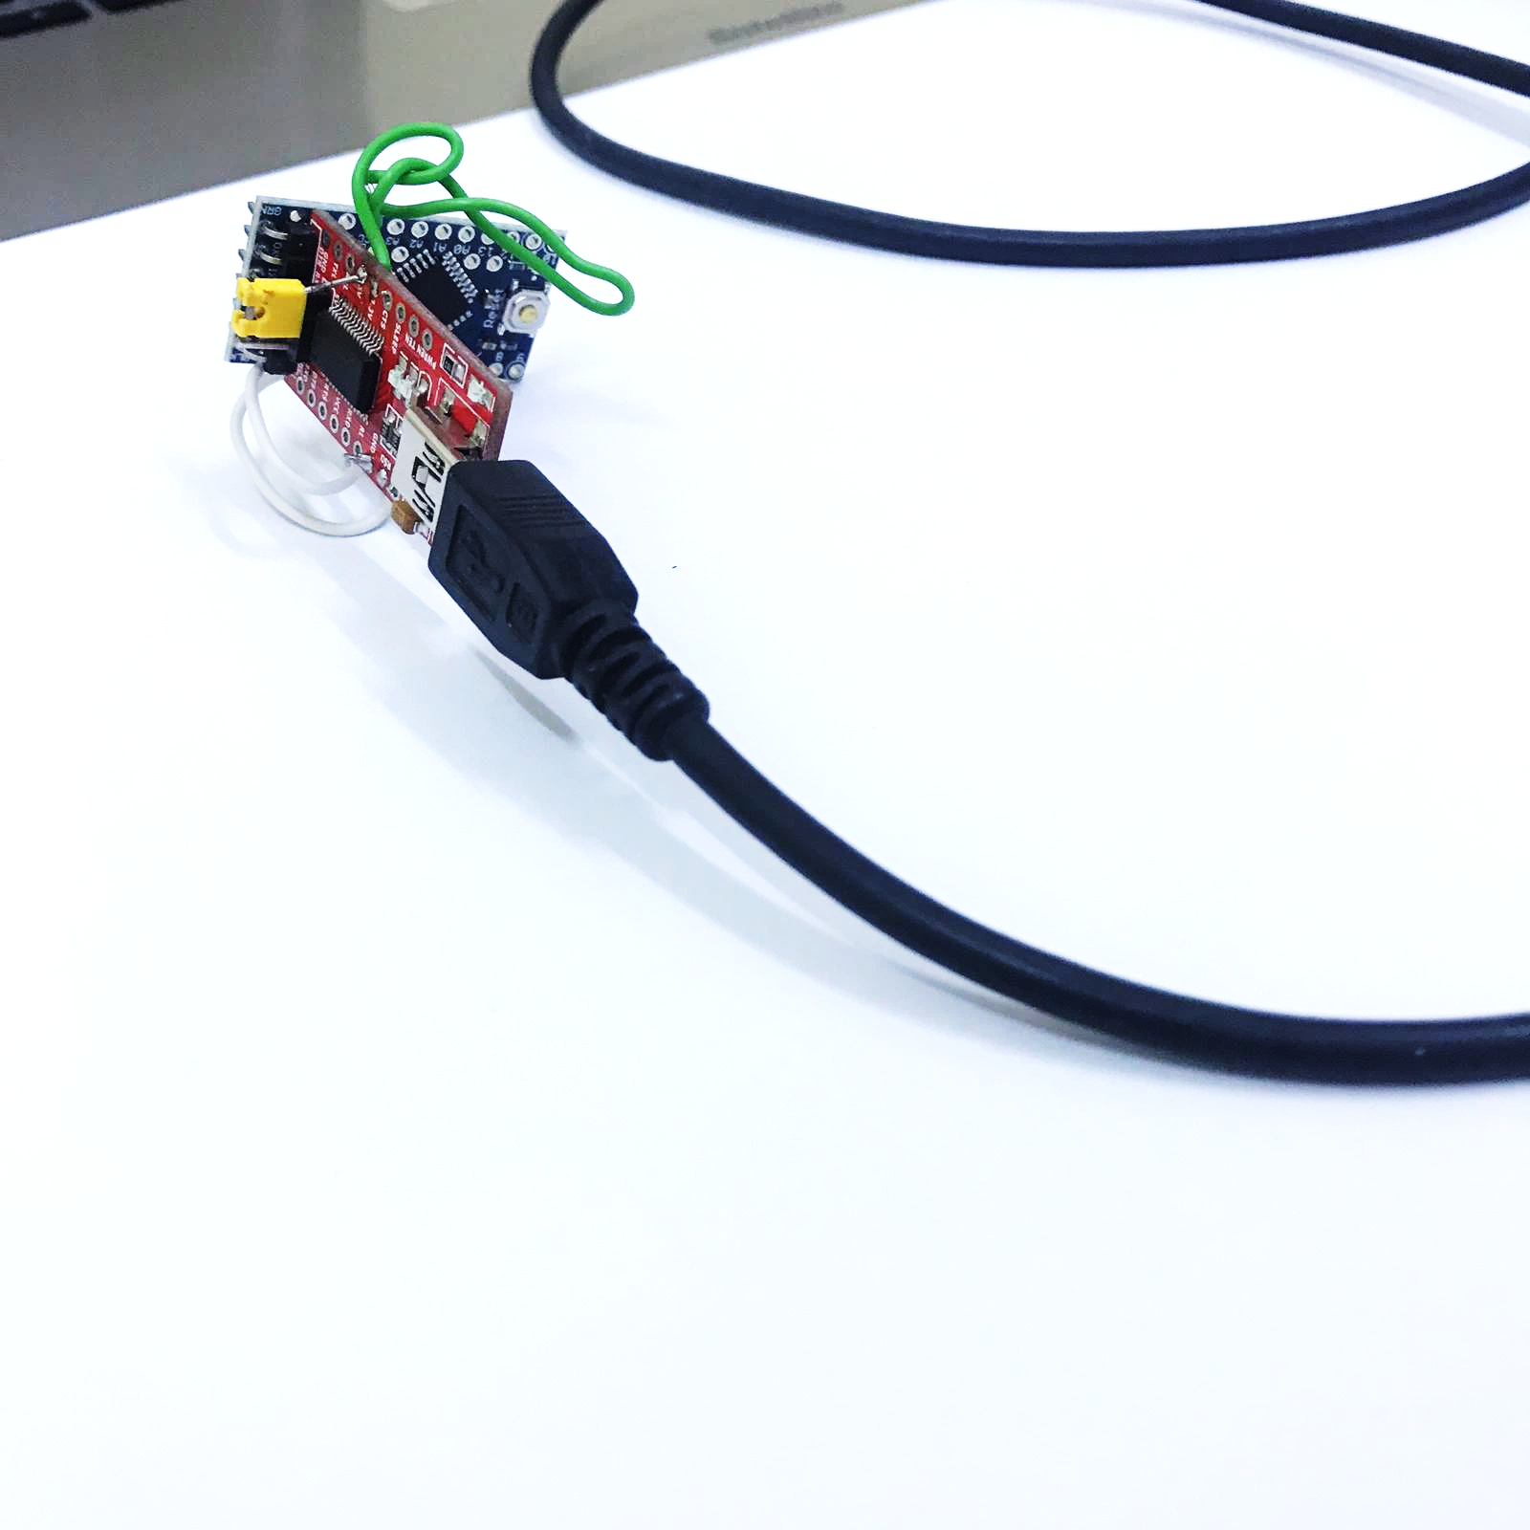

Figure 30: Microcontroller-to-Computer Connection

1. Storage method

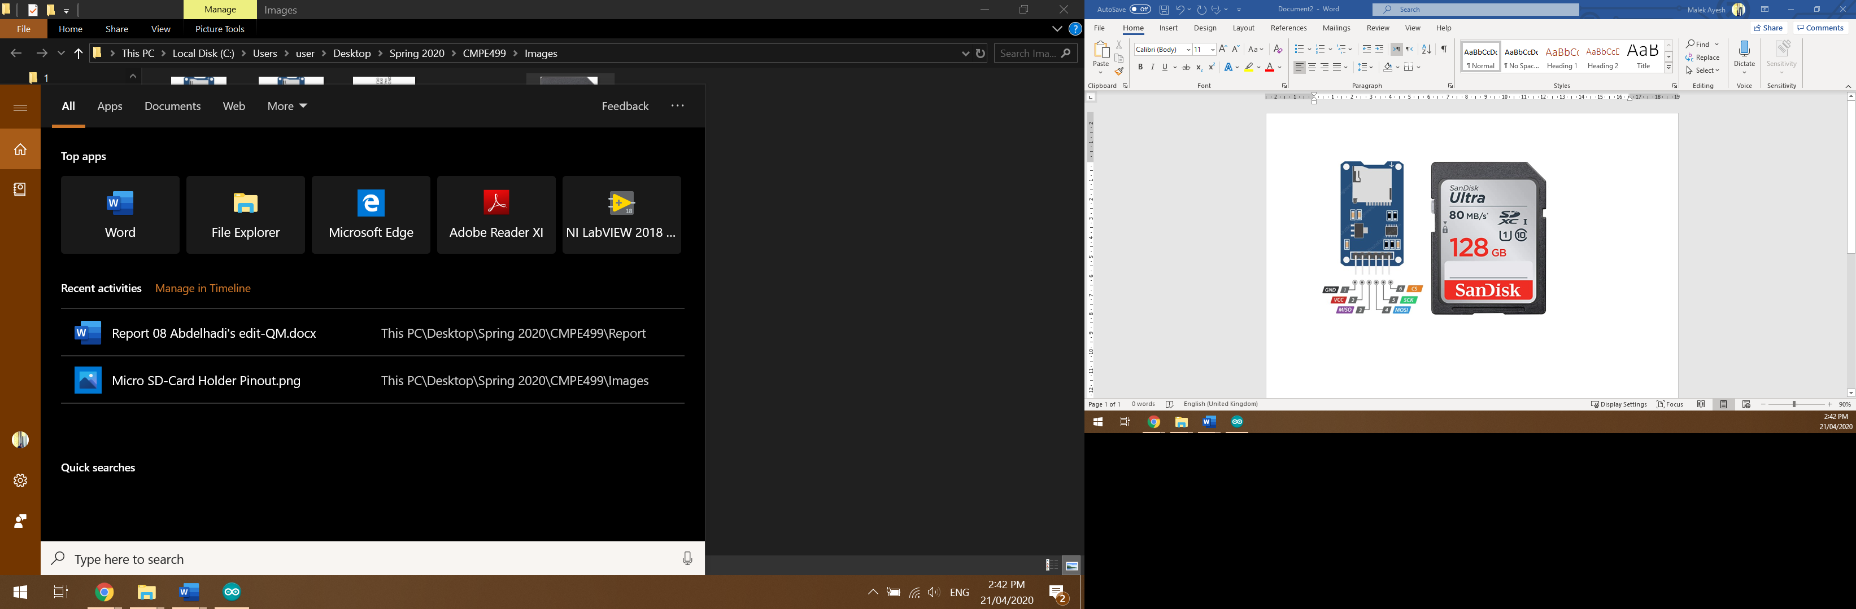Due to the nature of this project, stolen data must be hard to trace back to the attacker. If common active communication methods were used, such as Bluetooth, Wi-Fi and cellular, it increases the chances of data being intercepted since their operating frequencies are constantly scanned and monitored. For this reason, a passive communication method is used. The selected passive communication method used is an SD-Card, were data from the victim’s computer is stolen and transmitted in near-ultrasonic frequencies to a microcontroller, with a microphone SD-Card and an SD-Card attachment. The data is stored in .WAV format on the SD-Card. Once the data is stolen and the microcontroller stops recording, the SD-Card can be retrieved and placed in the attacker’s computer to obtain the sensitive information.

Figure 31: Storage Method

By referring to **Figure 31**, pin 1 and 2 are connected to GND and Vcc pins respectively, shown in **Figure 29**. Pins 3, Master in Slave Out (MISO) and 4, Master Out Slave In (MOSI) are used for Serial Peripheral Interface (SPI) communication and are connected to pins 11 and 12 from **Figure 29** as specified by the micro SD-card’s datasheet. Pin 5, Serial Clock (SCK) and pin 6, Chip Select (CS) are connected to pins 13 and 10 from **Figure 29** as also specified by the SD-card adapter’s datasheet. With these connections, audio can be stored on the SD-card once placed in the SD-card adapter.

1. Power source

This system is designed to be mobile. Therefore, a portable power source is needed. Li-Po batteries are used, and this is due to many factors. Li-Po batteries are really cheap, rechargeable and come in a large array of sizes and capacities. Yes, they can make the system really small, but this means running time is limited with a time of 13.89 hours for a 250mAh battery. When an ammeter is connected to the charging circuit, 18mA of current are drawn therefore:

$$Operating Time=\frac{Battery Capacity}{Current Draw}$$

$$=\frac{250}{18}$$

$$Operating Time=13.89 Hours$$

Paired with the battery is a TP4056 charging and protection circuit to ensure the system runs safely, by having the current constantly regulated at a steady 4.2V and makes the reuse of the system a lot easier when the battery runs out. The charging circuit uses a common micro-USB cable to charge. The TP4056 does not add extra bulk to the circuit since it has a similar size to the tiny 250mAh Li-Po battery.

Figure 32: Power Source

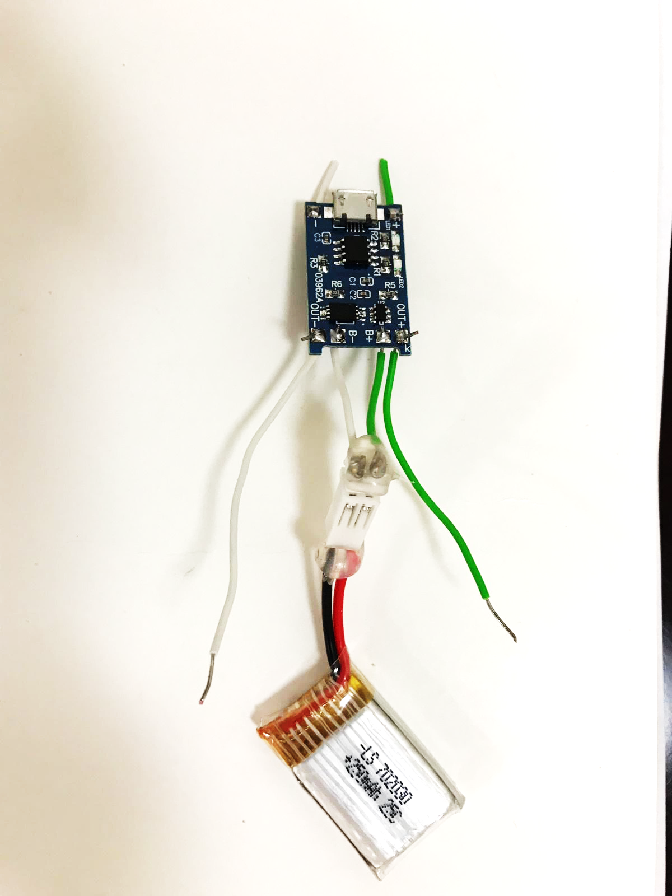

1. Microphone

To keep cost down and make the system more disposable, the cheap electret microphone is used. The humble electret microphone fits the requested criteria by having the ability of reading audio frequencies of up to 20KHz. Prebuilt microphones can reach the price of $500 or more and have unnecessary features for this project’s application. With slight modifications, the electret microphone accomplishes what is needed, for around $3 only.

1. Amplifier

When going the cheaper route, compromises need to be made. In this case, the use of an electret microphone requires effort to design a suitable amplification circuit to be able to read the transmitted near-ultrasonic data at a larger distance. The microphone only reads a specific frequency range, of audio data, at a maximum distance of 1.5m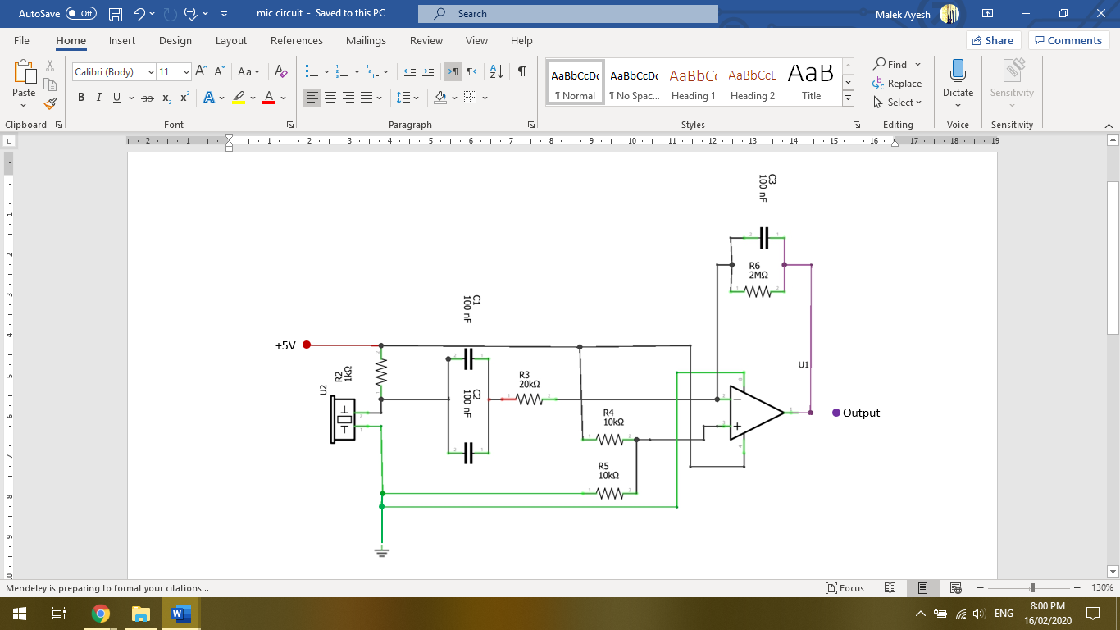.

Figure 33: Amplifier Circuit

* Amplifier gain

The basis of the amplifier/filter circuit is a ne5534 low-noise operational amplifier. The audio obtained by the electret microphone with be amplified. The amplification depends on R3 and R6 in **Figure 33**.

$Gain=\frac{R6}{R3}$

$=\frac{{2×10}^{6}}{{20×10}^{3}}$

$Gain=100 V/V$

* Band-Pass filter

This Band-Pass filter determines the upper and lower frequencies the microphone is able to pick up. A Low-Pass filter determines the lower frequency limit, and a High-pass filter for the upper frequency limit. The utilization of the Low-Pass and High-Pass filters together result in a Band-Pass filter. Capacitor values need to be found, keeping in mind the values of R3 and R6, which limit the lowest and highest frequency the microphone can read. When designing the filters, calculations will be done twice. Once with the theoretical frequency in mind, that will usually produce non-existing/uncommon capacitor values, and the second time will utilize common capacitor values to get a close enough frequency. When calculating the capacitor values needed, the resistor values are assumed. This is due to the resources available since there is a larger variety of resistor values, which makes the design process easier. $R_{3}$ is assumed to be 20KΩ while $R_{6}$ is assumed to be 2MΩ.

1. Low-pass filter

This filter provides the minimum frequency that can be recorded.

Table 7: Low-Pass Filter Calculation

|  |  |
| --- | --- |
| Theoretical calculations: | Actual calculations: |
| $$f_{LC}=\frac{1}{2π×C_{LC combined}{×R}_{3}}$$ $$17,000=\frac{1}{2π{×{20×10}^{3}×C}_{LC combined}}$$ $C_{LC combined}=468p$ F $C_{combined}$ is the summation of two capacitors in parallel therefore: $$C_{1}=C_{2}=\frac{C_{LC combined}}{2}$$ $$C_{1}=C_{2}=\frac{4.68×{10}^{-10}}{2}$$ $$C_{1}=C_{2}=234pF$$ | The theoretical value of $C_{1} C_{2}$ does not exist therefore realistic and available values were tested. The chosen values have the following calculation: $$f_{LC}=\frac{1}{2π×C_{LC combined}{×R}_{3}}$$ $$f_{LC}=\frac{1}{2π×480×{10}^{-12}×20×{10}^{3}}$$ $$f_{LC}=16,579Hz$$ The calculated value of $f_{LC}$, with realistic values of $C_{1}=C_{2}=\frac{C_{combined}}{2}=240pF$,  puts out a minimum frequency of 16,579Hz. This is close enough to the requested 17KHz. |

1. High-pass filter

This filter provides the maximum frequency that can be recorded.

Table 8: High-Pass Filter

|  |  |
| --- | --- |
| Theoretical calculations: | Actual calculations: |
| $$f_{HC}=\frac{1}{2π×C_{3}{×R}_{6}}$$ $$19,000=\frac{1}{2π{×{2×10}^{6}×C}_{3}}$$ $C_{3}=4.19p$ F | The theoretical value of $C_{3}$ does not exist therefore realistic and available values were tested. The chosen value has the following calculation: $$f_{HC}=\frac{1}{2π×C_{3}{×R}_{3}}$$ $$f_{HC}=\frac{1}{2π×4.1×{10}^{-12}×20×{10}^{3}}$$ $$f_{HC}=19,409Hz$$ The calculated value of $f_{HC}$, with realistic values of $C_{3}=4.1pF$,  puts out a maximum frequency of 19,409Hz. This is close enough to the requested 19KHz. |

1. Amplifier conclusion

The designed microphone circuit can amplify the audio signal coming into the electret microphone by one-hundred times and can read frequencies between 16,579Hz and 19,409Hz.

## Software design

The data from the victim pc to attacker pc go through three stages. Each stage has its own program.

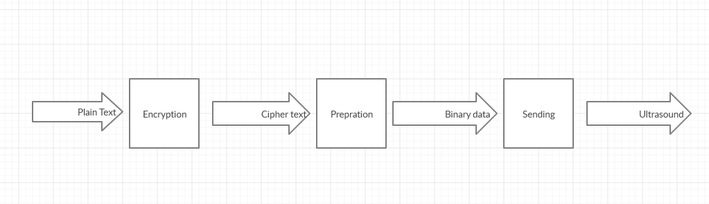An overview of the program can be shown in the figure below:

Figure 34: Victim PC to Attacker PC

1. Data encryption

The program uses the AES symmetric key encryption algorithm to encrypt the data, a block of 128 ciphertext bits is generated for every block of 128-bit plaintext input. To use AES four parameters should be set.

* Message: data which the program sends (“password”).
* Key length: a parameter that determines the functional output of a cryptographic algorithm. The program uses 128 bits key length (“senior_project20”).
* Mode: a block cipher mode of operation is an algorithm that uses a [block cipher](https://en.wikipedia.org/wiki/Block_cipher) to provide [information security](https://en.wikipedia.org/wiki/Information_security) such as [confidentiality](https://en.wikipedia.org/wiki/Confidentiality) or [authenticity](https://en.wikipedia.org/wiki/Authentication). The program uses “ECB” because it encrypts the data parallelly which make this step faster.
* IV: is a block of bits that is used by several modes to randomize the encryption. The program uses “\xa3+\r\xb9\xd2x\xb9N\xf2\x8c\x94\xc4\x92d\x05\x1a” as IV.
* Output: This is the ciphertext. “\x8e\x89L\xfe\r\x97\x8b\x1e\x819G\x08\x03\x98\x15c”

The PyCryptodome library encrypts strings which are 32 bytes exactly as in **Figure 35**. To encrypt strings less than 32 bytes or larger than 16 bytes the algorithm in **Figure 36** is used. This method will add more data to send.

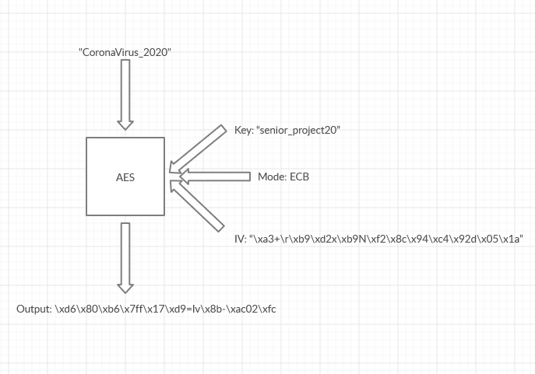

Figure 35: Text File Encryption

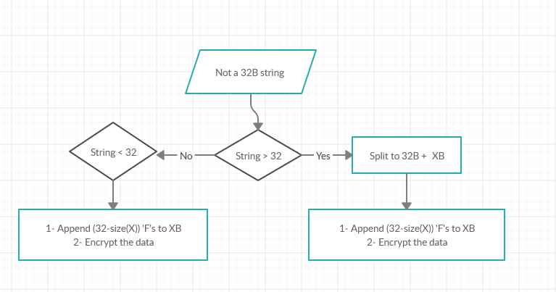

Figure 36: Deal with Different Data Size

Cipher text to binary

To convert the cipher text to binary data. Firstly, the cipher text is converted to integer and then to binary. Because AES class gives a string so converting from hexadecimal to binary directly generates an 8 bit for each hexadecimal number.

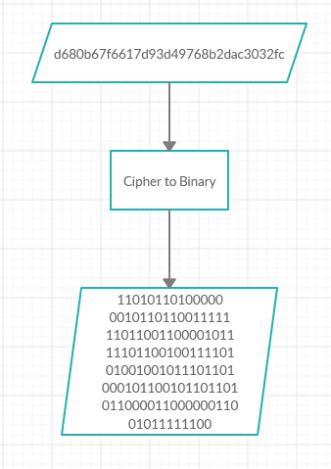

Figure 37: Cipher Text to Binary

1. Add preamble and postamble

Adding preamble and postamble is done using simple string concatenation. The preamble and postamble is 11111011111. The length of the preamble and postamble is chosen to be short because the data is sent multiple times for synchronization purposes. And because the time needed to send one bit is high. This pattern was chosen because this pattern is impossible to be repeated in the data because in ascii table one is maximum repeated 4 times.

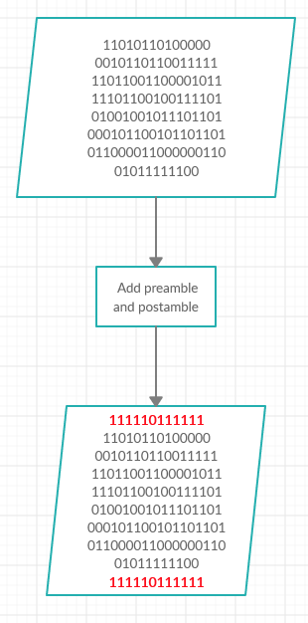

Figure 38: Add Preamble and Postamble

1. Binary to sound

To generate a sine wave from binary data in python, the pyAudio and NumPy packages are used. In the project one is represented as 18KHz and zero as no transmission. Those frequencies are used because the microcontroller's capability of not being able to receive more than 18KHz. The parameters used are

Volume: 0.5

Generating sound sampling rate: 44100

Duration: 1 to 5 seconds

Frequency: 18KHz

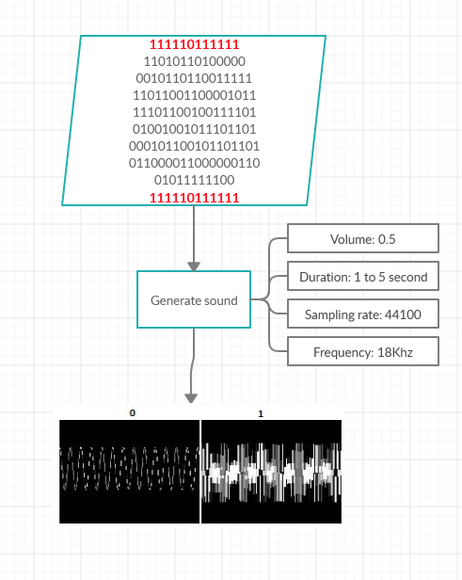

Figure 39: Binary to Sound

1. Listen to data from victim:

The Arduino code uploaded to the listening device obtains the data from the microphone through Analog pin 0 (A0). Pin A0 is programmed as an input pin. An Input pull up push button is programmed to digital pin 2 where when pressed, a new recording is started. A total of three recordings is possible, the start of each recording is indicated by an LED blink which is connected to digital pin 6 as an input pin. Using the TMRpcm, SD.h and SPI.h libraries, the audio obtained from the microphone is stored on a SD-card in WAV format.

1. Calculate Short-time Fourier transform (STFT):

To calculate Short-time Fourier transform (STFT) many parameters need to be set. The parameters depend on the application so to find the ideal parameters try and error method is used. After many tries on many audio files, those were the best to this application:

Frame size = 29

Overlap factor = 0.5, to retrieve whatever losing between the windows.

Window = Hanning, Hanning windows make the left and right information approach zero. More overlap gives more analysis points and therefore smoother results across time. The formula for STFT is:

$STFT=\left\{x\left[n\right]\right\}\left(m,w\right)≡X\left(m,w\right)=\sum_{n=-∞}^{∞}{x\left[n\right]w[n-m]ⅇ^{-jwn}}$

1. Data Extraction:

**Figure 40** to **Figure 45** are for visualization and clarification purposes. The STFT gives the spectrogram as in **Figure 40**. The spectrogram is a matrix of (48372, 513). The high 18KHz components are always between columns 410 and 425 of the matrix data. After extracting them the result is a matrix of (48372, 15) as in **Figure 40**. A zoomed-in section of **Figure 40** can be seen in **Figure 41**.

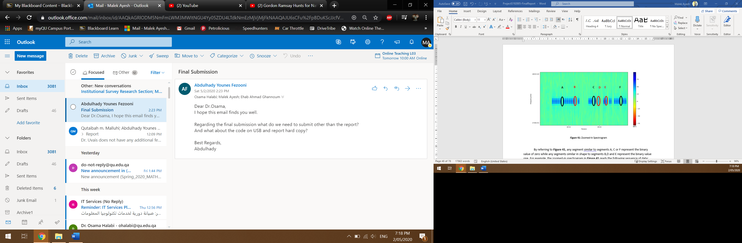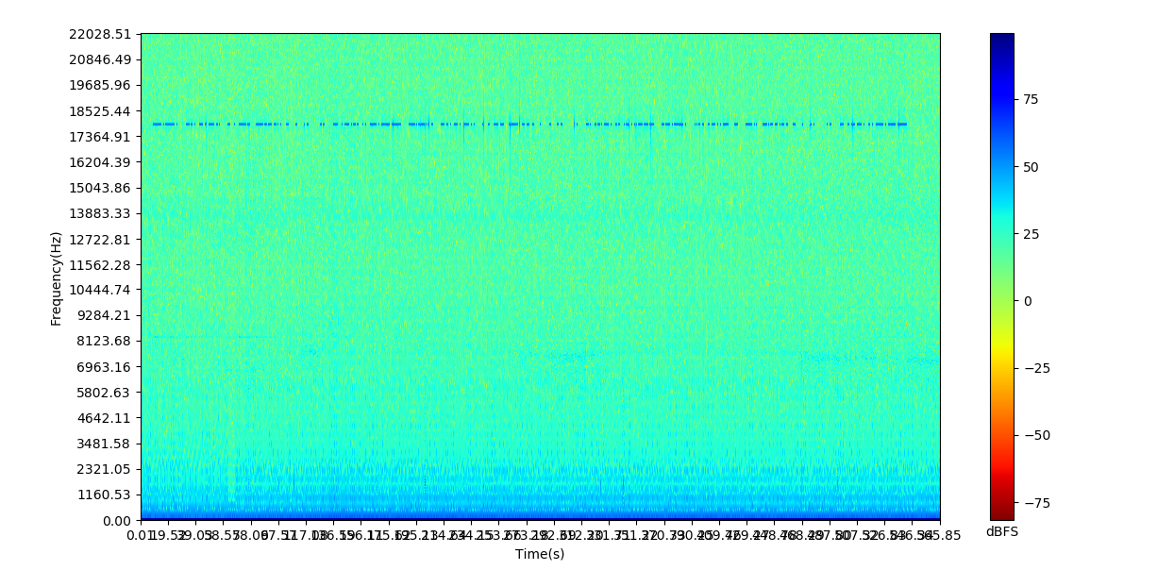

Figure 40: Zoomed-In Spectrogram

Figure 41: Spectrogram

By referring to **Figure 41**, any segment similar to segments A, C or F represent the binary value of zero while any segments similar in shape to segments B,D and E represent the binary value one. For example, the zoomed-in spectrogram in **Figure 41** contains the following sequence of binary data: 111 1101 1111 110010 0000 1101 0100 1101 1011 1011

In **Figure 40** and **Figure 41**, and blue representations show data being transmitted at 18KHz while anything in green or yellow represents noise present in the systems working environment.

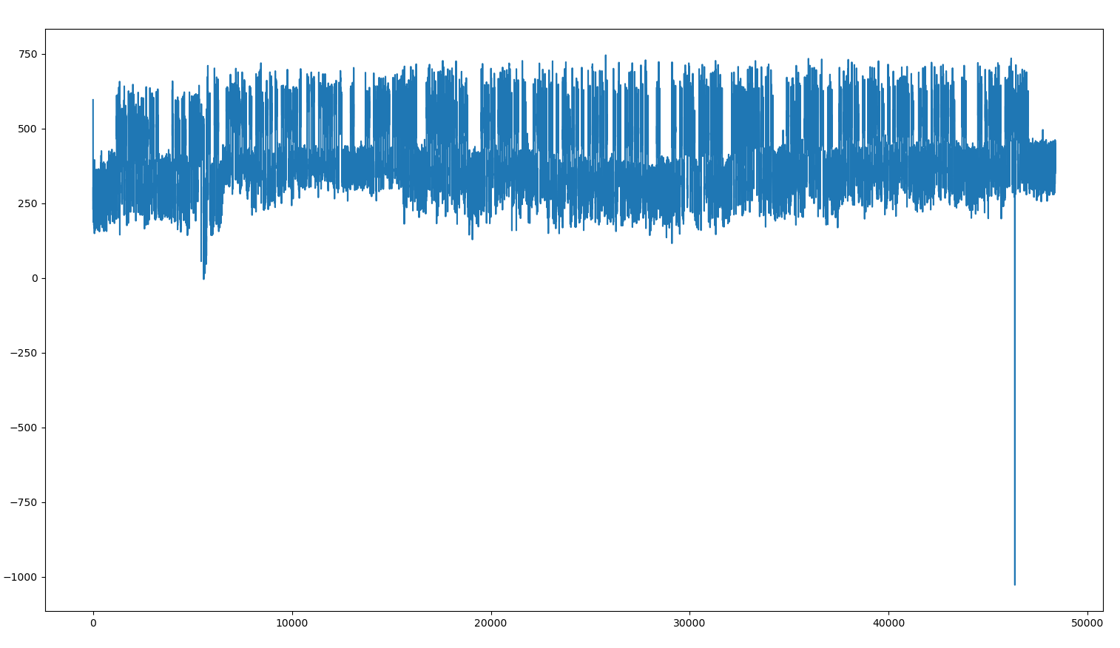The columns of data are summed together to get one row of data with shape of (48372,) which can be visualized as **Figure 42.**

Figure 42: After Summing the Rest of the Data

The spike in the signal at the beginning and end can be traced back to transient voltage. This phenomenon is caused by a sudden release of energy stored or induced in or by the circuit because of that first and last 20 samples should be removed. This makes the rest of analysis easier. The result of this step is show in **Figure 43.**

Figure 43: After Remove High Frequency from Beginning and Ending of the Data

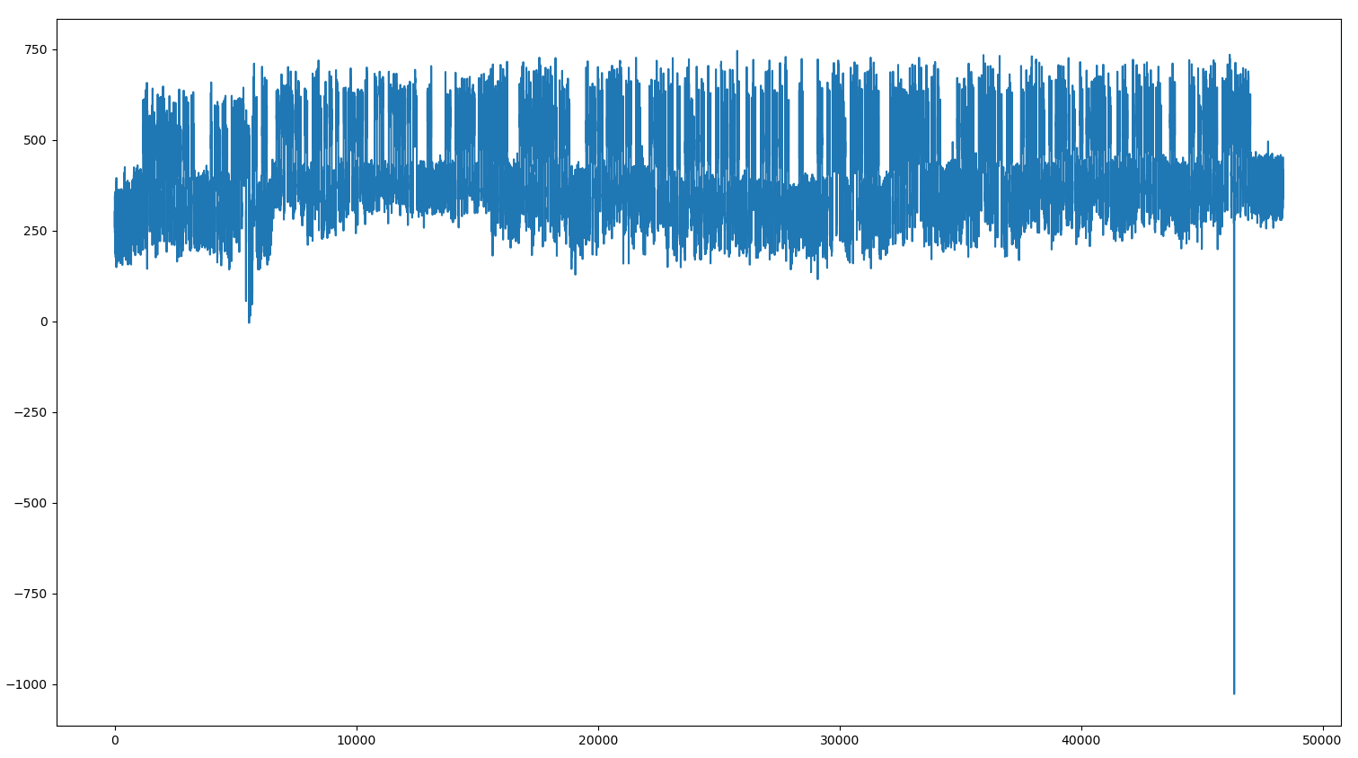

1. Normalize data and clean it

The aim of this step is to make the samples of the one’s equal to one and the samples of the zeros equal to zero. The mean of data is found, and it is considered as a threshold where all the values

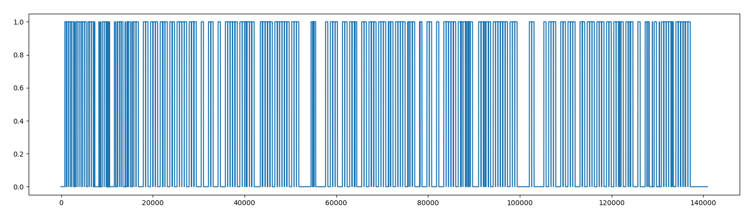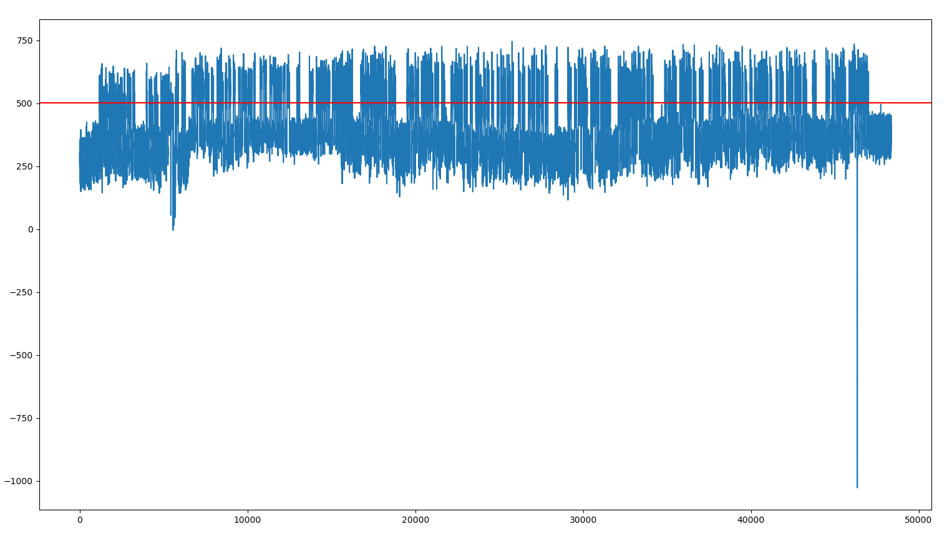about it is equal to one and below it equal to zero. To normalization is done by dividing over the maximum value of the array, this improve the performance of the calculation in the program.

Figure 44: Normalizing Data

Figure 45: Data with Threshold

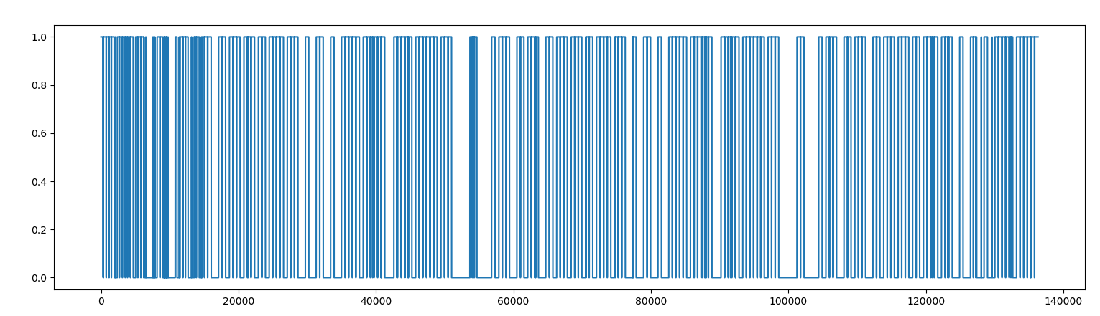Because the noise before and after sending the data will be zero after the previous step. The trim function is used to remove the zeros.

Figure 46: Cutting the Zeros from Beginning and Ending of the Data

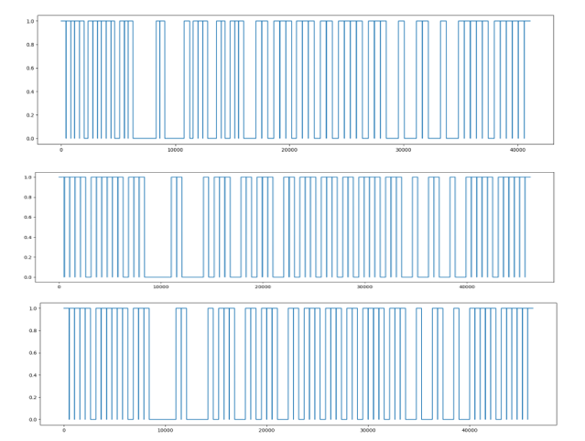Due to the limitations of the computer speak the bit duration is not constant. Therefore, cutting the signal into three parts and sum them to get one will not work (three parts because data in air gapped sent three time). To fix this problem the cutting and removing the zeros before and after the data done manually. To do this the end of first signal and second signal are entered manually.

Figure 47: Part 1-3 of the Data

1. Find zeros and ones

To find zeros and ones the array of each signal is split into 128 frames (AES algorithm block size) and for each frame area under the carve is calculated. After that testing different thresholds near to the mean to get the actual data. This works because whenever the attacker gets the start and end bit correctly the rest of bits will be correct.

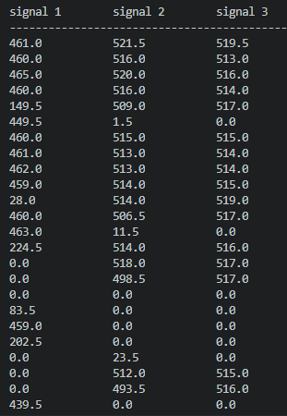

Figure 48: Result After Trapz Function the Three Signal

The value in this test sample was 53.5. So, by every value above 53.5 is one and every value below or equal to 53.5 is zero. To find the actual, the program tests all numbers from the Trapz method and if the program gets the preamble and postamble correct, it will try to decrypt it.

The output

11111011111111010110100000001011011001111111011001100001011111011001001111010100100101110110100010110010110110101100001100000011001011111100111110111111

After that preamble and postamble is removed then converted binary to string and decrypted it to get the original message with is “CoronaVirus_2020”.

# Implementation

## Design description

The system designed consists of two both hardware and software, that interact with one another to retrieve sensitive information from the air-gapped machine.

Figure 49: Listening Device Connection Diagram

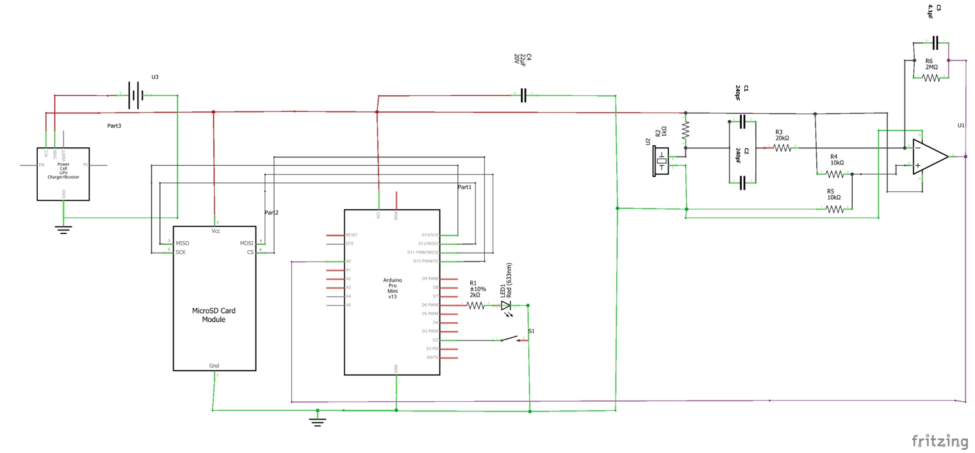



Figure 50: Electret Microphone Diagram

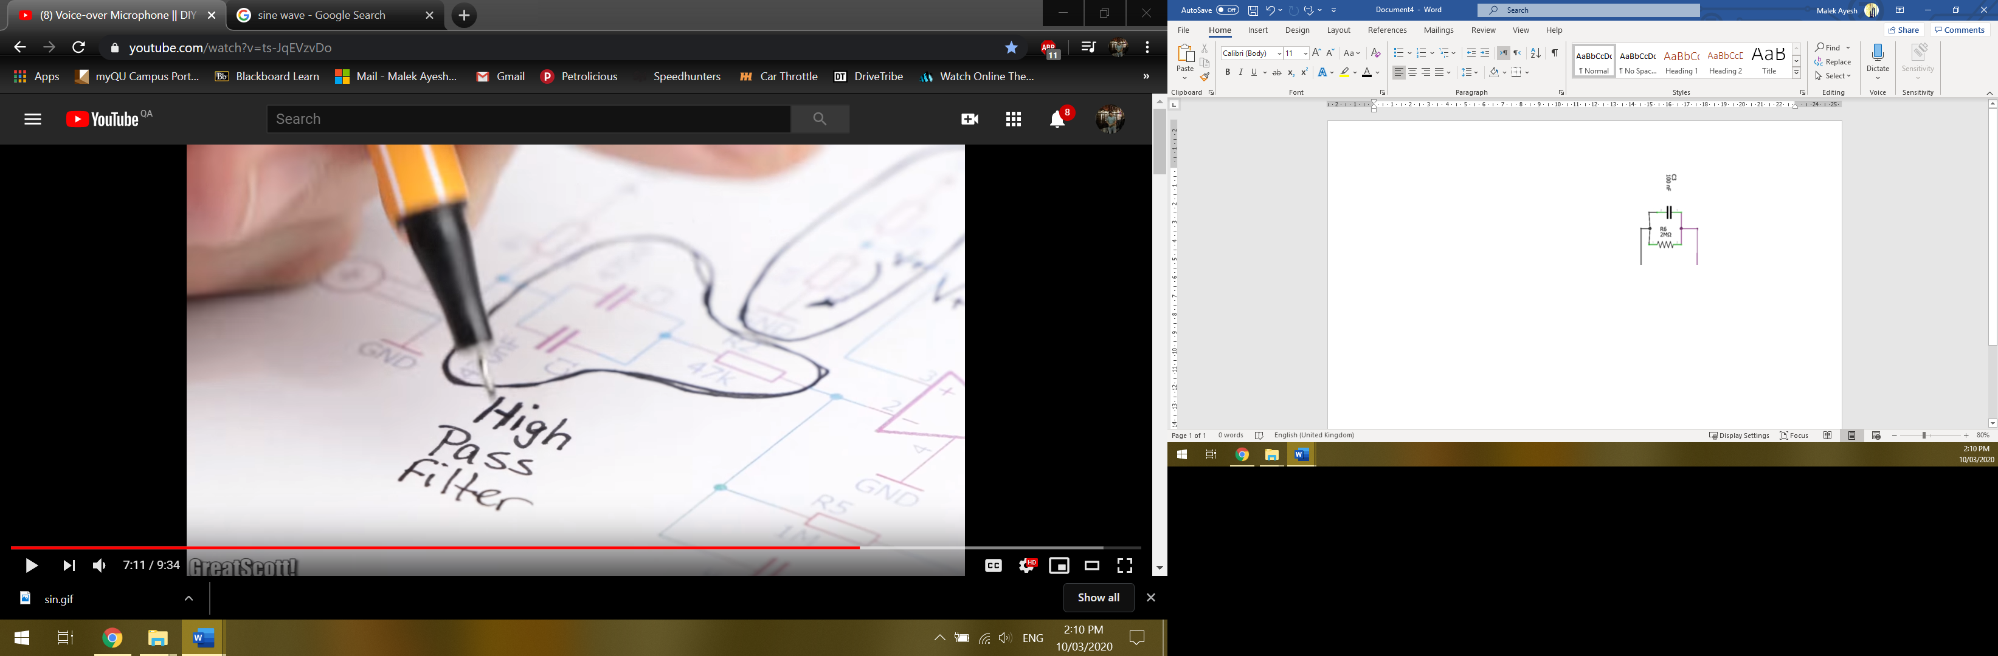Electret microphones are a form of capacitor and in this case, the microphone used has Field-Effect Transistor (FET) inside which helps in power amplification. To power this FET R2, from **Figure 51**, is used. The signal from the microphone passes through a High Pass filter and a Low-Pass filter, resulting in a Band-Pass filter, which determine which frequencies are taken. Other unwanted frequencies are discarded. Refer to section 4.3 for more details.

Figure 51: Low-Pass and High-Pass Amplifier

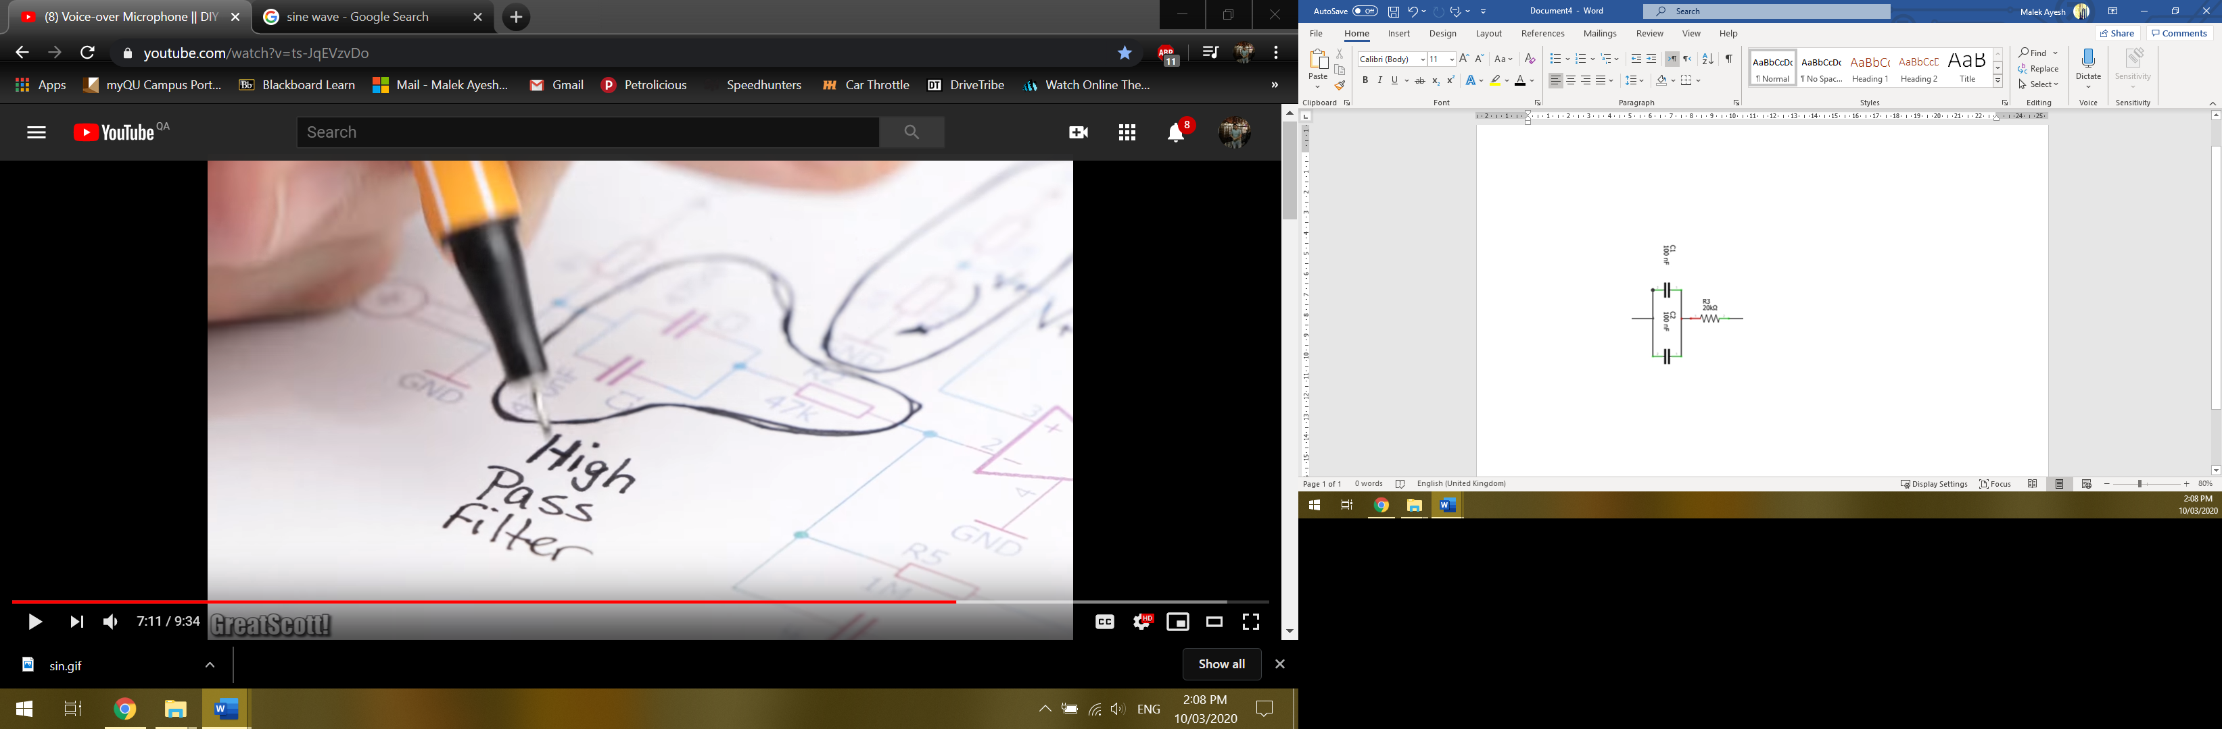

The filtered signal is then amplified by the low-noise Op-Amp, to increase its power. In this case, the amplifier produced a gain of 100V/V. Resistors R4 and R5 are a voltage divider. These resistors take the amplified audio and create a +2.5V offset, on which the output voltage will oscillate around.

$${Voltage}_{Offset}=\frac{R_{4}}{R_{4}R_{5}}×V_{in}$$

$${Voltage}_{Offset}=\frac{10×{10}^{3}}{(10×{10}^{3})(10×{10}^{3})}×5$$

$${Voltage}_{Offset}=+2.5V$$

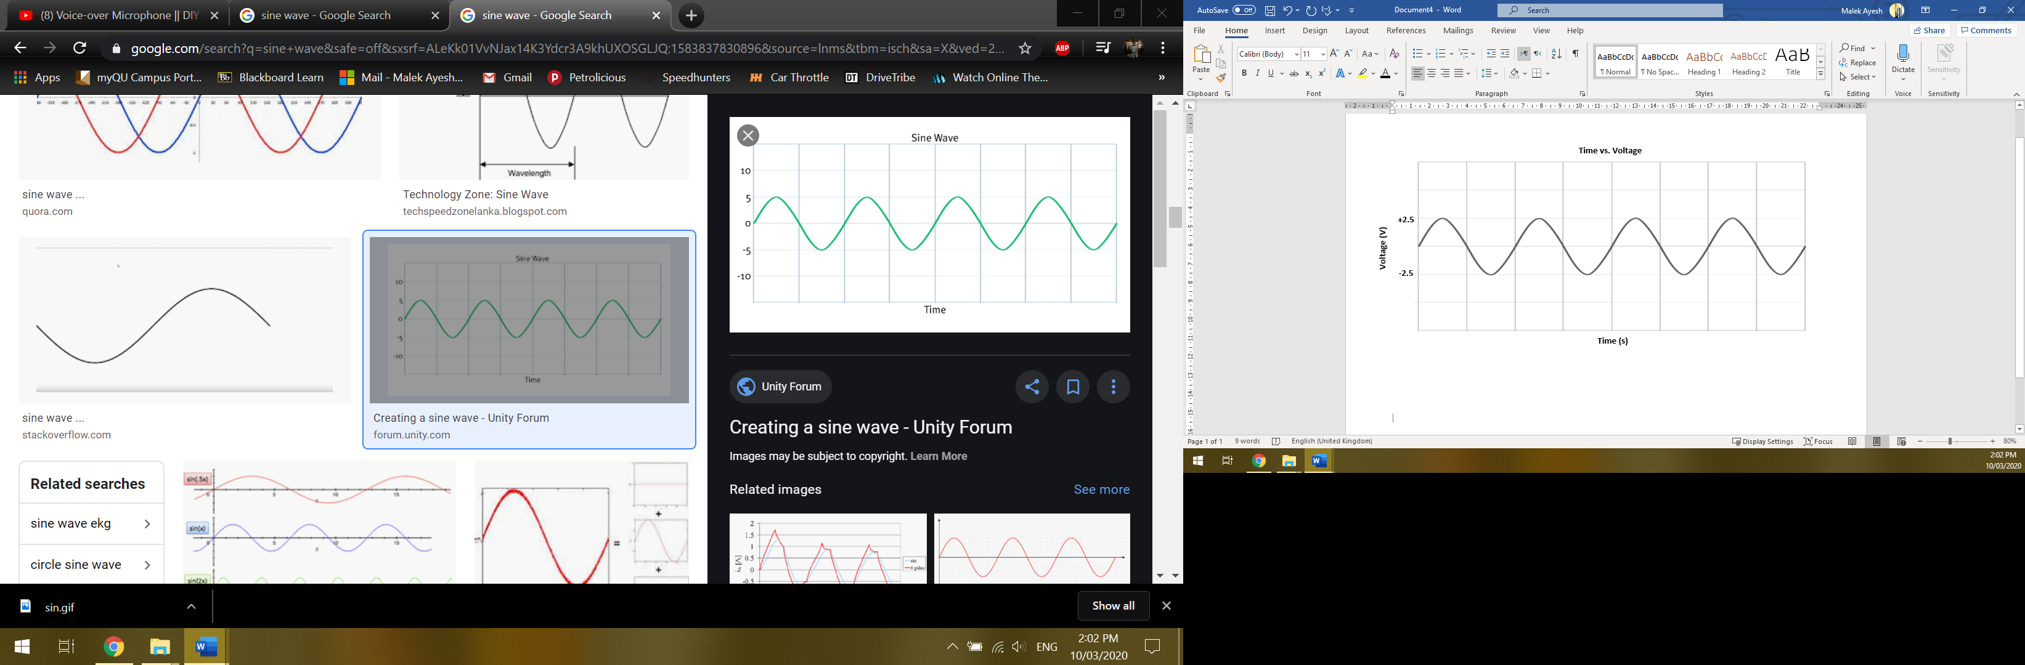

Figure 52: Time vs Voltage

The microphone, its amplification circuit and filtering circuit are all soldered onto an Adafruit solder board then connected to the rest of the components using wire connectors. The output of the microphone circuit is connected to the Arduino Pro mini’s Analog 0, VCC and ground pins.

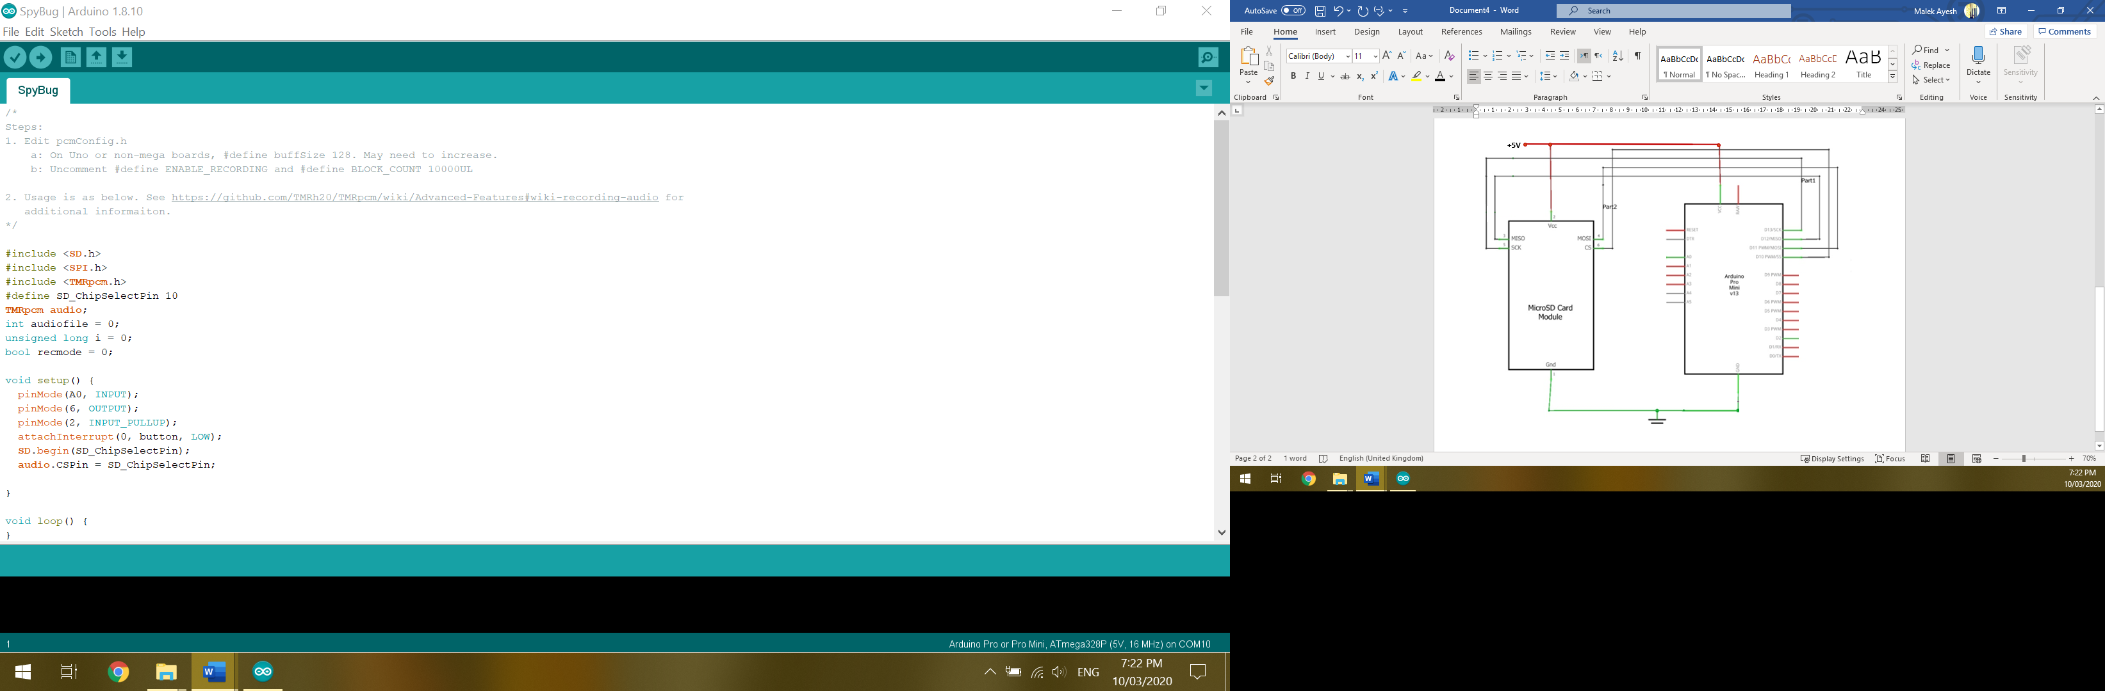By referring the Arduino Pro mini’s and the SD-card holder’s datasheets, they were connected accordingly.

Figure 53: Arduino & SD-Card Holder Diagram

To make the SD-card operate and communicate properly with the Arduino Pro Mini, some libraries must be included in the Arduino IDE code. Those libraries are:

* SD.h: Allows reading and writing from the SD-card.
* SPI.h: Allows the Arduino, the master, to communicate with SPI devices, slaves.
* TMRpcm.h: Allows asynchronous playback of WAV files recorded onto the SD-card.

With the use of these libraries, the output signal produced from the microphone circuit is stored in .WAV from on the SD-card.

1. The output signals stored on the SD-card get the .WAV header and footer added to with and is then ready for processing.
2. Power.
3. The multiple transmissions are compared bit by bit and averaged to determine the correct bit at each index.
4. The received data is decrypted and is converted from ASCII back to regular character.
5. The regular characters represent the retrieved data.

## Design novelties

### Hardware

* Microphone: This design cuts cost drastically since Ultrasonic microphones are very expensive. Moreover, this design is tailored to our exacts needs with regard to the wanted audio frequency range.
* SD-card and SD-card holder: Provide a passive communication method. Passive communication helps in better concealing the attacker’s identity in case the device was caught since there is no direct way of knowing the attacker.
* Microcontroller: The use of a fairly simple microcontroller, such as the Arduino Pro Mini, has a less chance of being discovered than using other devices such as mobile phones. Since this system does not use traditional communication methods such as Cellular, Wi-Fi and Bluetooth but rather depends on a passive communication method, which stores the data on a SD-card rather than directly sending it to the attacker. Using a passive communication method complicates the process of discovering the attacker.
* Signal form: Only the shape of the signal is needed to detect a zero or one and not its contents. Therefore, if the signal was picked up by a signal detector, it will appear as noise to the interceptor.

### Software

Python libraries: To write the air gapped and analysis program many libs were used. Some of them needed to be modified to work with the recent python programming language in addition to some problems in installing them on windows 10.

Wav files: The wav files generated by Arduino are not in their correct format. A third-party program is used to convert them to an acceptable wav file in python.

Analysis way: Many ways were tested to extract data from the wav file:

1. Trying statistical methods on the audio itself.
2. Performing FTT on each T period of the audio file.
3. Performing STFT to get the spectrogram.

## Challenges encountered

### Hardware

* Microphone and microphone circuit: This took multiple weeks of fine-tuning and master. Many factors needed to be taken in consideration which include:

1. Removal of the DC offset. Different types of Op-amps were tried for this, some include a built-in offset remover but none of them worked as good the NE5534p Op-amp with a voltage divider (resistors R4 and R5 in **Figure 54**).



Figure 54: Microphone Circuit

1. Similarly, multiple Op-amps were tested for their gain. An additional amplification circuit was considered but that will make the design too big and would compromise the concealability of the device. The maximum gain to be possible achieved is 100V/V for the NE5534p Op-amp.
2. Band-Pass filter: A combination of High-pass and low-pass filters. Finding such low values of capacitors was an issue and often times, the resistor values would be varied to adapt to the available capacitor values. Moreover, capacitors series and parallel combinations were made when possible to achieve the required values by the design.

* Sampling rate: The processor of the Arduino Pro Mini is only 16MHz with a 10-bit resolution while a 12-bit resolution was required due to the high frequency of the audio. This was resolved by looking at the shape of the signal rather than its contents to determine whether a zero or one was being sent.
* Miscellaneous: Like any project, small errors happened every now and then. These include loose grounds, burnt components and unplugged pins. These issues were resolved quickly but caused small hick-ups throughout the project.

### Software

The hardest part of analyzing is the distinction between zeros and ones. Because the bit duration is not constant there was not a systemic way to extract data from the wav file. To solve this issue the air gapped is programmed to send the data three times and in the attacker computer the program sums all the signal which reduces the effect of inconstant of bit duration.

## Listening device forms

The project consists of both hardware and software components. The listening device hardware can take different forms. The forms implemented for demonstration are:

1. Table lamp

Figure 55: Final Product (Table Lamp)

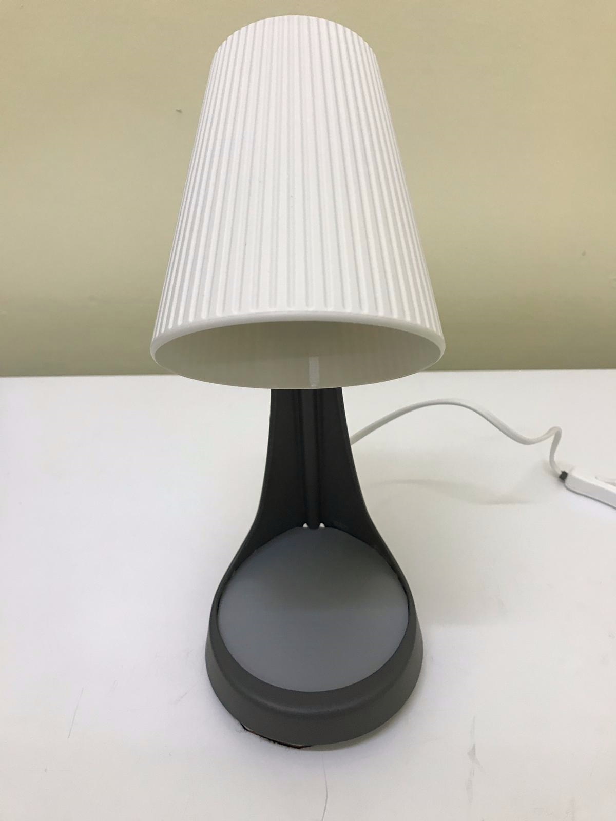

The table lamp is an excellent example were such device can be hidden, while not looking suspicious. The top part of the lamp, were the light bulb resides, is where the microphone is hidden. The top of the lamp is in the shape of a cone therefore it would help in collecting the transmitted audio signal. The base of the lamp is where the microcontroller, SD-card, battery and charging circuit are placed and concealed.

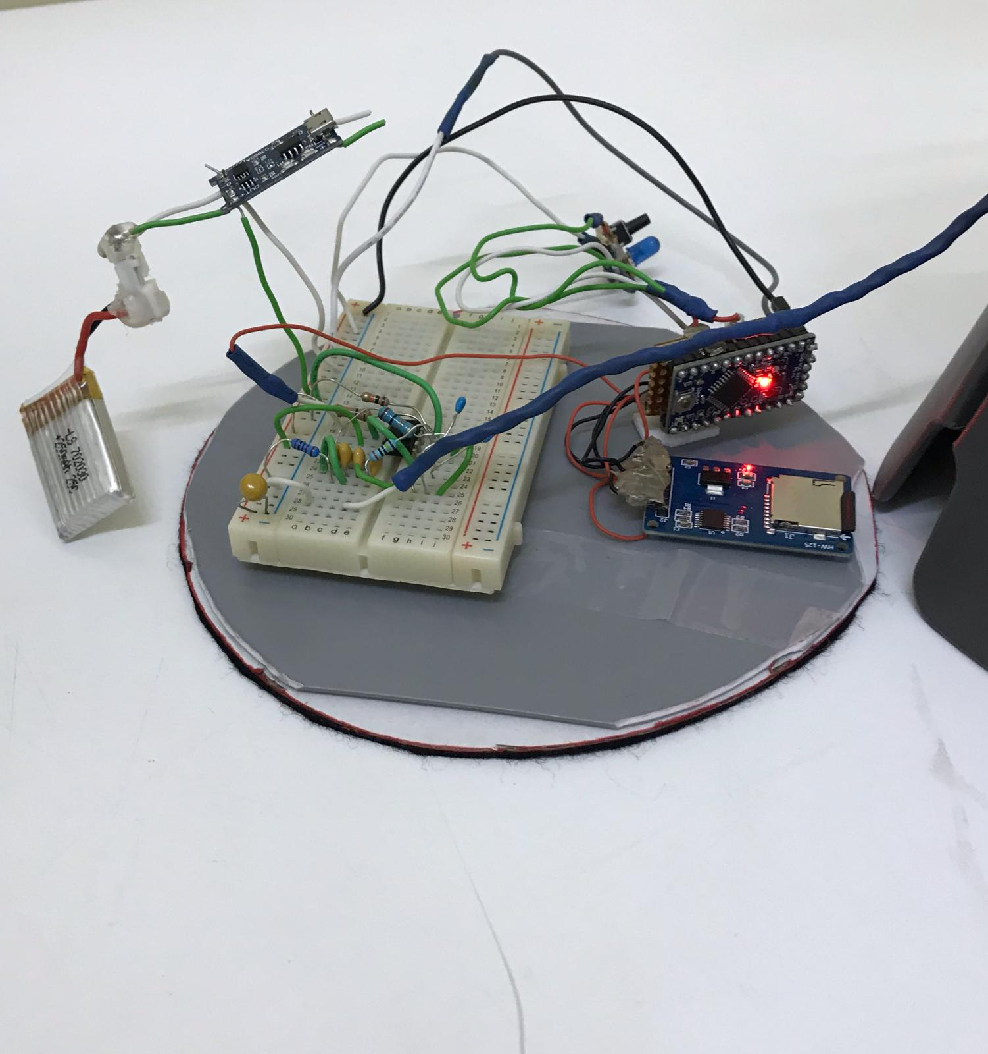

Figure 56: Circuit of Table Lamp

1. Disposable coffee cup

The circuit can take the shape of a disposable coffee cup that can be obtained from any café. The circuit is placed at the base of the cup and is well sealed to hold liquids. The microphone is sticking out from the side to receive the transmitted data. The benefit of having such a design is that the circuit is hidden in a functional object.

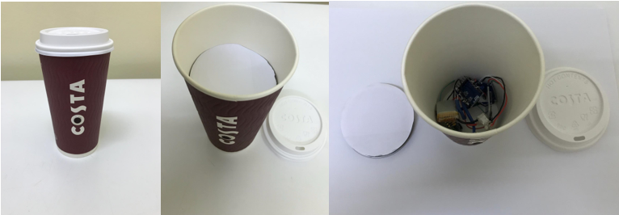

Figure 57: Final Product (Disposable Coffee Cup)

# Testing and Evaluation

This section highlights how the different parts of the system are tested and evaluated. This is done by testing the non-functional requirements, technical and practical design constraints. These tests enable us to conclude whether the system succeeded in fulfilling its purpose. In addition, improvements will be discussed accordingly. The following parameters are evaluated:

* Usable audio frequency range
* Accuracy versus bit duration (or equivalently versus bit transmission rate)
* Accuracy versus distance
* Accuracy versus packet size
* Achievement of design constraints and project requirements

## Audio frequency range test

The goal of this test is to make the system compatible with as many computers as possible. This test determines the lowest possible frequency that can be used, without being heard, to retrieve data from the victim machine. Computers with the lowest speaker frequency capabilities are chosen for this test. The goal is to evaluate an appropriate frequency range that does not dramatically affect the functionality of the system and make the system compatible with a wide range of computers.

Table 9: Device Speaker Frequency Range

|  |  |
| --- | --- |
| Device Brand and Model | Device Speaker Limits (Hz) |
| Toshiba Satellite S55 | 19000 |
| HP nx9010 | 19000 |
| HP pavilion | 18000 |
| Desktop Computer | 20000 |
| Lenovo Z41 | 18000 |
| MacBook Pro 2017 | 19000 |

Referring to Table. 9, due to the speakers of the Lenovo Z41 that can only emit a maximum audio frequency of 18KHz, this audio frequency is used to retrieve data from the victim.

## Distance and bit duration

This test shows how accuracy varies when the bit transmission rate is changed. We define accuracy as the percentage of correct bits identified in a transmission. The different bit durations demonstrated in this test are 500ms, 1000ms, 2000ms, 3000ms and 4000ms, which correspond to bit rates of 2, 1, 0.5, 0.33 and 0.25 bits/second, respectively. This test records the number of bits received by the listening device. Three recording are obtained for each distance. For the following tests, 88 bits are sent for all different bit durations to ensure fairness. The number of bits recorded for each trial are averaged and the accuracy for this average is found. Using three recordings helps reduce the error of the message obtained by the attacker. This is due to the three recordings being superimposed on each other and compared.

### For 500ms bit transmission duration

Table 10: Accuracy Versus Distance at Bit Duration of 500ms

|  |  |  |  |  |
| --- | --- | --- | --- | --- |
| Bit Duration of 500ms | | | | |
| Distance (m) | Recording 1  (bit) | Recording 2  (bit) | Recording 3  (bit) | Average Accuracy (%) |
| 0.00 | 0 | 0 | 0 | 0.00 |
| 0.25 | **0** | 0 | 0 | 0.00 |
| 0.50 | **0** | 0 | 0 | 0.00 |
| 0.75 | **0** | 0 | 0 | 0.00 |
| 1.00 | **0** | 0 | 0 | 0.00 |
| 1.50 | **0** | 0 | 0 | 0.00 |
| 2.00 | **0** | 0 | 0 | 0.00 |

Discussion:

For any bit duration of less than 1000ms, no results appear. The audio data is read by the microphone and is stored but during analysis, the bits appear to be scrambled. In Table, 500ms was used as a demonstration of this issue. This issue is due to the microcontroller’s capabilities. The Arduino Pro Mini has a 10-bit resolution, 1024 different value. This is not enough for 18KHz audio and the Arduino suffers when approximating values. A higher bit resolution is required therefore the Arduino Pro Mini needs to be replaced with a bigger in size and more powerful microcontroller. Since the system aims to be small and concealable, this is not be preferable.

### For 1000ms bit transmission duration

Table 11: Accuracy Versus Distance at Bit Duration of 1000ms

|  |  |  |  |  |
| --- | --- | --- | --- | --- |
| Bit Duration of 1000ms | | | | |
| Distance (m) | Recording 1 (bit) | Recording 2  (bit) | Recording 3  (bit) | Average Accuracy (%) |
| 0.00 | 88.00 | 88.00 | 88.00 | 100.00 |
| 0.25 | 88.00 | 88.00 | 88.00 | 100.00 |
| 0.50 | 82.00 | 78.00 | 77.00 | 89.70 |
| 0.75 | 65.00 | 72.00 | 73.00 | 79.50 |
| 1.00 | 65.00 | 72.00 | 67.00 | 77.30 |
| 1.50 | 55.00 | 47.00 | 50.00 | 57.58 |
| 2.00 | 0.00 | 0.00 | 0.00 | 0.00 |

Discussion:

At 1000ms we start to see results. Close distances appear to perform very well but as the distance increases, performance decreases rapidly until a distance of 1.50 meters. At this distance nearly half of the data is lost, which is not ideal. This is due to noise which affects the microcontrollers reading ability, therefore some bits do not reach the microphone. Observe that when the distance reaches 2.00 meters, no bits were read by the microcontroller. This is the case for all other bit transmission durations at 2 meters and will be discussed in section 6.3.

### For 2000ms bit transmission duration

Table 12: Accuracy Versus Distance at Bit Duration of 2000ms

|  |  |  |  |  |
| --- | --- | --- | --- | --- |
| Bit Duration of 2000ms | | | | |
| Distance (m) | Recording 1  (bit) | Recording 2  (bit) | Recording 3  (bit) | Average Accuracy (%) |
| 0.00 | 88.00 | 88.00 | 88.00 | 100.00 |
| 0.25 | 88.00 | 88.00 | 88.00 | 100.00 |
| 0.50 | 88.00 | 88.00 | 88.00 | 100.00 |
| 0.75 | 88.00 | 84.00 | 88.00 | 98.48 |
| 1.00 | 86.00 | 86.00 | 88.00 | 96.60 |
| 1.50 | 88.00 | 80.00 | 85.00 | 95.83 |
| 2.00 | 0.00 | 0.00 | 0.00 | 0.00 |

Discussion:

Significant improvements can be observed when the bit duration is increased to 2000ms, less than 5.00% data is being lost at 1.50 meters. Observe that the accuracy at 0.50 meters increased from 89.70%, for 1000ms bit transmission duration, to 100% for 2000ms. Although accuracy is high, improvements can be made, which will be discussed in section 6.2.d, by increasing the bit transmission duration.

### For 3000ms bit transmission duration

Table 13: Accuracy Versus Distance at Bit Duration of 3000ms

|  |  |  |  |  |
| --- | --- | --- | --- | --- |
| Bit Duration of 3000ms | | | | |
| Distance (m) | Recording 1  (bit) | Recording 2  (bit) | Recording 3  (bit) | Average Accuracy (%) |
| 0.00 | 88.00 | 88.00 | 88.00 | 100.00 |
| 0.25 | 88.00 | 88.00 | 88.00 | 100.00 |
| 0.50 | 88.00 | 88.00 | 88.00 | 100.00 |
| 0.75 | 88.00 | 88.00 | 88.00 | 100.00 |
| 1.00 | 88.00 | 88.00 | 88.00 | 100.00 |
| 1.50 | 88.00 | 88.00 | 88.00 | 100.00 |
| 2.00 | 0.00 | 0.00 | 0.00 | 0.00 |

Discussion:

At 3000ms perfect results are retrieved from the system, with exception of 2.00 meters. All the bits being sent by the victim’s computer are read by the microphone and are stored properly in the microcontroller. Since the purpose of this section is to test the system, it was decided to also test a bit transmission duration of 4000ms to see if we would obtain different results.

### For 4000ms bit transmission duration

Table 14: Accuracy Versus Distance at Bit Duration of 4000ms

|  |  |  |  |  |
| --- | --- | --- | --- | --- |
| Bit Duration of 4000ms | | | | |
| Distance (m) | Recording 1  (bit) | Recording 2  (bit) | Recording 3  (bit) | Average Accuracy (%) |
| 0.00 | 88.00 | 88.00 | 88.00 | 100.00 |
| 0.25 | 88.00 | 88.00 | 88.00 | 100.00 |
| 0.50 | 88.00 | 88.00 | 88.00 | 100.00 |
| 0.75 | 88.00 | 88.00 | 88.00 | 100.00 |
| 1.00 | 88.00 | 88.00 | 88.00 | 100.00 |
| 1.50 | 88.00 | 88.00 | 88.00 | 100.00 |
| 2.00 | 0.00 | 0.00 | 0.00 | 0.00 |

Discussion:

4000ms bit transmission duration appears to present perfect results with the exception of 2.00 meters. Overall, 4000ms performs well but will take a longer time to retrieve information from the victim’s computer.

### Graphical comparison between different bit transmission durations

Figure 58: Distance vs Bit Transmission Duration

Discussion:

**Figure 58** shows how different bit transmission durations impact the accuracy at different distances. As the duration increases, accuracy increases. Notice the 3000ms and 4000ms perform similarly as their lines are on the top of each other.

## Distance vs decibels relative to full scale (dBFS)

The purpose of this test is to observe how the decibels relative to Full Scale (dBFS), of the audio read by the microphone, behave when distance is varied. This is useful to determine the effective range of the system.

Table 15: Accuracy Versus Distance at Distance vs dBFS

|  |  |  |  |  |  |  |  |
| --- | --- | --- | --- | --- | --- | --- | --- |
| Distance (m) | 0.00 | 0.25 | 0.50 | 0.75 | 1.00 | 1.50 | 2.00 |
| dBFs | -31.62 | -37.97 | -43.66 | -48.24 | -49.02 | -50.46 | -52.96 |

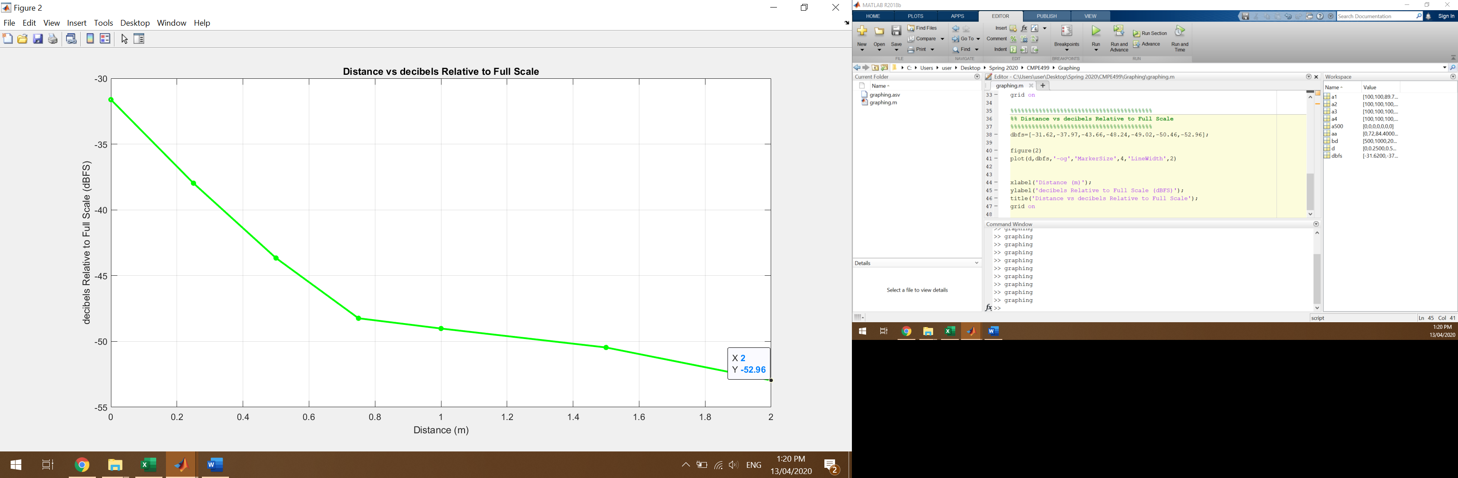

Figure 59: Distance vs dBFS

Discussion:

**Figure 59** shows how decibels Relative to Full scale decays with distance. Notice that at 2.00 meters, the reading is at -52.96 dBFS. This explains why no readings were obtained for different bit transmission duration since the electret microphone used has an experimental cut-off rating of -50dBFS [39]. With this hardware, the effective range of the system is 1.50 meters due to limitations of the electret microphone.

## Packet size vs accuracy

Large messages are divided into smaller packets (batch of bits with one preamble and one postamble). The purpose of this test is to know whether the number of bits transmitted from the victim’s computer in one batch (packet) affects the accuracy of the data received by the attacker. At a bit transmission rate of 2000ms and a fixed distance of 1.00-meter, Different packet sizes were determined as shown in **Table 16**:

Table 16: Packet Size vs Accuracy

|  |  |  |
| --- | --- | --- |
| Data Bits Sent | Data Bits Received | Accuracy (%) |
| 128 | 128 | 100.00 |
| 256 | 252 | 98.44 |
| 384 | 375 | 97.66 |
| 512 | 499 | 97.46 |
| 640 | 623 | 97.34 |
| 768 | 747 | 97.27 |
| 896 | 870 | 97.10 |
| 1024 | 993 | 96.97 |

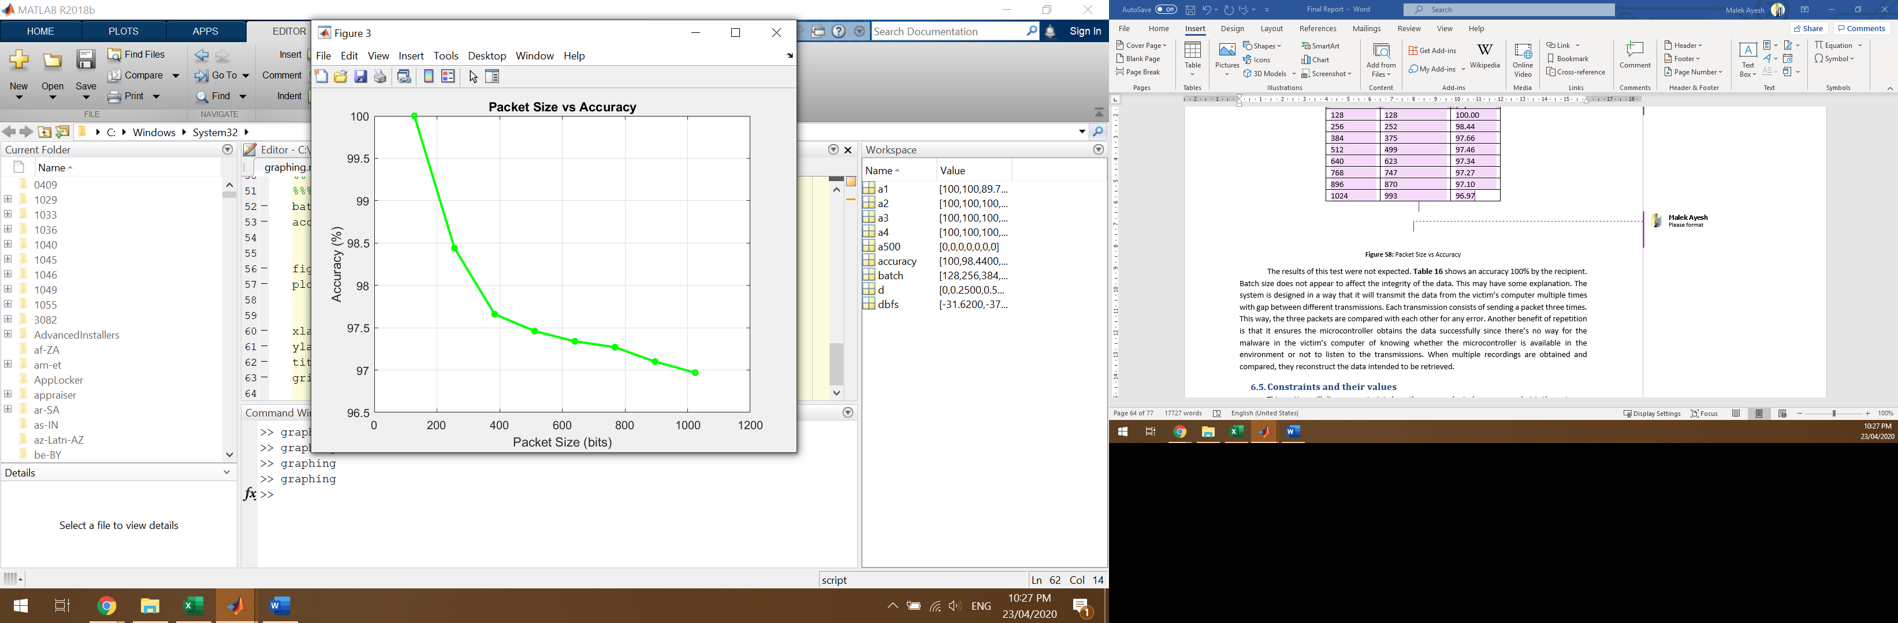

Figure 60: Packet Size vs Accuracy

The results of this test were not expected. **Table 16** shows an accuracy of 96.97% to 100% by the recipient. Packet size appears slightly affect the integrity of the data. This may have some explanation. The system is designed in a way that it transmits data from the victim’s computer multiple times with gap between different transmissions. Each transmission consists of sending a packet three times. This way, the three packets are compared with each other for any error. Another benefit of repetition is that it ensures the microcontroller obtains the data successfully since there’s no way for the malware in the victim’s computer of knowing whether the microcontroller is available in the environment or not to listen to the transmissions. When multiple recordings are obtained and compared, they reconstruct the data intended to be retrieved.

## Constraints and their values

This section will discuss constraints how they are evaluated moreover, what is the outcome of each constraint’s evaluation.

Table 17: Constraint Evaluation & Values

|  |  |  |
| --- | --- | --- |
| Constraint and Description | Constraint Evaluation | Constraint Values |
| Audio Frequency Range | Due to the test conducted on multiple Computers, presented in **Table 9**, the lowest inaudible frequency was selected. This is to ensure that the system is compatible with as many computers as possible. | Audio transmitted from the victim’s device at 18,000Hz |
| Transmission Rate | From the data obtained from the tables in section 6.B, the optimal bit transmission rate is 3000ms. This is due the high accuracy this transmission rate provides with the least amount of time. | Bit Transmission rate of 3000ms per bit. |
| Accuracy | As the bit transmission rate increase so does the accuracy. The bit transmission rates of 3000ms and higher provide 100% accuracy for distances up to 1.50 meters. | Accuracy of 100% for 3000ms bit transmission rate at 1.50 meters. |
| Memory | Assuming a message is 88 bits,  When the 88 bits are sent in audio form they are received by the microphone. The audio form, obtained by the microphone, is 8.53MB on average per message, when stored on the SD-card.  A 16GB memory card can store 625 messages:  16000MB/8.53MB=1875 messages.  Each transmitted bit will need 0.1MB for it to be stored in audio from:  8.53MB/88=0.1MB/audio bit. | 0.1MB/audio bit is needed. 16GB memory card is more than sufficient. |
| Battery Life | By connecting a multimeter to the OUT+ terminal of the battery charging and protection circuit, the current draw can be measure. The current draw is 18mA. Assuming we are using a 250mAh battery, the system will function for 13.89 hours:  250mAh/18mA=13.89 hours. | The system will function for 13.89 hours on a 250mAh battery. |
| Size | The system aims to be concealable. This prototype is relatively small in size. It measures 4.00cmx2.50cmx2.00cm. further versions of this system aim to be considerably smaller. | The system measures at 4.00cmx2.50cmx2.00cm. |
| System Forms | The goal of this project is to make it as concealable as possible and aims to be placed in objects without grabbing anyone’s attention. For demonstration, the system will take two forms: a table lamp and disposable coffee cup. | The system will be displayed as either a table lamp or a disposable coffer cup. |
| Cost | The purpose of this project is to make it as inexpensive as possible. This is due to the nature of the environment it will be used in. Ideally, if the system is thrown away or destroyed, the organization using it should not lose much money. | The total cost of each system totals to $25 each. |

## Prototype requirements evaluation

As designed, this prototype was able to successfully accomplish its purpose. The main purpose of this system was to organize and send information from a victim’s computer using an inaudible audio frequency. This in-audible frequency will be received by a microcontroller with a specially designed microphone that picks up high, near ultrasonic sonic sound, and data gets stored on an onboard SD-card that will be later placed in the attacker’s computer. The attacker’s computer will reconstruct and transform the audio back into actual characters. Those characters are the targeted information from the victim’s device.

Like any academic prototype, there is room for improvement. This will be explained in more details in section 9.

# Evaluation of the impact of the engineered solution

The overall effect of this system is evaluated to determine whether it serves a purpose or not. Factors that are investigated include global, economic, environmental and societal. Below, in **Table 18** these factors are discussed.

Table 18: Evaluation Context

|  |  |  |  |
| --- | --- | --- | --- |
|  | Evaluation Context | Specific Contribution through the Project | level of impact (High, Medium, low) |
| 1 | Global | This project definitely has a global impact. State sponsored attacks have become common. Countries employ tactics against each other to retrieve sensitive information from air-gapped devices (Stuxnet is an example). Doing this project alerts governments about such exploits and helps them think outside the box when it comes to protecting and investigating such crimes. | High impact |
| 2 | Economical | This project has no major effect on the country’s economy but has an effect when it comes to protecting it. When demonstrating this project as a viable method of attacking, the potential exploits have a serious impact on protecting valuable data and intellectual property. The device itself is cheap, made up of very common tools and components, reliable and fairly simple to manufacture. | Medium Impact |
| 3 | Environmental | No health risks exist for this project. The main concern may be with regard to the audio frequency used. This is not an issue since 18KHz cannot be heard and is not be a health hazard. | Low Impact |
| 4 | Societal | The project contributes to the critical area of cyber security and offer opportunity for future research. It helps organizations to defend themselves in the never-ending war between hackers and organizations. This project will hopefully motivate organizations, researchers and governments to look in other viable methods of attack that were not previously considered. | High Impact |

# Conclusion

This project was an overall success. It achieved its main objective by demonstrating that an air-gapped device can be attacked to retrieve sensitive information, via a covert channel. In this case, the covert channel is an inaudible acoustic covert channel. This project grabbed the attention of many people ranging from professors and researchers to just ordinary people. People are interested to hear of such ideas that most of the time feel fictional. The project was on display at the IEEE’s ICIoT20 conference, where it received first place for the poster award. From the traction gained by this project, awareness was spread. And simple precautions were advised to people that will protect them from such attacks, which include disabling the computer’s speakers and USB ports.

The experience gained by the team was unbelievable. Skill and gained academic knowledge were well tested through this project to resolve issues and innovate ideas to advance each team member’s knowledge on the subject. Some of the fields that were used include signal processing, data communication, cryptography and electric circuits.

At the end, the system was able to achieve data transmission from an air gapped computer, the victim, to another computer, the attacker. This was done using a sound covert channel that functions at near ultrasonic frequencies which sends and stores acoustic data in a microcontroller with a specially designed microphone. Data transmission is most successful when the distance separating the air-gapped device and the microcontroller does not exceed 1.50 meters. Best results were produced when the bit transmission rate is 3000ms.

Like any other academic prototype, there is a large room for project improvements and further development. This includes increasing the effective range by having a better microphone and circuit, reducing the size of the hardware used and looking into other possible covert channels.

This system is unique and is different from other similar attempts. Other projects did not use a hardware device while this design did. The advantage of using a hardware device similar to the one deployed improves the chances of such an attack to succeed. The hardware device used is very basic compared to others such as mobile phones, tablets and laptops. Usually such devices are prohibited in sensitive facilities and sometimes do not even function there due to signal jammers. Since this project uses an uncommon frequency, it gives it a higher chance achieving its goal. This project has so much potential. It warns and motivates people to protect themselves or at least be open-minded that attacks do not just occur through networks.

# Future work

This project has unlimited potential for improvements and further development. The following summarizes possible project improvements:

1. The system’s effective range

Further development on this project will mainly revolve around increasing the effective range of the system. The weakness of this system can be diagnosed as one of the following: the victim’s computer speakers not being powerful enough and the microphones limitations. The issue of the computer speakers cannot be fixed as this system should be compatible with most devices, but the microphone issue can be addressed. The microphone circuit, that’s attached to the microcontroller, is limited to -50 dB and this limits the effective range of the system to 1.50 meters. The upside to the microphone used is that it is very inexpensive and is made of common components such as operational amplifiers, capacitors and resistors. Replacing the current microphone and its circuit with a higher quality and better sensitivity one would improve the performance of the system but will also increase the cost of the system significantly. Therefore, improving the effective range has a downfall. Nothing can be done with the circuit since components like operation amplifiers are functioning at their highest capabilities.

1. The size of the hardware components

Size of the hardware is another area of improvement for this system. The system currently measures at 4.00cmx2.50cmx2.00cm. This is small but it can be smaller. Companies are coming up with newer, smaller microcontrollers that would be suitable for this project, like the Arduino Pico. The perfect choice of microphone and its circuit will play a major role in reducing the overall size significantly, compared the one currently used. The current microphone and its circuit measure at 4.00cmx2.50cmx0.3cm. The biggest issue with size would be the SD-card adapter since it is fairly large. Future work will focus on finding a substitute for SD-cards by researching microcontrollers with onboard memory. The easiest component to address its size issue would be the Li-Po battery since it comes in so many different sizes. Till now, no clear answer of how much current will be drawn when using a smaller microcontroller therefore no exact number can be given regarding how long the new improved system will function. Overall functioning time is expected to decrease with a smaller battery.

1. Explore different channels

Looking into other covert channels will be exciting. This project proves the ability of transmitting data from one computer to another using a near-ultrasonic sound covert channel. The field of covert channels and their detectors will be explored in future work to compare efficiency, effectiveness, and the overall capabilities of each system.

# Student reflections

1. ***Malek Ayesh***

This project had many challenges. It showed that problem solving does not only depend on academic knowledge but also depends on other factors like teamwork. Many new skills were gained as this project dives into the different sectors of the computer engineering and science fields. The team has the basic knowledge of concepts used in this project but had to develop on them to complete the project successfully. Fields explored include programming, signal processing, microprocessors, encryption, and computer architecture. Overall, this project will support a personal goal of being a network security engineer and the experiences gained provide a robust foundation for the future, this is due to many reasons. This project improved the team’s communication skills, time management and problem-solving skill and taught the team that no matter how certain a design may appear, problems will arise. This improved the team’s ability to solve problems in short amounts of time. This experience will prepare the team for their careers and help them work with different people in the workplace more efficiently.

* ***Abdulhady Fezooni***

Valuable knowledge and skills were gained during the one year of this senior project. This project led to the introduction of new hardware and software related concepts and their functionalities. Some of the fields investigated include microprocessors (Arduino), signal processing and software libraries. Of course, much research was done to satisfy the project’s requirements in both hardware and software aspects. Other technical skills were obtained which include time management and teamwork. This Senior project is important for pursuing a future career since it provided experience regarding communicating with teammates, achieving a goal and decisions making efficiently and effectively.

* ***Ehab Ghannoum***

I learned a lot from the project since this project combines multiply things not like other university courses where we focus on a specific topic. To start with I learned how to do research. Also, how to combine multiply things hardware and software together to make a full product. I learned time management because there was a plan to follow and we have to commit to it. For new skills. I learned more about python especially using python for digital signal processing. Also, I learned to use many new python libraries, in addition, learning how to use GitHub for software development version control. Nothing to avoid in future projects since each project is a new experience and challenge.

# References

1. Afcea.org. (2012). The History of Stuxnet: Key Takeaways for Cyber Decision Makers. [online] Available at: https://www.afcea.org/committees/cyber/documents/thehistoryofstuxnet.pdf.
2. M. Guri, B. Zadov, D. Bykhovsky, and Y. Elovici, “PowerHammer: Exfiltrating Data from Air-Gapped Computers through Power Lines,” 10-Apr-2018. [Online]. Available: https://arxiv.org/pdf/1804.04014.pdf.
3. Harris, R. (2017). Four methods hackers use to steal data from air-gapped computers | ZDNet. [online] ZDNet. Available at: https://www.zdnet.com/article/stealing-data-from-air-gapped-computers/
4. Nast, C. (2018). This Researcher Steals Data With Noise and Light [Online]. Available: <https://www.wired.com/story/air-gap-researcher-mordechai-guri/>. [Accessed Dec.6, 2019].
5. Kumar, M. (2018). MOSQUITO Attack Allows Air-Gapped Computers to Covertly Exchange Data [Online]. Available: https://thehackernews.com/2018/03/air-gap-computer-hacking.html. [Accessed Dec.6, 2019].
6. Power, J. (2014). Mind the gap: Are air-gapped systems safe from breaches? [online] Symantec Security Response. Available at: https://www.symantec.com/connect/blogs/mind-gap-are-air-gapped-systems-safe-breaches.
7. M. Guri and Y. Elovici, “Bridgeware: The Air-Gap Malware,” ACM, 01-Apr-2018. [Online]. Available: https://cacm.acm.org/magazines/2018/4/226377-bridgeware/abstract . [Accessed Dec.6, 2019].
8. Shearer, J. (2010). W32.Stuxnet | Symantec. Retrieved from https://www.symantec.com/security-center/writeup/2010-071400-3123-99.
9. Tahir R., A Study on Malware and Malware Detection Techniques. I.J. Education and Management Engineering, 08 March 2018.
10. Elhadi, Ammar AE, Mohd A. Maarof, and Ahmed H. Osman. "Malware detection based on hybrid signature behaviour application programming interface call graph." American Journal of Applied Sciences 9.3 (2012): 283
11. Landage, Jyoti, and M. P. Wankhade. "Malware and malware detection techniques: A survey." International Journal of Engineering Research and Technology (IJERT) 2.12 (2013): 2278-0181.
12. Jacob, Grégoire, Hervé Debar, and Eric Filiol. "Behavioral detection of malware: from a survey towards an established taxonomy." Journal in computer Virology 4.3 (2008): 251-266.
13. Robiah, Y., et al. "A new generic taxonomy on hybrid malware detection technique." arXiv preprint arXiv: 0909.4860 (2009).
14. Chu, E., Kim, P., Liu, F., Sharma, J. and Yu, J. (2000). The Selection of the Advanced Encryption Standard.
15. Anon, (2012). Data Encoding Techniques - Tutorialspoint. <https://www.tutorialspoint.com/digital_communication/digital_communication_data_encoding_techniques.htm>.
16. Rouse, M. What is frequency-shift keying. <https://searchnetworking.techtarget.com/definition/frequency-shift-keying>.
17. Anon, (2013). Microphone Definition. <https://techterms.com/definition/microphone>.
18. Guri, M., Solewicz, Y., Daidakulov, A. and Elovici, Y. (2016). Fansmitter: Acoustic Data Exfiltration from (Speakerless) Air-Gapped Computers.
19. Kumar, M. (2018). MOSQUITO Attack Allows Air-Gapped Computers to Covertly Exchange Data. <https://thehackernews.com/2018/03/air-gap-computer-hacking.html>
20. Fahmy, S. (2018). Encryption and Decryption of Audio Signal Based on RSA Algorithm. <https://www.researchgate.net/publication/327100541_ENCRYPTION_AND_DECRYPTION_OF_AUDIO_SIGNAL_BASED_ON_RSA_ALGORITHN>.
21. O’Malley, S. and Raymond Choo, K. (2014). Bridging the Air Gap: Inaudible Data Exfiltration by Insiders.
22. Soderi. S., Security in Body Networks: Watermark-based Communications on Air-gap Acoustic Channel. Springer Science. 28 October 2019.
23. Do It Easy With ScienceProg. (2014). Electret condenser microphone amplifier for use in microcontroller projects | Do It Easy With ScienceProg. <https://scienceprog.com/electret-condenser-microphone-amplifier-for-use-in-microcontroller-projects>.
24. Caldwell, J. (n.d.). Single-Supply, Electret Microphone Pre-Amplifier Reference Design.
25. Sathyamoorthy, D. (2014). Wireless spy devices: A review of technologies and detection methods.
26. L. Peterson, L. and S. Davie, B. (2012). Ethernet Frame.
27. Ee.hawaii.edu. (2017). The ASCII Character Set. <https://ee.hawaii.edu/~tep/EE160/Book/chap4/subsection2.1.1.1.html>
28. GeeksForGeeks. (2016) Ethernet Frame Format [Online]. Available: <https://www.geeksforgeeks.org/ethernet-frame-format/s/>. [Accessed Dec.6, 2019].
29. Singh, P. and Shende, P. (2014). Symmetric Key Cryptography: Current Trends.
30. Peterson, J. (2003). Fiber Optics Illustrated Dictionary.
31. Musmann, H. (2006). Genesis of the MP3 audio coding standard - IEEE Journals & Magazine.
32. Anon, (2019). SD Express Memory Cards with PCle and NVMe Interfaces. <https://www.sdcard.org/downloads/pls/latest_whitepapers/SD_and_microSD_Express_Cards_7_1_WhitePaper20190225.pdf>.
33. He, F. (2015). USB Port and power delivery: An overview of USB port interoperabiliy - IEEE Conference Publication.
34. (2000). Qualification and Performance Specification for Rigid Printed Boards. http://www.ipc.org/TOC/IPC-6012B.pdf.
35. (2004). EIA Resistor Series Values Table (E12-E192). <https://www.pc-control.co.uk/resistor-eia.htm>.
36. (2005). International Battery Standards. <https://www.mpoweruk.com/standards.htm>.
37. Ieee.org. (2019). IEEE Code of Ethics. http://www.ieee.org/about/corporate/governance/p7-8.html
38. Acm.org. (2018). The Code affirms an obligation of computing professionals to use their skills for the benefit of society. <http://www.acm.org/about/code-of-ethics>.
39. Amazon. [2019]. Cylewet Cylindrical Electret Condenser Microphone Pickup. https://www.amazon.com/Cylewet-Cylindrical-Electret-Condenser-Microphone/dp/B01N0VMN9P?ref_=fsclp_pl_dp_1

# Appendix A – Project Plan

## A.1. Project milestones

Senior design project 1:

* Researching potential problems

Writing a summary of problems and searching for solutions. Discussing the importance of the project and its benefit in this region. Point out all the objectives of the project and the outcomes to be archived. This milestone includes problem statement, project significance, and project objectives.

* Researching previous work

Search for previous and related work along with advantage and disadvantage identification, to evolve and improve our solution over previous work. Writing the steps related to this project and its flow. This milestone includes background and related work.

* Requirement analysis

Making use case diagram, flow work, data/signal input/output of the system along with processes performed by each function. List all the technical and practical design constraints along with the design standards. Also, list the code of ethics and the assumptions that might be true or false. This milestone includes functional requirements, design standards, professional code of ethics, and assumptions.

* Design and architecture

Investigating and analyzing the overview solution. Show how the architecture diagram composed and organized into components. Compare between the hardware and software that will be used by explaining each component’s function. This milestone includes solution overview, high level architecture, and hardware/software to be used.

* Final report

Complete the report by making sure all the requirements have been fulfilled and start preparing for the final submission and presentation.

Senior design project 2 milestones:

* Building the microphone-microcontroller circuit

Construct the circuit. This includes adding filters, memory and charging circuit. After the construction, it is made sure that the circuit functions properly.

* Produce near-ultrasound data from ‘victims’ computer

Write a code that successfully encrypts, encodes and sends data in the form of near ultrasound.

* Analysis of ‘stolen’ data

Making sure that the data received is correct and both the ‘victims’ computer and the microphone circuit function properly.

* Fine tuning and optimization

Optimization of both software and hardware by addressing weak points.

* Finalize the circuit design

Design the circuit in hidden form to avoid detection when stolen data. The circuit will have two different forms.

* Documenting results and writing the report

Record the results produced after fine tuning and optimization along with document those results and putting them in the final report.

## A.2. Project timeline

Figure 61: Project Timeline

## A.3. Anticipated risks

Table 19: Anticipated Risks

|  |  |  |
| --- | --- | --- |
| Risk | Description | Approach to Minimize Risk |
| Data Interception | Data to be stolen is intercepted, either by listening to near-ultrasound signal sent or if the SD-Card gets confiscated. | Data to be sent is Encrypted |
| Data Retrieved is Mixed Up | After retrieving the data and analyzing it, the data may be meaningless due to not knowing when the start of transmission and end of transmission. | Preamble and Postamble used to organize data by signifying start and end of transmission. |
| Microcontroller Picking up useless frequencies and noise | Microcontroller picking up unwanted frequencies like audible frequencies and noise. | High pass and low pass filters used to read specific frequencies. |
| Delay in Component Shipping | Some components may take longer time than expected to arrive. | Ordering the components as soon as possible. |